The Church in Gojna Gora

We have visited today the Church of Saint Demetrius of Thessalonica in Gojna Gora. We have learnt many interesting information from the local people.
Petar Marić, who was born and grew up in Gojna Gora, and now he is living and working in Čačak, thought that he could build the church in his birth place. He accomplished the idea. The municipality of Gornji Milanovac gave the part of land for the building of the Church, next to the school ''Ivo Andrić'' in the centre of the place. The building of the Church began in the middle of May, in 2017 and the construction was finished by the end of the year. It was built according to the project of Dr Miloš Radovanović from Čačak. The Church is the copy of the Monastery of Studenica . The iconostasis and frescoes were drawn inside.
The local people say that now it is much easier, because they don’t have to go anymore for 7 km to the Church in the nearest place. The Church is still being built.
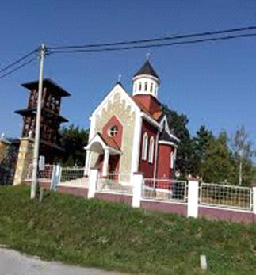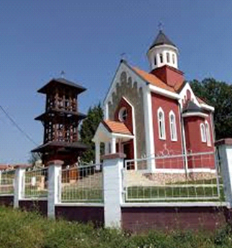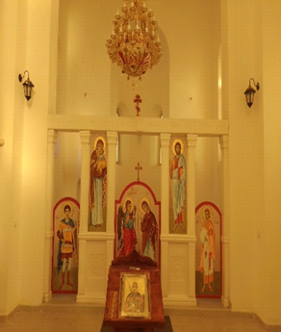

Dragana Tešović , 6th class

