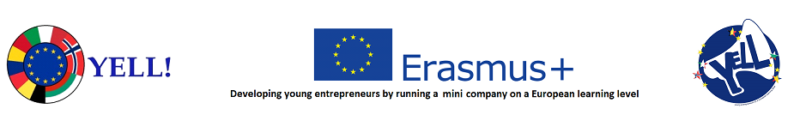
Belgium Mobility 09/02/2020-16/02/2020

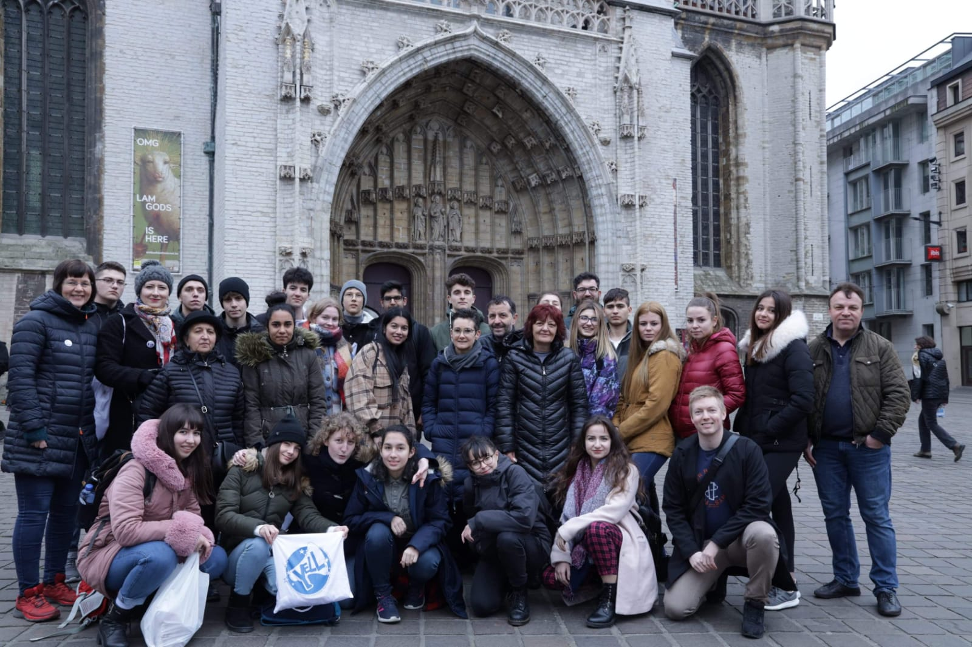

Entrepreneurship is very important nowadays; due to this, the week spent in Belgium was based on discovering the best ways to set up our international mini company and to acquire as much knowledge in this field.
The first meeting with the idea of ​​entrepreneurship was on the second day, when we discovered the Ellio electric bike, which was surprising and impressive. At the same time, the bike manufacturer explained about the contents of a successful business plan. Later that day, we went to Statik, where we attended to the presentation made by the company director, who had started the business on his own. Profitability permitted him to grow the company to the top.
To reach our goal, we were divided into 5 groups for each department: Financial, Marketing, Technical, CEO and Human Resources. It was very interesting to discuss with the other students in the project, summing up the price, the way of promotion, the resources used and the final product.
In the end, each department shared it’s conclusions with the others, and as a last task, each country had to establish a final form of the business plan.
All in all, this experience showed us our level in the field of entrepreneurship, because working with other colleagues from foreign countries, we realized that our theoretical knowledge is more comprehensive, while our peers had less theoretical information, but more practice.
Belgium was a unique experience from which we gained a lot: close friends, many ideas of ​​what we can do in the future in terms of entrepreneurship and new approach about many cultures that impressed us.
Maruntu Mari
Madalina Radu
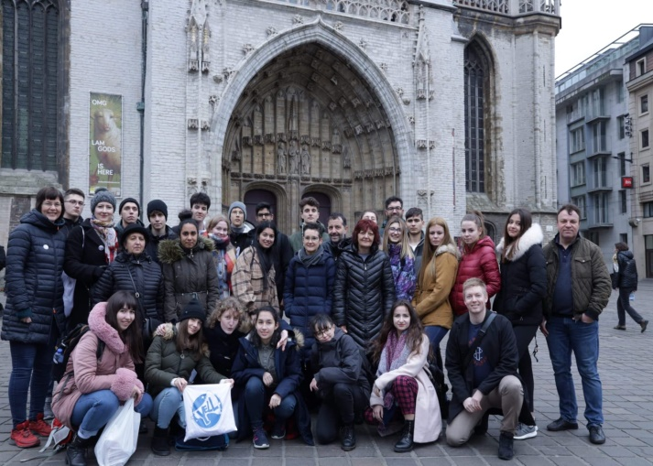
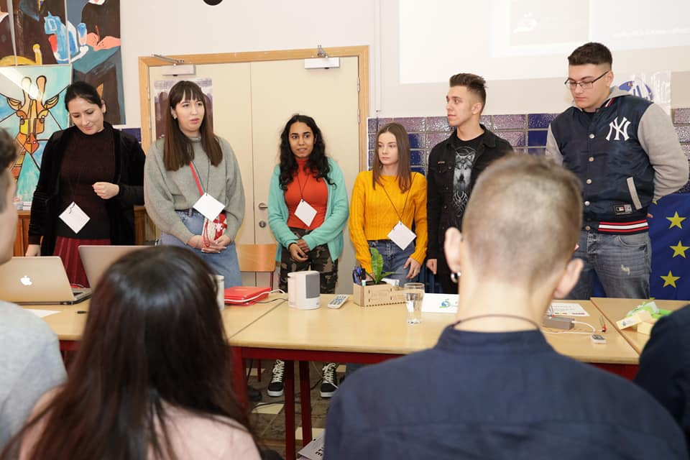

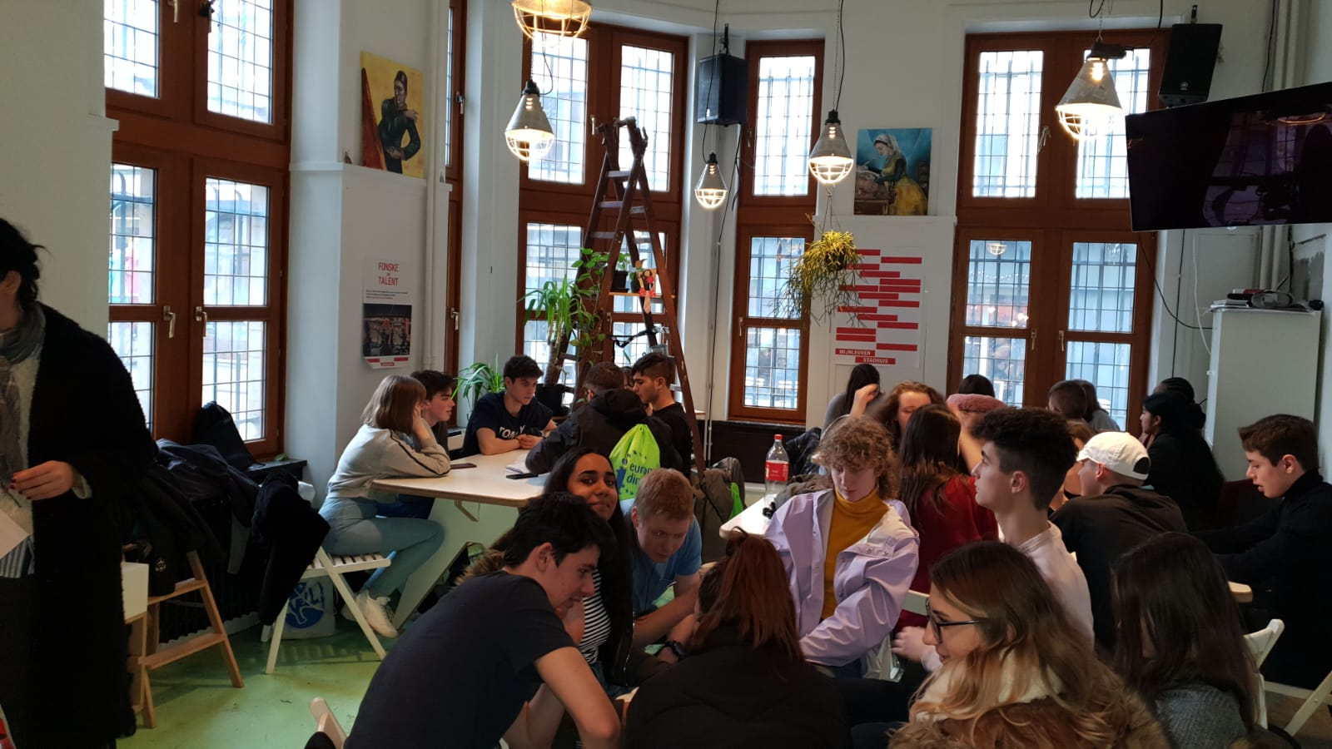

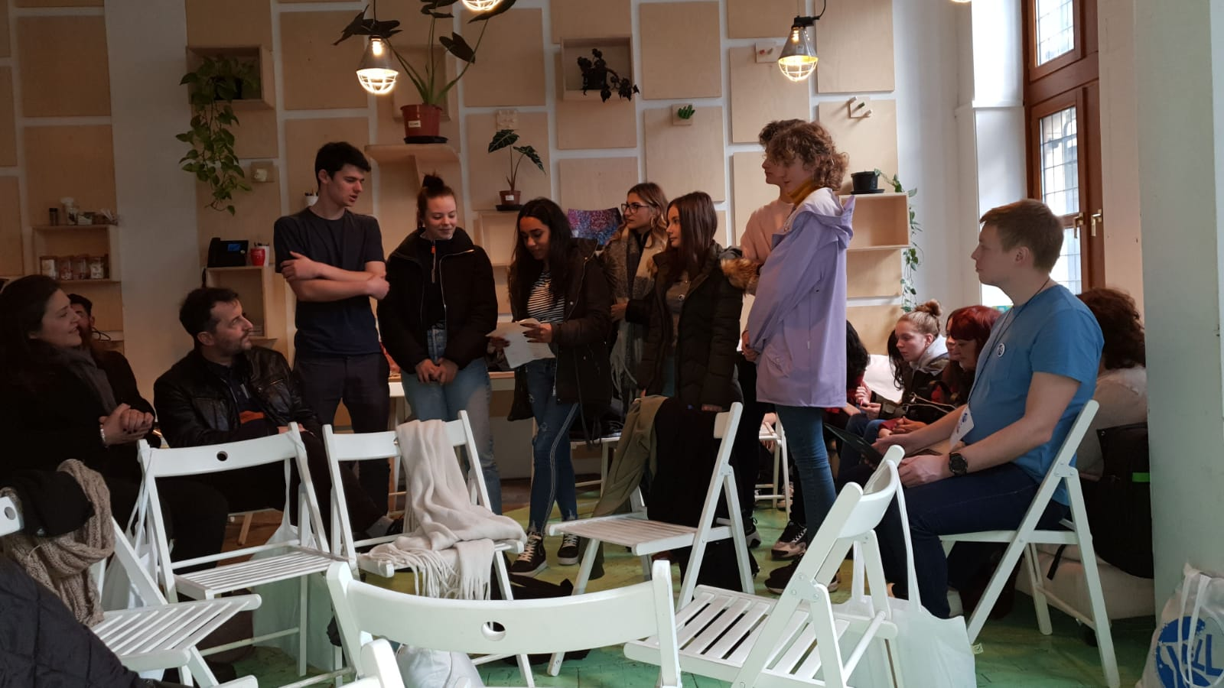
Architecture & Style

I discovered Belgium as an old historical country, full of art and creativity. Leuven has a lot of narrow streets with stores and graffiti. Cathedrals, churches (Black Church), parks, museums, artistic buildings. It is covered in brown and grey shades, which gives it a modern and simple style.
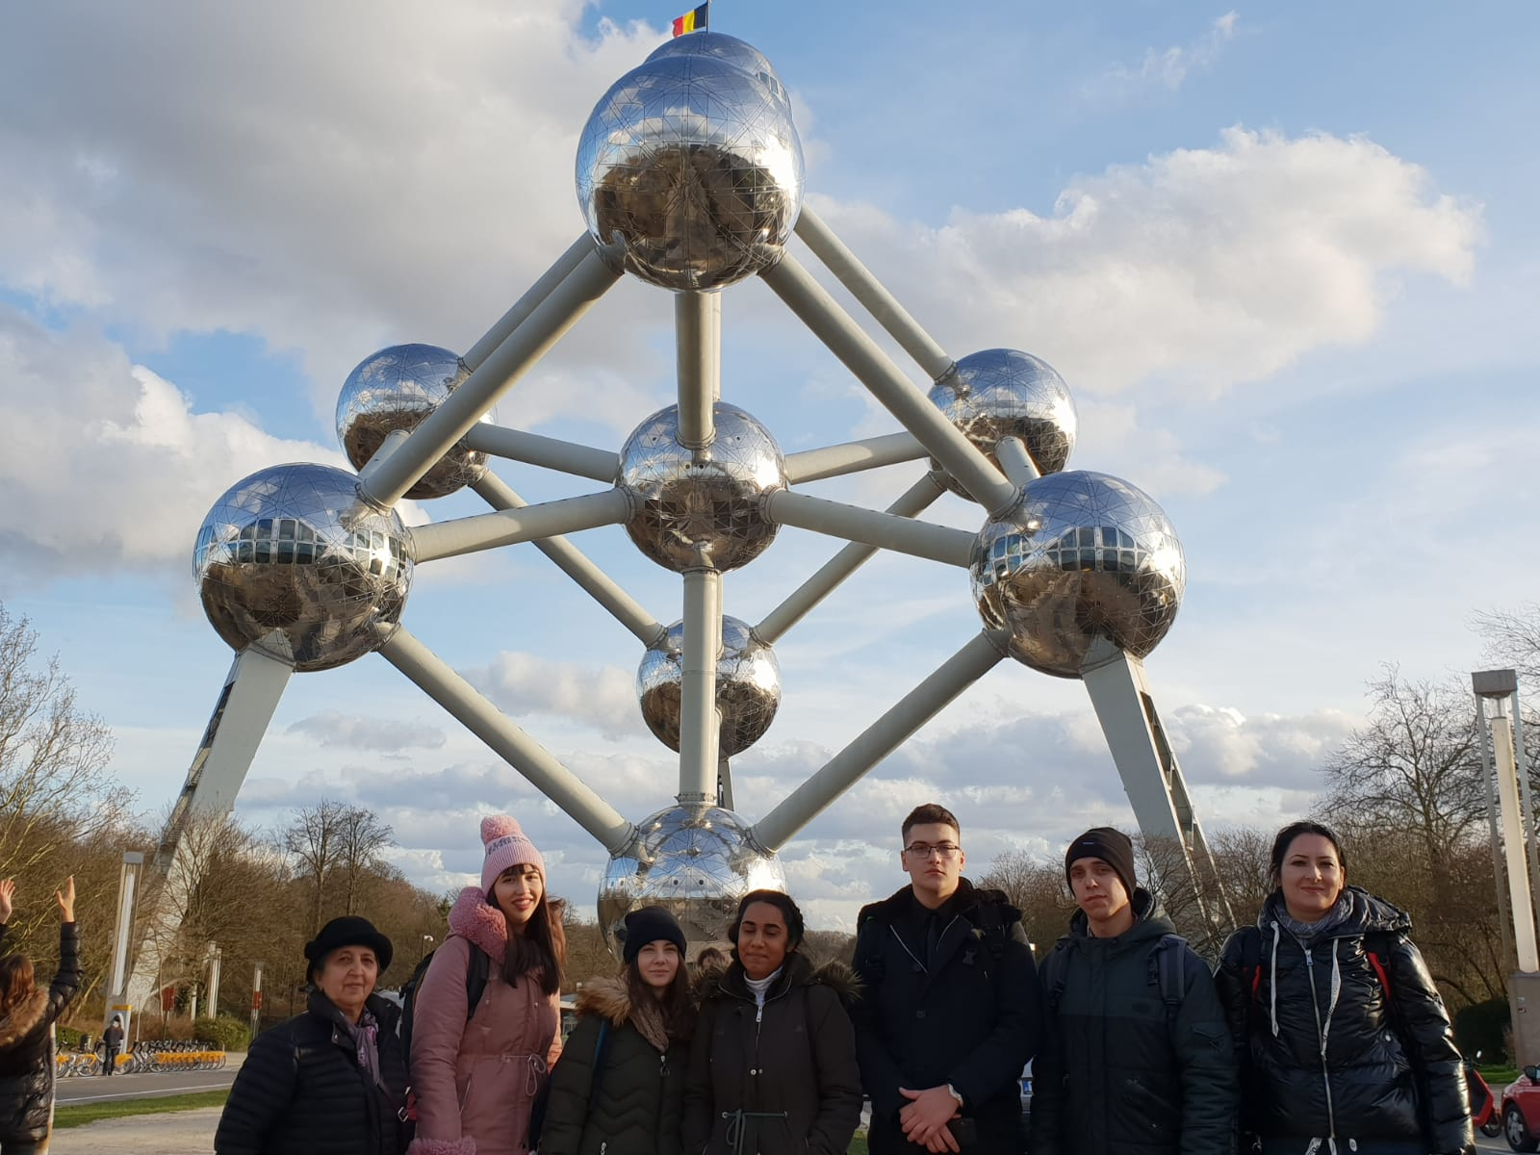
In Belgium gothic art is dominant... For example the Town Hall - one of the most stunning buildings.
I love taking pictures, so this city was an escapade from my monotone and typical type of photography. Those buildings have their “personal” stories.

ATOMIUM ...

This is the symbol of Belgium, which is formed by nine spheres - designed by Andre Waterkeyn.
It was recently renovated and three of the steel spheres are available to visit and they contain for example a restaurant, and a place for Belgian school kids.
One reason why I appreciate Belgium is because it has many museums and a lot of art institutes. I see this country as a place where many creative people can live…

Spinu Eva Alessandra
Colorful Creativity over the Ghent’s Walls … Where art rules

People sometimes say you can recognize a vibrant city by its street art. Ghent is a canvas for street artists, a hip and free-thinking cultural city where everyone is welcome and free to do their thing.
A few remarkable things..
There are a variety of languages they speak … English, German, French… But also Flemish! Have you ever heard of this unique language? This is a combination of German and French which is typically spoken in Belgium .
Most people (old/young ) use the bike. In Belgium you’ll never frequently see a car parking, but parkings for bikes are almost everywhere! Do you remember those car parking lots with thousands of cars? Imagine one with bikes (Ghent - one hour distance from Leuven) .
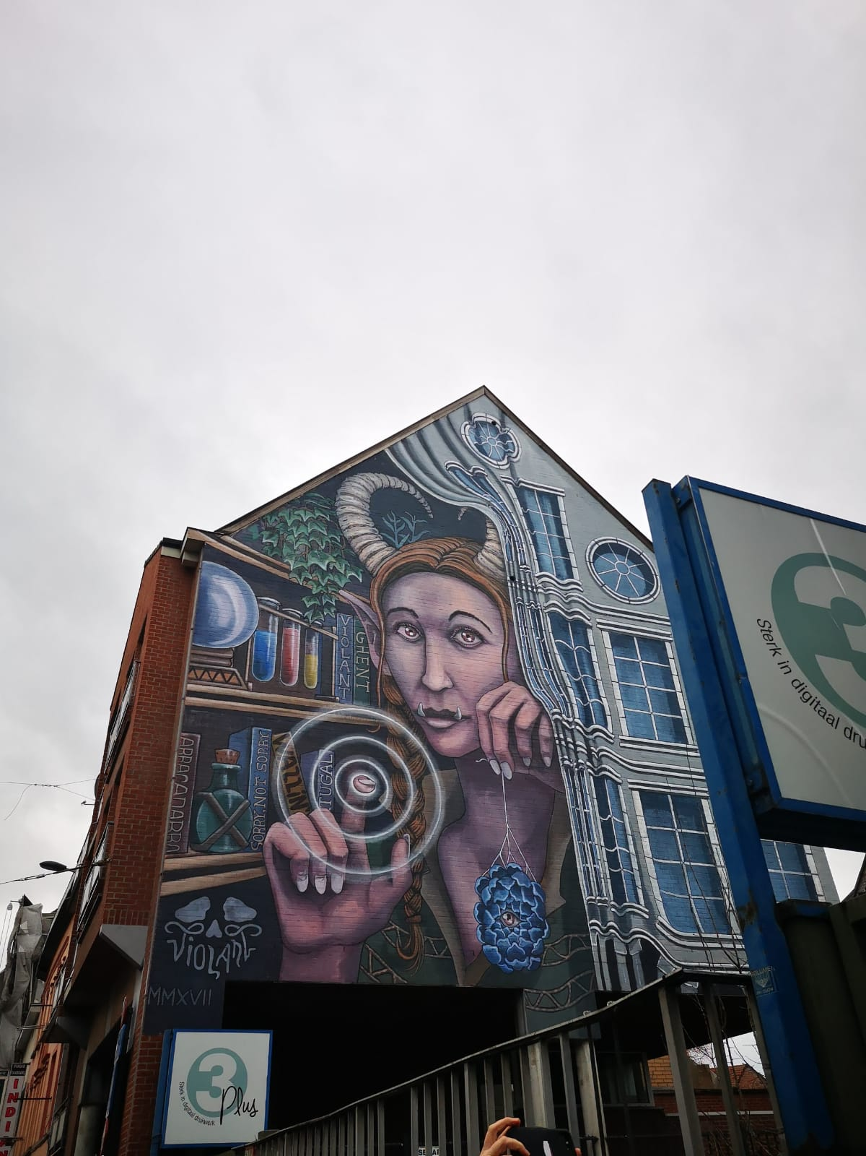
They’re maybe the most natural people. They’re style is the simplest: large hoodies, and jeans, old jackets (like in the 80’s) . Also, in Belgium you can find many nationalities. (I met Romanians, too).
Belgium is the second country which has the best chocolate in the world (after Switzerland).
Belgium people save a lot of money and invest in travelling and socialising! They believe that seeing other countries, developing industries, and staying healthy is more important than having the most fashionable and expensive clothes/makeup. They are not wrong...
To be honest, a Belgian girl told me they have a lot of second-hand shops - they are very proud to recycle everything !

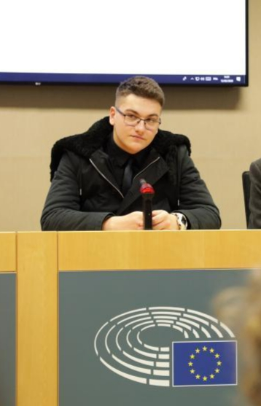
The European Parliament

My trip to Brussels was amazing. The only way of transportation was the train, and I loved it. The public transit system is fully electric and cheap for such a developed country.
I arrived in Brussels, and the first stop was the Central Market; I saw the Manneken Pis, an important Belgian symbol. After sightseeing, I headed to the European Parliament. I attended a tour of the building, Europe’s largest parliament visitors’ centre, and I learned about the origins of democracy, and the historical events that happened.
I got to speak English from the tribune, in front of 50 people, and it was stunning. I was proud to answer some questions about our mini company, but most of all I was extremely pleased to see that I can do very well in front of an audience – something new I learned about myself.
After the European Parliament visit, we headed to the Atomium, a 95m high metal building, representing an atom. The view from the last level is breathtaking, I saw Brussels in its beauty.
I think this experience made me understand how important Brussels is for Europe.
Dumitrache Relu
The Flowganiser

In our mobility to Belgium, one interesting part was when I learned the process of creating the Flowganiser.
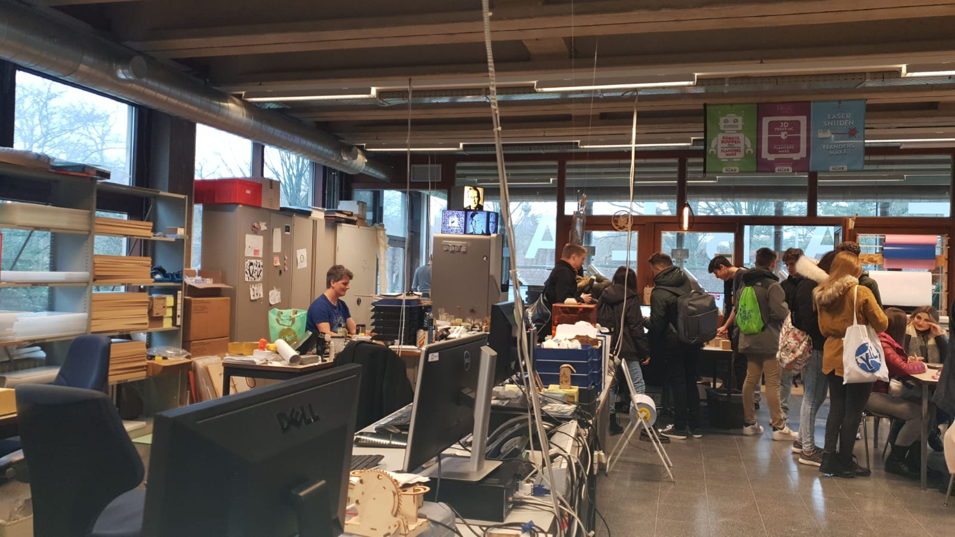

The Flowganiser is a fully modular house item, that helps you organize everything from pens, pencils, paper clips, small radios, Bluetooth speakers, even plants… or soap.
The production takes place at FabLab Leuven, where both staff and students are in charge of creating the product, the Flowganiser.
They use MDF as base material and, in order to engrave different designs, they use a laser cutting machine. I was quite amazed of the process, seeing the machines that work with such precision was something new for me.

Marius Moraru

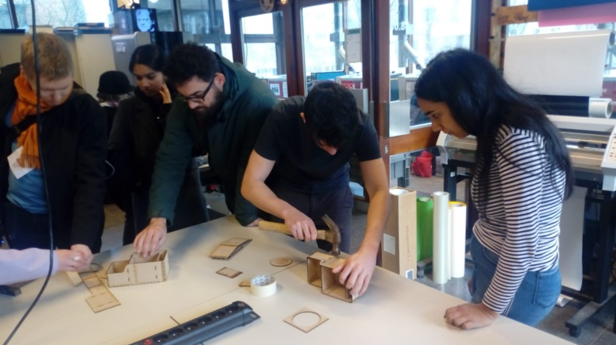
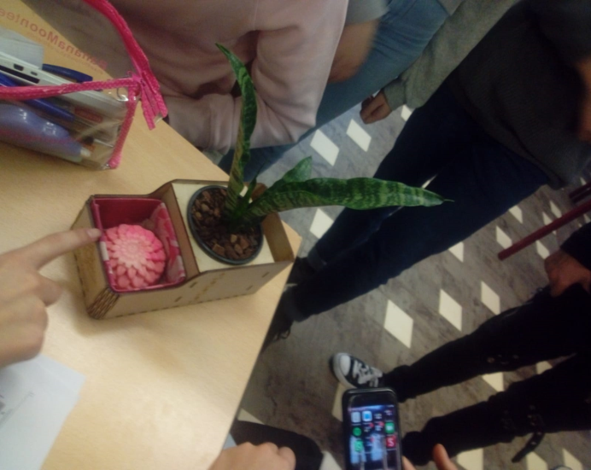
All in all…

• This opportunity given by the Erasmus + Yell project meant a lot to me, because I had the chance to meet new people and things. Certainly, I will use in my future activities the advice received from the entrepreneurs, and why not, I will try to make my own business.
- Madalina Radu

• This week was full of beautiful memories but most important, it was full of learning experiences. This mobility helped me develop as a young entrepreneur by offering me the opportunity of engaging with real entrepreneurs and learning from them.
- Marius Moraru

• This project made me understand how much team work requires to carry out any project. And besides that, I had the best personal experience in Belgium. I've learned new useful things in one week and I tied new friendships with other students. I won't forget this.
- Relu Dumitrache

• Time passed very fast but the memories still remain. First of all, I really feel that I learnt more about entrepreneurship, and that's why I'm more involved in it as the time goes by. Also our mini company developed at a high level because we have a common product. Personally, I became more daring and sociable than last year . I've gained so many friendships with people of different nationalities and I'm glad I've met them, because even we're different and we think differently, we reached our goal. Every time I remember Belgium, I have nostalgic thoughts because I know that I'll never see again some people .
The end of this Belgium story gave me a lot of mixed emotions. I'm glad because I'm still in Erasmus.
- Eva Spinu

• For me, the experience in Erasmus + Yell project was unforgettable. I had the chance to see new places, to meet nice and friendly people that I will remember.
- Mari Maruntu

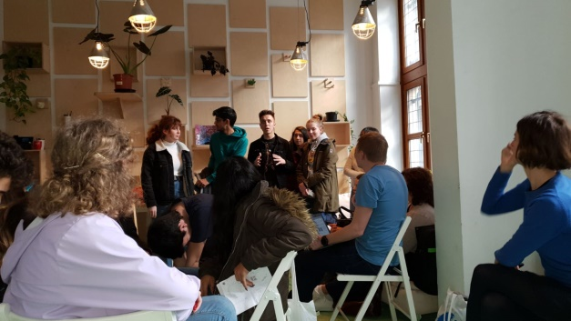

DISCLAIMER OF THE NATIONAL AGENCY

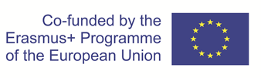
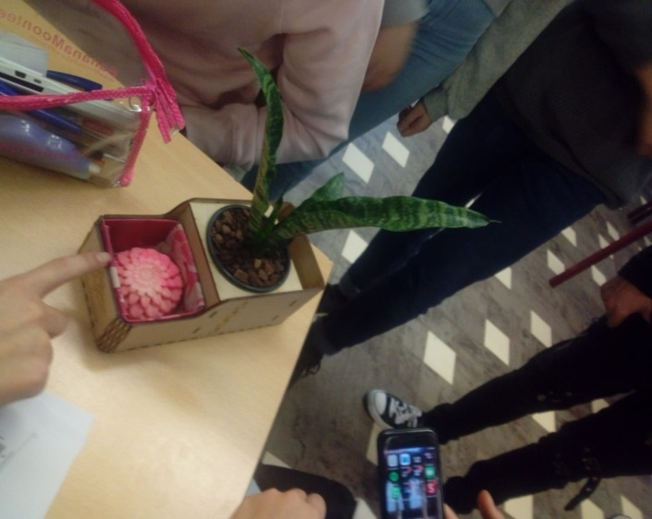
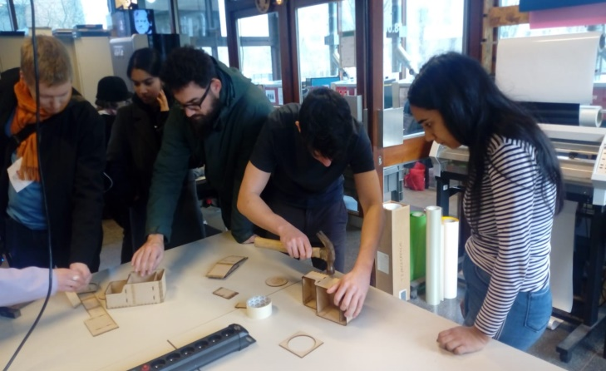
This material has been created with the financial support of the European Commission. The authors are solely responsible for the contents of this material. The National Agency and the European Commission assume no responsibility whatsoever for the manner in which the contents is to be used.

