Presentation of the vocational program Service and Transport, and The youth enterprise Wrappy UB
Stend upper secondary school, Norway
School year: 2017 - 2018
The vocational program Service and Transport, leads to eight different professions within a variety of different types of industries. Our pupils can become salesmen, marketers, professional drivers, security and ICT personnel, receptionists, travel agents, office workers and logistic operators. Some of them might establish their own companies and create their own jobs.
Youth Entrepreneurship
At our vocational program, Service and Transport, we have several different approaches to involve our pupils in different kinds of entrepreneurial tasks. Last year 16 of them were involved in taking their youth company to the national finals, hosted by Young Entrepreneurship in Norway. There, they became top eight in three different contests: Most sustainable business, best business strategy and best vocational business.
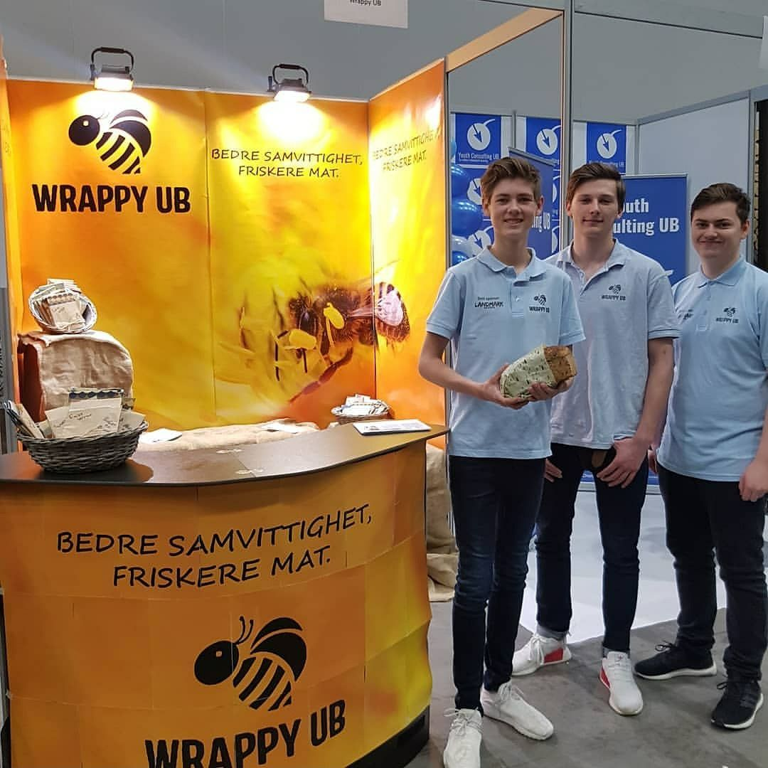
Their business idea was to make an environmentally friendly alternative to cling film, greaseproof paper and other disposable products used to store food, which also were even easier to use. To produce the bees wrap, the used ecological cotton and beeswax, bought at a local hive farm.
Practical learning approach
We do not necessarily go ahead with youth entrepreneurship companies every year. That depends on several factors including the pupils motivation, autonomy and the prospect of the business idea. However, we do work with building entrepreneurial skills every week. At our department the classroom is not the main location for our learning activities. That is because we have got our own farm store, including a nursery at our school. In addition we also have a warehouse. Along with the teachers and some skilled workers, the pupils take on the responsibility of operating these businesses, dealing with real customers and clients on a weekly basis. Idea development is also something we take seriously. All of our pupils go through a project were they are developing a mini company or an event.
Event planning (mini company):
We are trying to learn our pupils to combine theoretical and practical skills. One of the learning methods we are trying out is to create an event planning project. It is important that the pupils develop an event plan, including skills in organization, marketing and finance. After a planning period, we create the event and invite different customers to attend. After the event the group evaluate and reflect upon their work.
By using different project tools, focusing on details, structure, knowledge about the market we will like to target combined with economic skills we hope to develop an understanding of event planning. We have so far arranged a Halloween for children in kindergarten and are working on a surprise event for other pupils at our school. This event will combine both theoretical skills, teambuilding and visiting a local successful business.
Apprenticeship
After the two year vocational programme the pupils go through at out school, the are going into a two year long apprenticeship in a local business, depending on which of the eight professions they want to pursue…
One day a week our first year pupils are apprentices in local stores and companies, were they get even more experience related to the subjects they learn at school. Many of our pupils are tired of going to school and wants to go quickly into professions and steady salaries. Therefore learning in a practical manner is important to maintain the pupils motivation.
By learning them to operate businesses and to experience the crafts and value chains within those businesses, we hope to give them significant benefits if they choose to develop their own idea, either as an youth entrepreneur or an adults later on.

