Price: Innovation

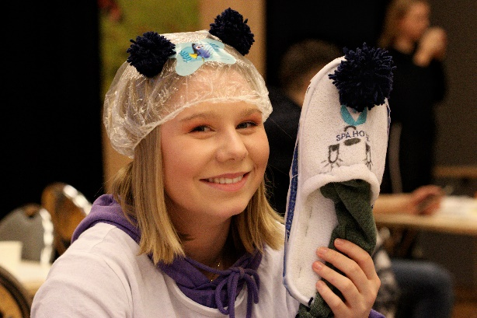
YELL Norway UB is a subsidiary of YELL International JA, which has branches in five countries. Our company was based on an Erasmus+ mobility project, between the countries Belgium, Bulgaria, Italy, Romania and our team in Norway. Through creative processes based on the UN Sustainable Development Goals, we came up with a plan for how we could create value together, by making the world easier for parents and more fun for children. We will:

Make hygiene fun and motivating for children by providing environmentally and health-friendly bathroom products.

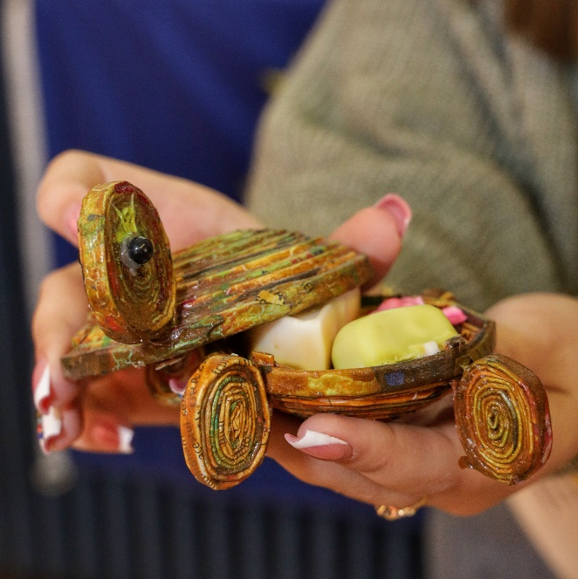
The departments in each country have been given different specific responsibilities. Romania develops and manufactures soap pieces with a toy inside (or on the outside). Norway develop and manufacture packaging for the soap pieces. This will be our smallest viable product (MVP), which we will use to collect information for further product development.

Students from GO! Atheneum De Ring Leuven in Belgium, already offers a flowganiser that refreshes the office with plant life and new opportunities to keep your desk tidy. This will be developed with a customized version of, which fits as hand in glove to bathrooms and with our products.

We will examine which design best appeals to children. One example of an option can be a pirate's theme, with small treasures inside the soap and an organizer designed as a pirate ship where the sail can also be toothpain. The product should be modular, so that the price of each module will be relatively low.
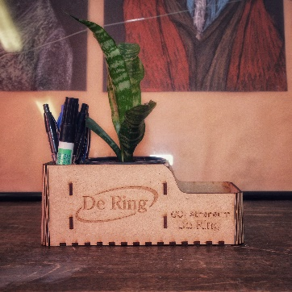 | 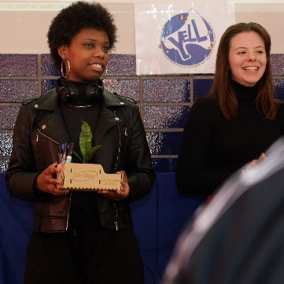 | 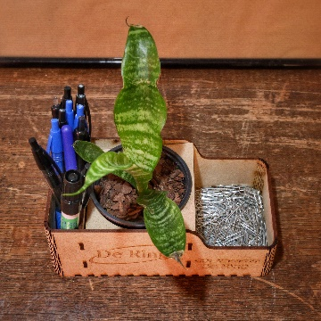 | 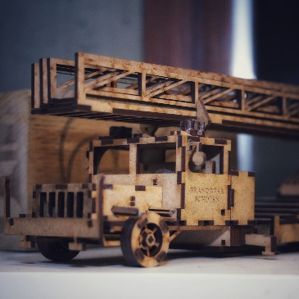
Picture: Flowganiseren refreshes the desktop. The fire truck is an example of what our Belgian department can design with laser cutting technology.

In Bulgaria, students have developed a seed paper that children can use to grow their own flower. The idea is that the children will be curious about how much the plant grows for each passing day, which will motivate them to join the bathroom for washing and brushing teeth.

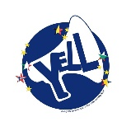
At ITTS "A. Volta" in Perugia, our department works with sensor technology. The sensors can measure temperature, humidity and movements. Does the plant need to be watered? How many times has the soap been lifted in a day? The data is fed to an app on your phone or tablet, which can provide praise and rewards for proper use.

Sensorenhet:  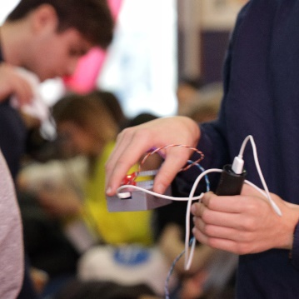 | 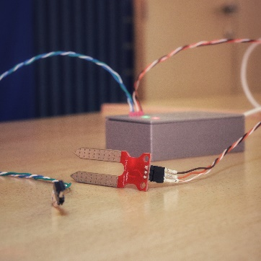 | The packaging of the soap:  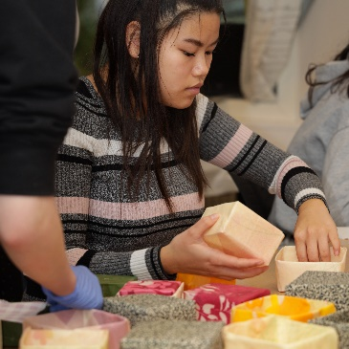 | 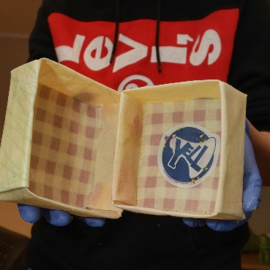

Needs and innovation
The importance of hand hygiene is indisputable. In today's market there are actors who, through influence, try to show that it is cool for children to use soap, but it stops there. Our surveys of today's market show that almost no one has done anything significant with the product itself, to make it attractive to use for the children. We have spoken to some parents and many of them could report that on several occasions they had been frustrated by their children's reluctance to take hand hygiene seriously.

As the basis for the development of our products, we have the value of the triple bottom line. Firstly, we will develop a product that is capable of creating value, for our customers and for us, so that we can continue with what we do. Secondly, we will develop the product in the most sustainable way possible. Keywords such as natural, environmentally friendly, reusable and safe to use should permeate the entire value chain. Wei should contribute socially by making the atmosphere in homes better between parents and children. The motivating elements of our products can turn into something exciting that the children and parents can explore together.

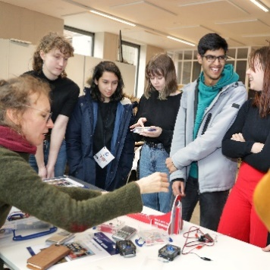  Katrien Kolenberg  Astronomer | 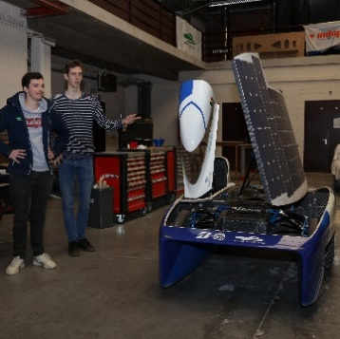  Agoria Solar Team
Third, our project is about learning about cultural understanding, technology and networking. Since the beginning of cooperation, we have explored and gained insight into each other's culture. We have shared knowledge of different technologies and working methods and discussed extensively to come to an agreement on the way forward. Not least, we have gained access to each other's contact networks, including exciting and skilled entrepreneurs and researchers from the various countries. The international cooperation also gives us access to and access to several different markets. This gives us opportunities that we have not previously thought about that we could have.

The Norwegian Team attended a regional Fair in March 2020, just days before lockdown due to Covid 19.

