Interview about Entrepreneurship Education
On Mondaymorning the 15th of April 2019 I had a meeting with Karin Soete and Ben Peeters, 2 members of Vlajo, the National Agency of JA in Flanders.
We talked about Entrepreneurship Education in general, on a Flemish and European level, and we discussed how to overcome barriers that arise when creating a real mini-company on a European level.
spoiler alert: I returned with a lot of tips and tricks ready to apply in our ongoing project.
1. Teachers are key
Without motivated and engaged teachers every activity will fail.
2. syllabus and other learning materials
Every country has it own specific learning material. Use the Company Programme from JA Europe as base and select all useable learning material of each country. The easist way is that every country makes an inventory.
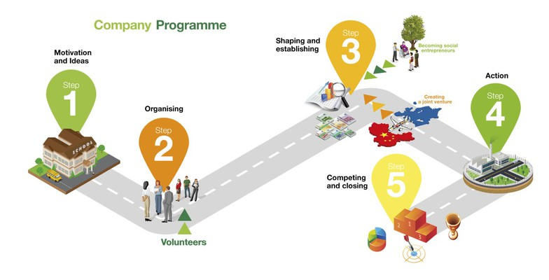
3. Same, same but different
Think like a multinational enterprise! Use one HQ and different subsidiaries.
Use in every country the same mini-company but with other participants. Every pupil should be enrolled in their own country but the data used is in every country the same. eg, online and offline communication, sales, prices, ...
Also every country should have its own accountancy division (following the rules of every NA) but an overview of the different results is needed.
4. It is all about the 3 C's: communication, communication and... communication
Even with motivated and engaged teachers... without enough communication succes is limited.
Just two words: be prepared! Draw up a shedule and follow it. Reflect about which communication chanels to use, when to communicate... how many times, ...
Every meeting should be prepared in advance: starting by drafting an agenda and ending by agree upon which goals to achieve. It is normal to have several conversation before holding a meeting.
5. Support
Seek support. There are many organisations relating to the topic of entrepreneurship who can give advice and even financial support.
6. Scriptease
It doesn't sound sexy at all but once doing it is very joyfull. Use your script as a compass that will navigate you through your partnership.

