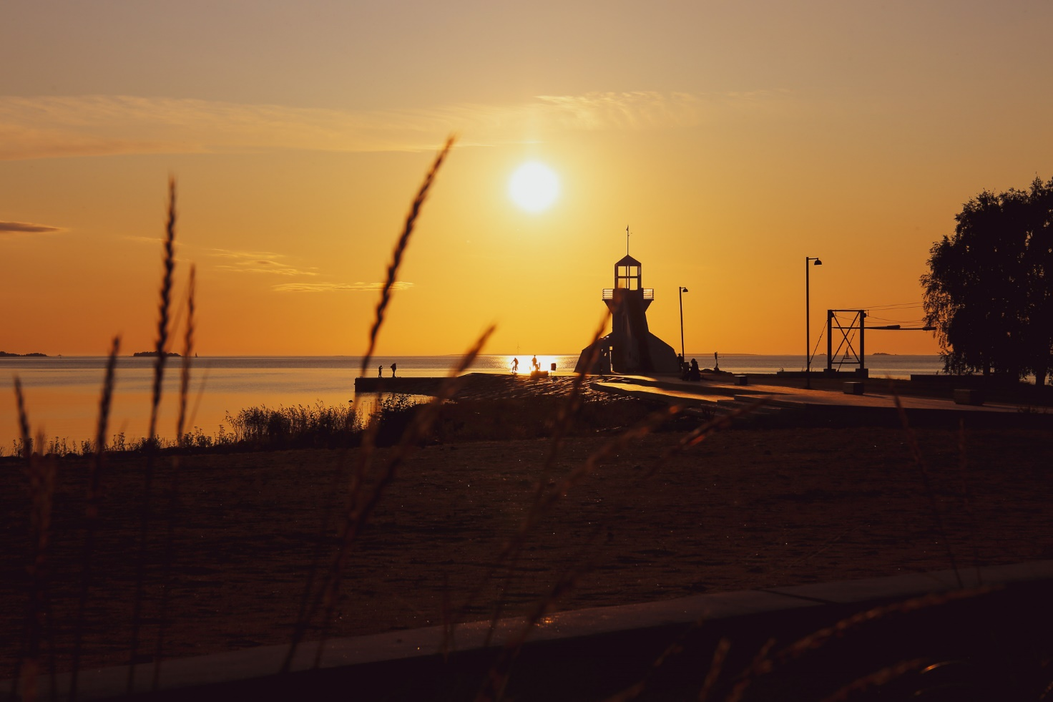

Reunionese exchange students exploring the life in Finland 9th-15th November 2019
Erasmusplus Finland Instagram:
https://www.instagram.com/p/B41oeuilUl-/?igshid=ssbc7mi7oefg

