Pre-war Architecture

Building before World War one had the architectural designs of Victorian mansions, after the ww1 the buildings have started to change, with two-storied house and a basement. The urbanization of large cities started to increase, as many moved from the countryside to towns and cities. Homes before world war one had fine touches such as high ceiling, arch doorways, but living wise, they were uncomfortable.
Some of the key elements of the prewar houses can be easily noticed when comparing to architecture after the war. Prewar houses had oak floor with frames around of the door, also made of wood. A lot of houses had moldings, connected between ceiling and the wall, giving a fine deluxe touch. As mentioned before, some houses had high ceiling, the ceiling would be 9 feet from the ground, some Victorian Houses even had up to 12 feet. One last important key element of a house was the fireplace, which has been for a long time, since 1700s.
The outsides of houses don’t follow the blocky look which we have today (but also after the world war). Looking back at some houses from 1909, from the outside the houses looked similar to mansions, they had a roof which looked somewhat like ancient Greek roofs. Many houses and buildings had pillars which split the balconies into three or more sections. And the balconies themselves had a cover with the shape of an arch.

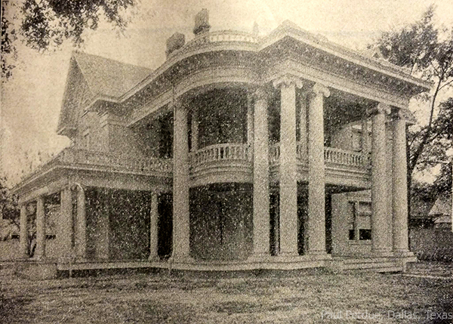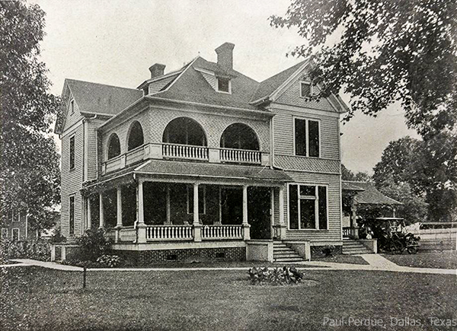

740 Park Avenue is an example of a pre-war architecture. The pre-war apartment house 740 Park Avenue is so famous that a book has been written about it: Michael Gross's 740 Park: The Story of the World's Richest Apartment Building (Broadway, 2006). The apartment house building was developed by New York architects Rosario Candela and Arthur Loomis Harmon. Among its famed residents, Jacqueline Kennedy Onassis, John D. Rockefeller and Vera Wang. This was such an appreciated apartment that like book says, the 15th floor, as an example, had 15-foot ceilings, 11 closets and three bathrooms, some of the foyers were the size of ballrooms.

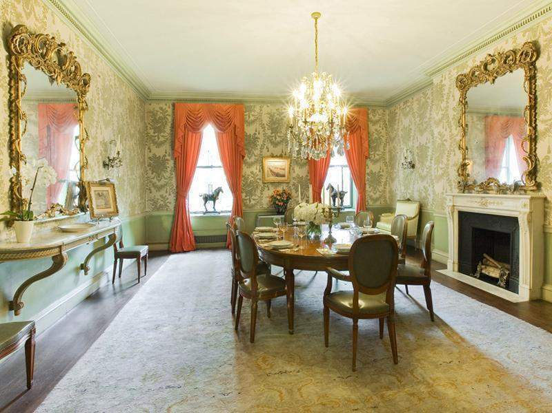
(an example of an apartment on Park Avenue)

And so, after the terrible events following, the architecture of buildings has drastically changed, the importance of the fine details is no longer important, but the efficiency of the of the homes. The outside of buildings today, are made of simple geometrical shapes with no luxurious details, and no balcony split by pillars with Greek design.

