Visit to Bojimans Museum

We went to the Bojimans museum on 16th February 2018. This museum visit was very special because we got to see the artworks by famous artists such Kathe Kollwitz, jacoba van heemskerck van beest, Otto Dix, which were not exhibited in the museum. We were specially allowed to go behind the scenes and see all these artworks on a special request. I also got the idea for my artwork from the book that I got to see in the museum. We looked at art of different movements such as surrealism, realism, impressionism, expressionism, cubism, futurism, dada etc.

Expressionism-

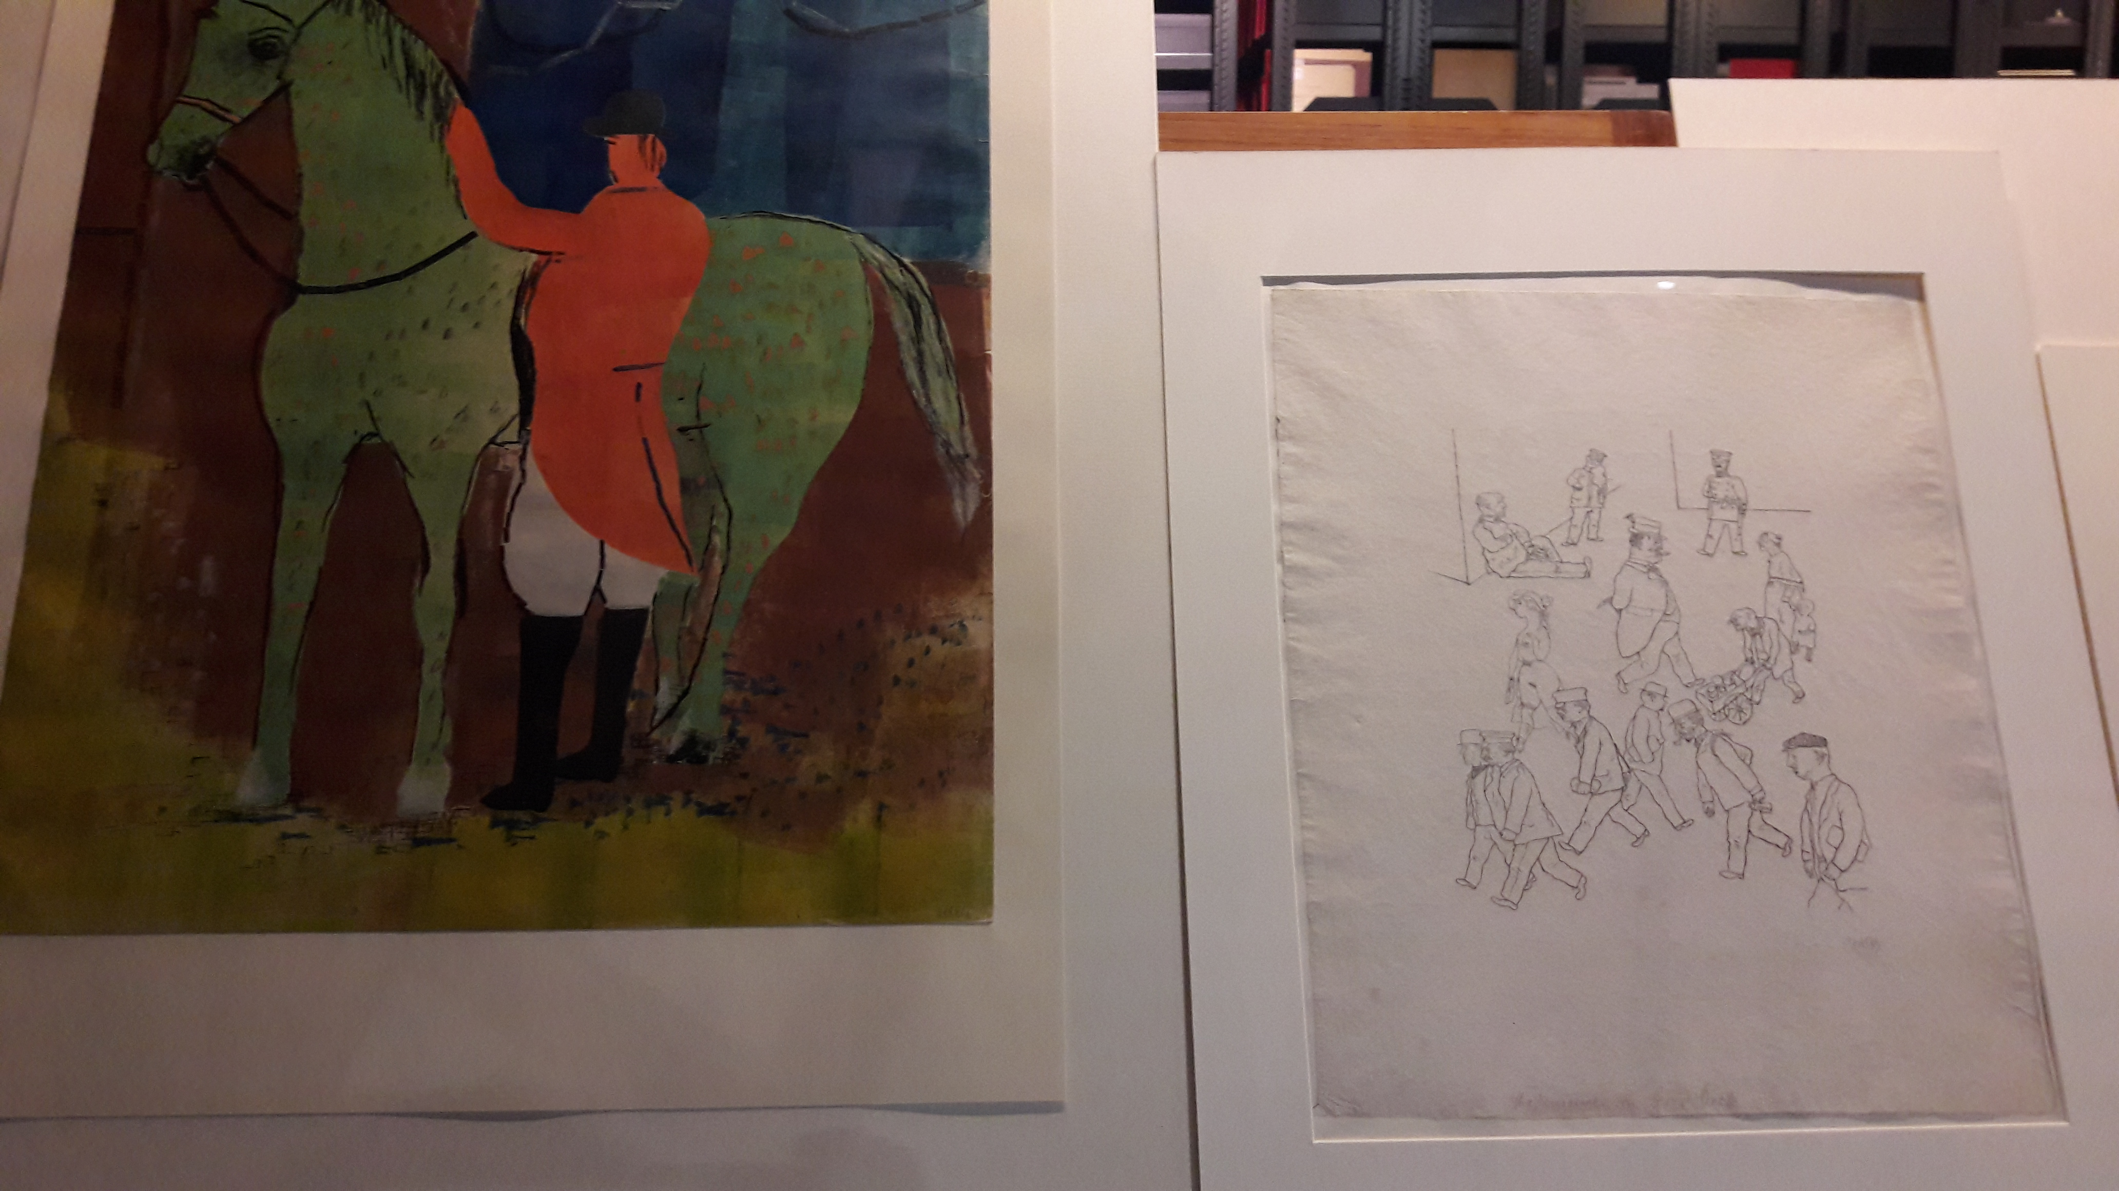
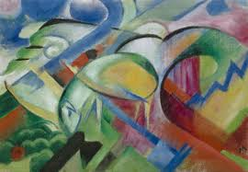
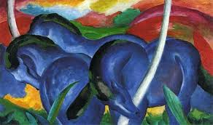
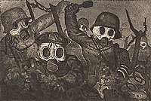
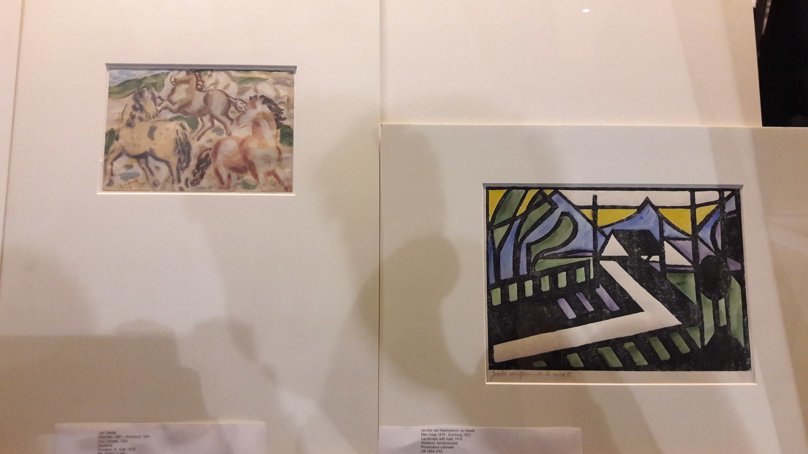
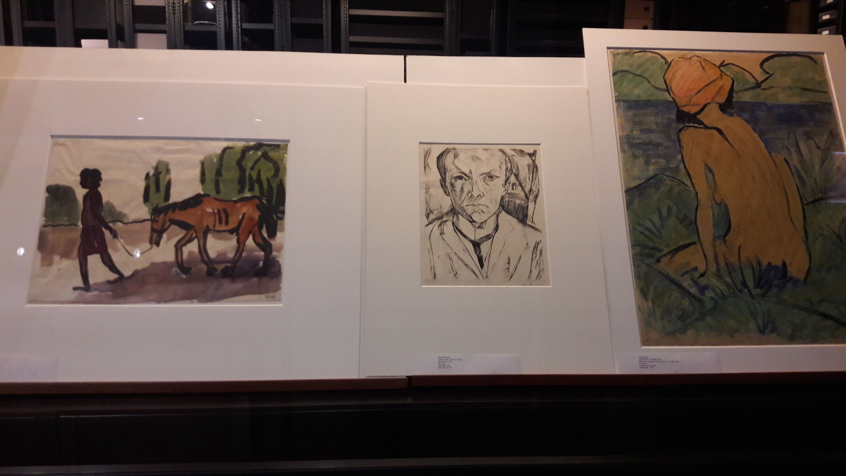
Expressionism emerged simultaneously in various cities across Germany as a response to a widespread anxiety about humanity's increasingly discordant relationship with the world and accompanying lost feelings of authenticity and spirituality. It originated at the beginning of 20th century and was inspired heavily by the Symbolist currents in late nineteenth-century art. Vincent van Gogh, Edvard Munch are some great influential artists for Expressionism. It remained popular during the Weimar Republic, particularly in Berlin. The style extended to a wide range of the arts, including expressionist architecture, painting, literature, theatre, dance, film and music. Expressionist artists often employed swirling, swaying, and exaggeratedly executed brushstrokes in the depiction of their subjects. These techniques were meant to convey the turgid emotional state of the artist reacting to the anxieties of the modern world. The arrival of Expressionism announced new standards in the creation and judgment of art. Art was now meant to come forth from within the artist, rather than from a depiction of the external visual world, and the standard for assessing the quality of a work of art became the character of the artist's feelings rather than an analysis of the composition.

