POST – WAR ART:
TASK: find an example of post – WW1 art and write a comparison.
Surrealism is a cultural movement that began in the early 1920s, and is best known for its visual artworks and writings. Artists painted unnerving, illogical scenes with photographic precision, created strange creatures from everyday objects, and developed painting techniques that allowed the unconscious to express itself. Its aim was to "resolve the previously contradictory conditions of dream and reality into an absolute reality, a super-reality".
Surrealism developed out of the Dada activities during World War I and the most important center of the movement was Paris. From the 1920s onward, the movement spread around the globe, eventually affecting the visual arts, literature, film, and music of many countries and languages, as well as political thought and practice, philosophy, and social theory.
THE ELEPHANT CELEBES:
The Elephant Celebes was painted in Cologne in 1921 and was Max Ernst's first large picture. It was bought shortly after its completion by his friend the poet Paul Eluard and later passed from him to Sir Roland Penrose, who owned it until 1975 when he gave it to be sold for the benefit of the Institute of Contemporary Arts. Sir Roland's Charlton Lecture, is by far the most detailed study of it and is the basis of the following note. The reader is referred to it for a detailed compositional analysis and interpretation.
This painting grew directly out of Ernst's use of collage from 1919 onwards to produce bizarre combinations of images, though no preliminary collages or sketches were made for it. The idea of the painting appeared spontaneously on the canvas with few alterations as it progressed.
The boiler-like monster to which the title refers is, like the rest of the painting, highly ambiguous. It has a horned head with apparently sightless eyes, but a pair of tusks projecting on the left suggests the possible presence of a second head (or perhaps the real head?) on the other side. Its neck seems to consist of a long snake-like coil which emerges from a hole in its upper section; the top is surmounted by a brightly-coloured construction containing a mysterious eye. It seems to be standing in a large open space, but there are also indications that it is embedded in a solid b ackground, while two fishes swim in the sky above. Three upright objects stand around it, while in the bottom corner a headless mannequin figure with a raised arm appears to be beckoning the monster towards it.
As was first noted by John Craxton and subsequently confirmed by Ernst himself, the image of the boiler-like form on its pair of 'legs' was originally inspired by an illustration in an English anthropological journal of a huge communal corn-bin peculiar to the Konkombwa tribe of the southern Sudan. The photograph is taken from the same angle and is basically very similar, but the artist has given the hollow clay container a metallic appearance and changed its character completely by adding the various appendages described above.

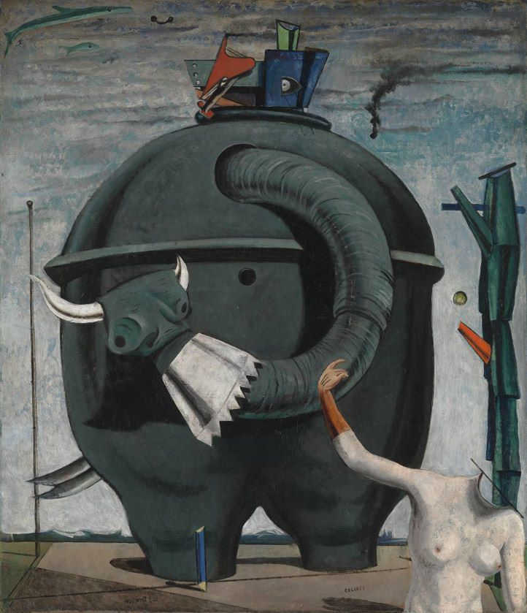
The elephant celebes

Before First World War, Art still had heavy influences from Classicism. This influence turned into Impressionism. The Impressionists incorporated new scientific research into the physics of colour to achieve a more exact representation of colour and tone. They painted contemporary landscapes and scenes of modern life, especially of bourgeois leisure and recreation. Impressionism evolved into Post-Impressionism.Post-Impressionists tended to pay more attention to emotional expression, symbolism, geometric structure, and artistic subjectivity.
In general, Post-Impressionism led away from a naturalistic approach and toward the two major movements of early 20th-century art that superseded it: Cubism and Fauvism.
The tension before the begining of the First World War led to changes in art. Cubism was the most important movement of the 20th century and marked the birth of abstract art. Invented and pursued by Pablo Picasso and Georges Braque in Paris between 1907 and 1914. Picasso and Braque created more conceptual, subjective paintings that sought to represent the underlying structure of existence. Cubism ought to avoid static view points, choosing to represent, in 2D, more than one side of their subject. One of the most famous Cubism paintings is Woman with the Guitar by French painter and sculptor Georges Braque.
With the end of WW1 started new movement called surrealism.
These 2 art movements from around the same period of history clearly had very different ideas and practices. Surrealism was far more of a concept, with psychological and almost mystical ideas, where as Cubism was more of a direct challenge on the traditions of painting – and the representation of objects. Surrealism vanished with the coming of the Second World War but Cubism continued its prevalence in the world of art over many decades and has influenced many movements and the progression of abstract art.

In short:
Art before the WW1 was full of colour, natural, positive and whan the war pressure started to rise is changed and became non structured, boxy, with many lines and less realistic. From Impressionism it gradually changed into Modernism that still affects Art today.

