**Franjo Šimunaci - postcards**

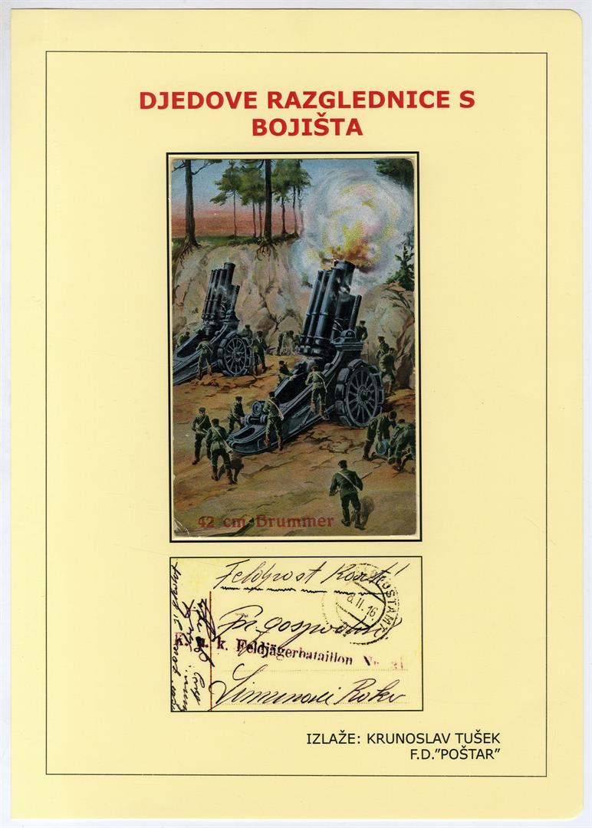

My grandfather Franjo Šimunaci (1890-1958) participated, as a soldier, in Austrian-Hungarian army in WW1. He was mobilized into the 31st battalion. He fought in the Eastern battlefield in Galicia. In a war clash he was imprisoned by the Russians. As their prisoner he worked on a farm. There he was seriously injured by a horse and transferred to Zagreb where he had an operation.The doctor who operated him gave him small chances of survival.Despite the odds, he survived but never returned to the battlefield. Franjo was very close to his eldest brother Roko and wrote him frequently during the war.Roko Šimunaci (1886-1937) was a famous musician, music composer for the tambura instrument, and a conductor of the orchestra.His compositions are, despite his death 79 years ago, still on the repertoire of tambura orchestras today.

Grandfather once bought 50 postcards and sent them to his brother Roko. There were days when he even sent two postcards on a single day. The preserved ones are the subjects of this exhibit. They were written 100 years ago. The text in red describes the contents of the postcard and the rest is a short representation of WW1.

Sadly, my grandfather and I spent little time together because we lived in different cities so I didn't have a chance to speak with him about his time in the war.He himself didn't like remembering those times

I. WORLD WAR 1914.-1918.

It was a war of unseen proportions and horrors. In certain countries, it is called The Great War. The spark which ignited the conflict on a global level was the assassination of Austro-Hungarian heir Franz Ferdinand and his wife, Sofia von Hohenberg, on 28th of June 1914 in Sarajevo. The assassination was preceded by competition in the armament of great forces and alliances alongside with antagonism and rivalry between them and their imperialistic pursuit. The war started on 28th of July 1914. after Serbia's refusal of Austro-Hungarian ultimatum (23rd of July) to admitresponsibility to the assassination. War was based on a conflict of two alliance's:

**1. Central Powers**- Germany, Austria-Hungary, Bulgaria, and Turkey

**2. Entente Powers**- France, Great Britain and Russia, which were later joined by Belgium, Serbia, Montenegro, Japan, Italy Romania, USA, and Greece. The war lasted for 4 years, 3 months and 14 days. Croats in that war participated as a part of the Austro-Hungarian army on three battlefields: Balkan battlefield- East battlefield- Southwest (Italian) battlefield.

**Battlefield**

**Written 7 Feb 1916**

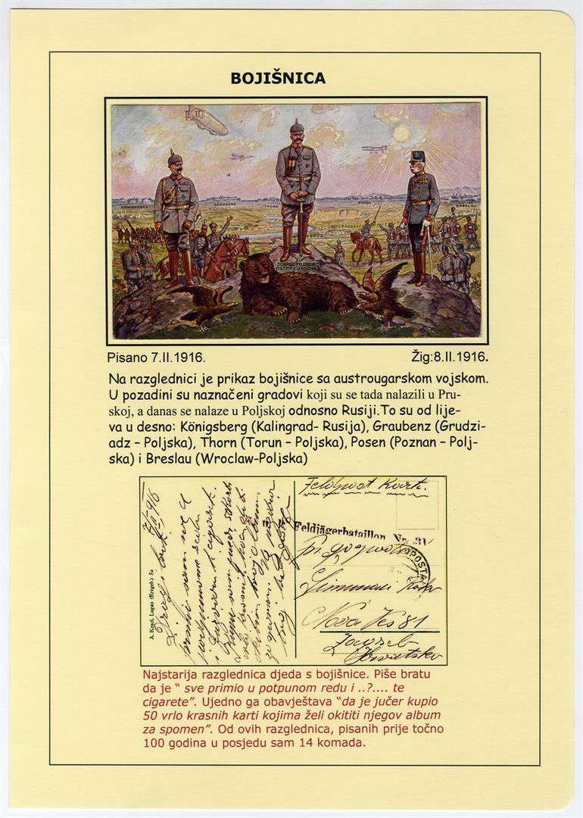

There is a representation of the battlefield with Austro Hungarian army on the postcard. The cities that were situated in Prussia are shown in the background.Nowadays, those cities are in Poland and Russia. From left to right Königsberg (Kalingrad-Russia), Graubenz (Grudziadz-Poland),Thorn (Torun-Poland), Posen (Poznan-Poland) and Breslau (Wroclaw-Poland)

My grandfather's oldest battlefield postcard. He is writing to his brother that he "received everything in order and ..?.... alongside with cigarettes". At the same time he informs him that "he purchased 50 beautiful cards the day before which will decorate his album as souvenirs. Out o these postcards, written exactly 100 years ago, I own 14 altogether.

**War stories**

**Written 16 Jan 1916**

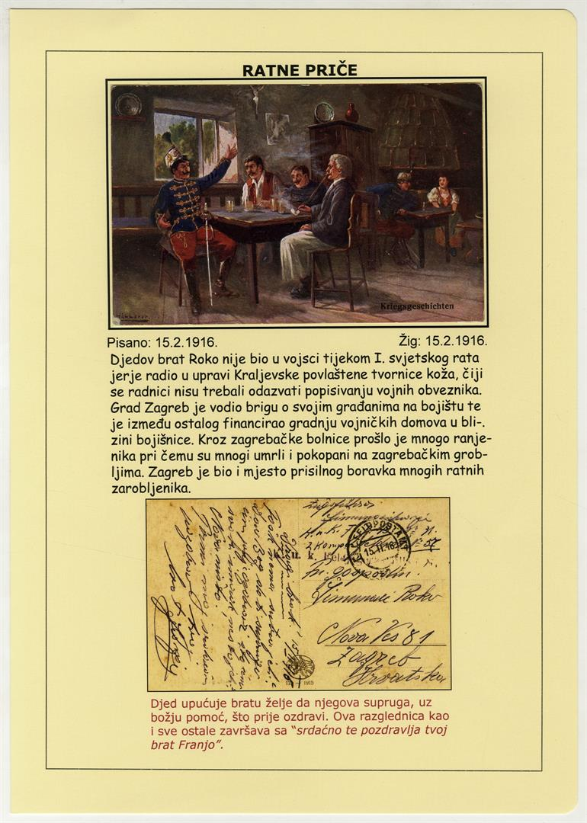

Grandfather’s brother, Roko, was not in the army during the First World War because he was working in the administration of the Royal Preferential Leather Workshop where the workers did not have to be enlisted in the army.

The city of Zagreb took care of its citizens in the battlefield and, among other things, financed building homes for the soldiers near the battlefield. Many soldiers passed through Zagreb hospitals and those who died were buried at Zagreb cemeteries. Many war prisoners were forced to stay in Zagreb.

Grandfather is instructing his brother that he wishes his wife, with the help of God, to get well soon. This postcard, like all the others, ends with “warm regards from your brother Franjo”.

**The fights in Russian Poland**

**Written 8 Feb 1916**

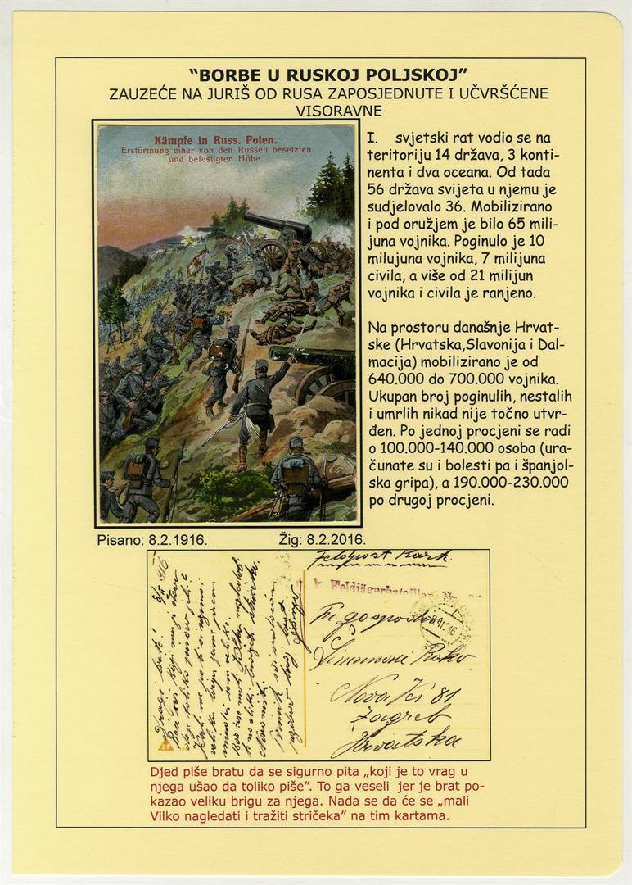

The occupation by means of charging on the occupied and fortified the Russian plateau

The First World War was fought on the territory of 14 countries, 3 continents and two oceans. At the time, 36 of 56 countries of the world have been involved in it. 65 million soldiers have been mobilised and were under arms. 10 million soldiers and 7 million civilians have been slaughtered and more than 21 million soldiers and civilians have been wounded.

On the territory what is now Croatia (Croatia, Slavonia and Dalmatia) from 640.000 to 700.000 soldiers have been mobilised. The exact number of the death toll and missing people was never established. One assessment says that the number varies between 100.000 and 140.000 people. (The Spanish flu was also taken into consideration), while the other states that the number varies between 190.000 and 230.000.

The grandfather is writing to the grandson that he must be wondering what the hell has gotten into him that he keeps writing so much. It makes him happy because his brother showed that he cares a lot about him. He hopes that “ little Vilko will look and spot the uncle” on the maps.

**Father guide me**

**Written 8 Feb 1916**

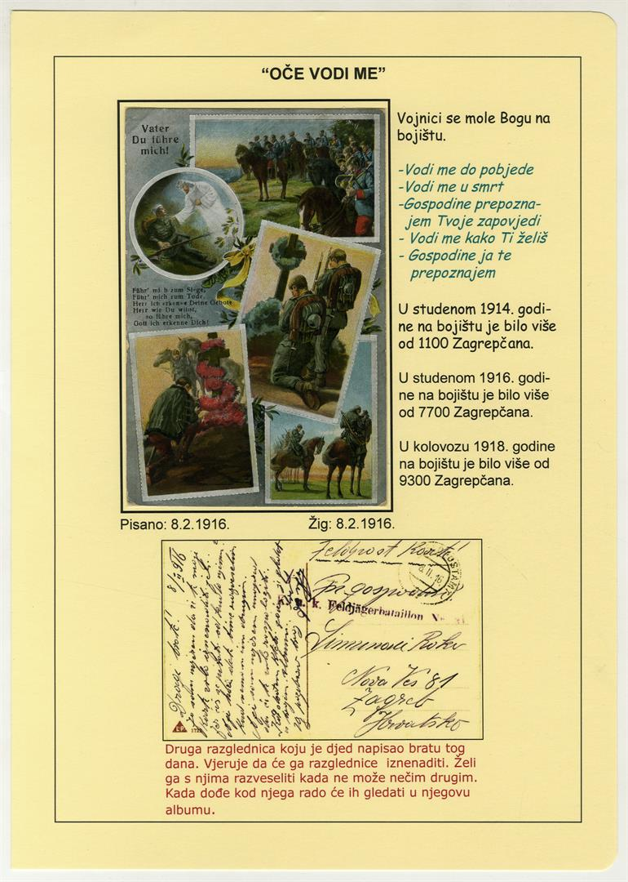

Soldiers pray to God on the battlefield:

* Lead me to victory
* Lead me to death
* Lord, i understand Your commands
* Lead me as You wish
* Lord, i recognize you

In November 1914. there were more than 1100 soldiers from Zagreb.

In November 1916. there were more than 7700 soldiers from Zagreb.

In August 1918. there were more than 9300 soldiers from Zagreb.

A second postcard that grandfather wrote to his brother that day. He believes that the postcards will surprise him. He wants to surprise him with them because he can`t surprise him with anything else. When he visits him he will gladly look at them in his album.

**Written 10 Feb 1916**

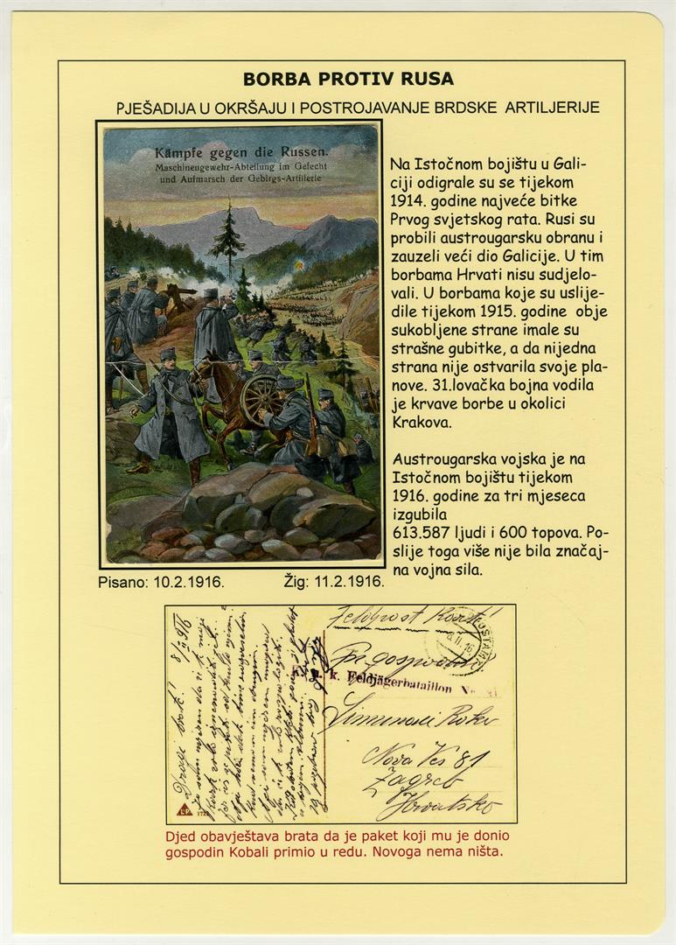

**Written 23 Feb 1916**

