Art analysis Myrthe van Seggelen The Netherlands

2. Art of WWI
Post a picture of a WWI sketch, painting or war poster and write an analysis on eTwinning.

Cavalry and Tanks at Arras by Lieutenant Alfred Bastien (1918)

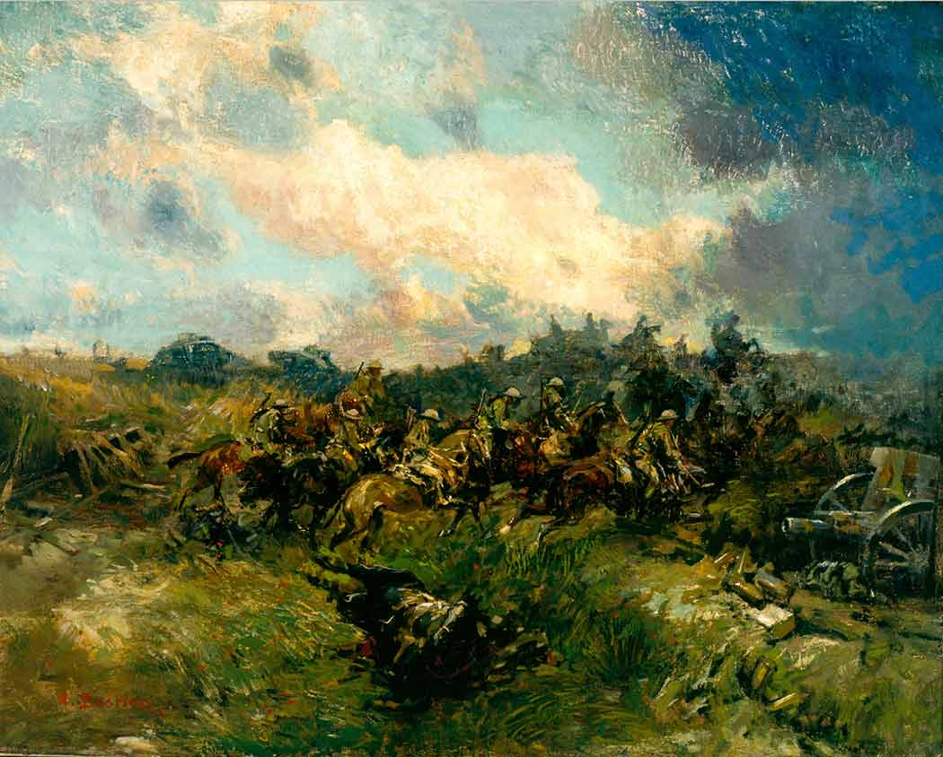

I chose to analyze this artwork as it is one of the few World War One artworks that on first sight doesn’t necessarily show the horrors of the war. Other paintings have dark grey or black colours to indicate the literally dark places as they were constantly surrounded by bombs and gasses, but also the mental dark place the soldiers went through due to the many deaths and inner feelings of struggle for bravery, sadness, fear etc. I find this painting so interesting as it has bright green and blue tints and tones, which all blend very well and therefore create a very beautiful scenario and maybe an idealized version of what the war was like. I wouldn’t state that you can compare it to war propaganda as that would be presented more heroically, but the bright tones and the horses create the idea that it wasn’t all that bad (implying that there was still a bright sky and green grass and beautiful surroundings and therefore ‘’enough’’ positive aspects). However, you can also see how brutal the war was by the dynamics of the horses that go fast, but have difficulties staying stable in the muddy and wet grass. You can almost feel the horses fear of falling and their resistance as they see the opponents firing bombs etc. You can see that they are struggling to jump over, what it seems to be, a ditch. The soldiers on the back of the horses live the fear of falling as well, but in a way share the fear with the horses, which leads to maybe a sort of security too. What I find particularly interesting is that the left side of the painting where the soldiers start to approach the enemy is still light blue and green and therefore representing less worries, less death and more freedom. As they get closer to the enemy (the righter side of the painting) the grass gets darker and almost grey. The colours merge together, making it unable to recognize the individual soldiers or the different troops at all. The fact that the battleground and the exact encounter of both troops are so vague and all one shadowland of dark blue and green images could highly possible indicate that whilst fighting the troops merge together the question what they are truly fighting for disappears as both parties sacrifice men and have to go through misery. It could help us understand that a lot of the men participating didn’t quite want to fight, but had no option. You can spot some grey-green silhouettes in the pile of fighting soldiers. The silhouette looks scary as you know that this person will possibly also soon die. It is as if you can with your own eyes understand and see that they were step by step approaching their own deaths. The significant change of the weather from the left to the right also indicates ‘’darker’’ times and a storm as the dark clouds evoke this feeling of a natural source of danger. What I also find really interesting is that the left starts of with a natural environment, but this changes to machinery guns and tanks in the background of the right side of the painting. In my eyes this points to the industrial revolution and the technological ‘’progress’’ World War One also brought with it. Overall the atmosphere created is one of chaos and the lack of security and safety due to the unexpected change of weather (indicating how quickly someone’s life can change at war and how unexpectedly the enemy can attack etc.), but also the destroyed fences laying on the ground (possibly foreboding the corpses that will later lay on the ground). One thing we can’t ignore is that there is a large figure of possibly a horse and a man laying on the ground surrounded with a pool of blood, this is a large contrast to the required motivation of the soldiers starting fighting. It shows that the bravery that the soldiers felt pre-battle would shortly transform into a realization that they had miscalculated war. That soldier who died before even encountering the enemies shows how unfortunate war was and how unfair the ‘’chances’’ of the soldiers were. You see the horses facing the machine guns and tanks and you already feel that they won’t stand much of a chance as many battles were so oddly divided in better armed and the powerless. It also shows that war doesn’t consider someone’s personality, life or good will and that the nicest and good-hearted men passed away whilst others survived. The fact that war was so unfair is really well represented in this artwork.

5. Art Work
Produce a piece of art inspired by your research on the period and upload a picture of it to eTwinning.
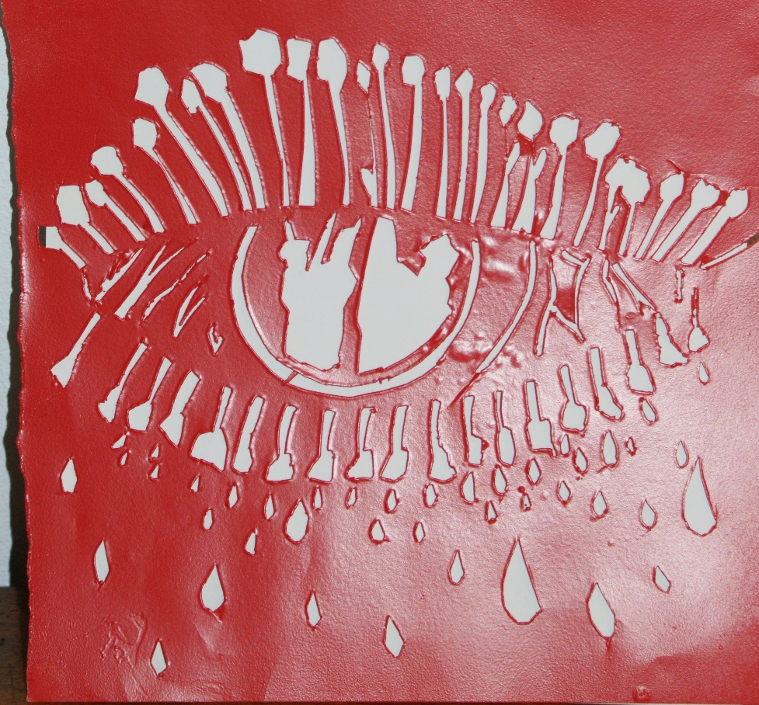
I made a stencil (see above) with paper to spray-paint over it. I firstly spray-painted in red and later painted certain areas with black and blue acrylic paint to enhance my art work. 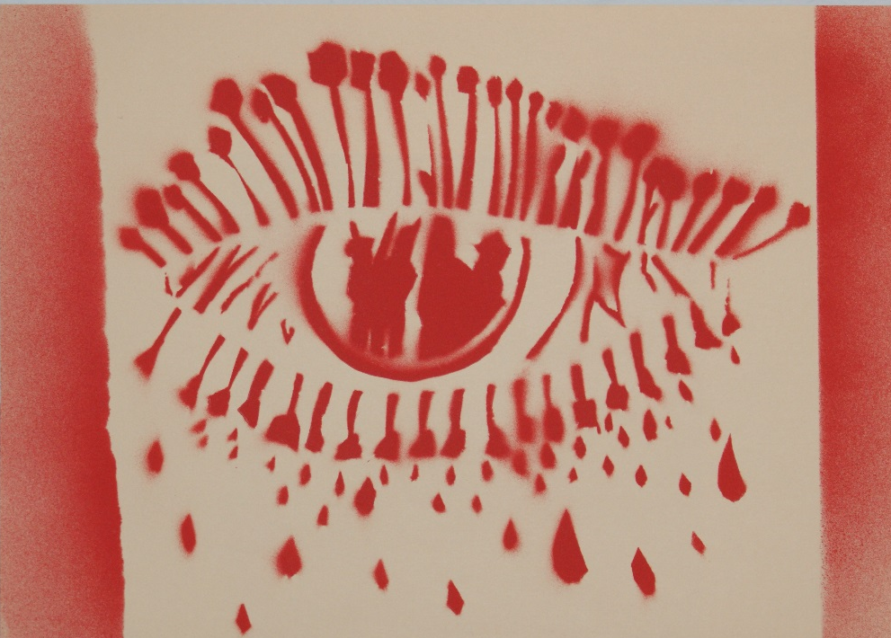

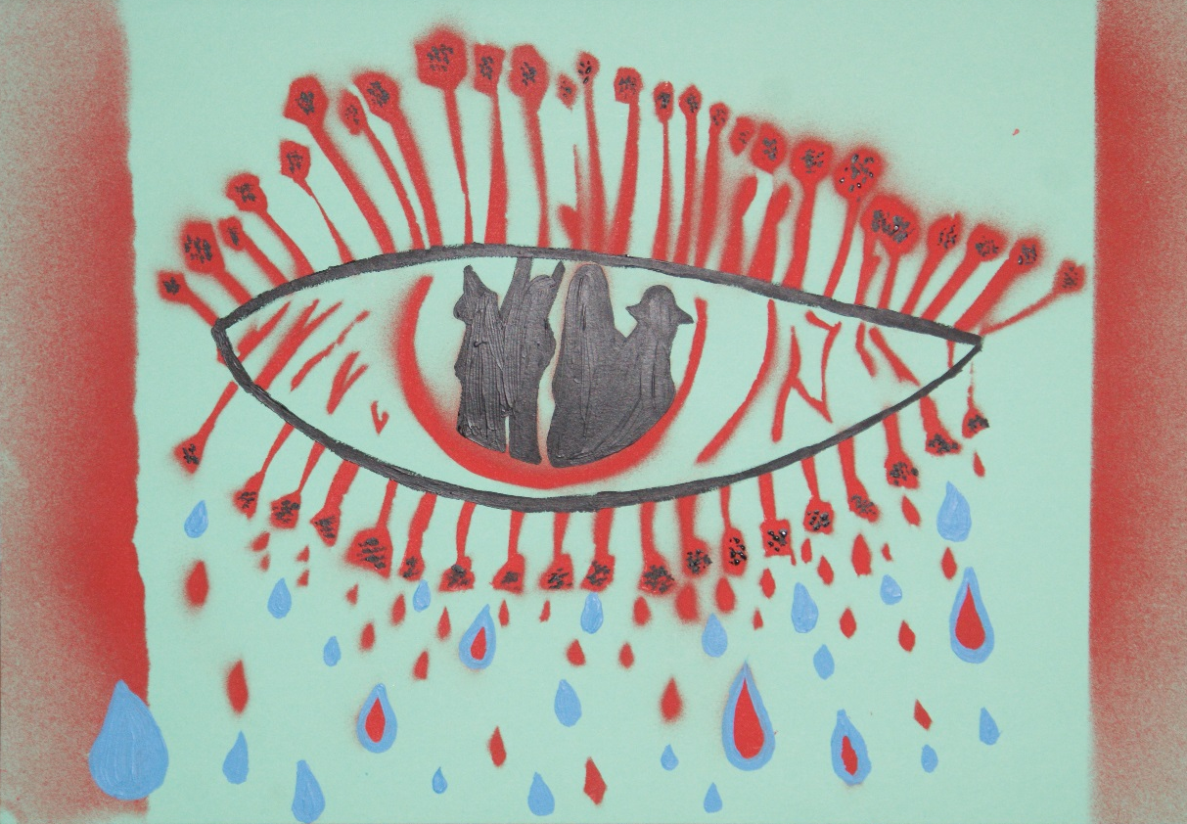
I wanted to make an eye of someone who went to war. The pupil of the eye shows soldiers and therefore represents the memories of the things seen at war, which will haunt you forever.

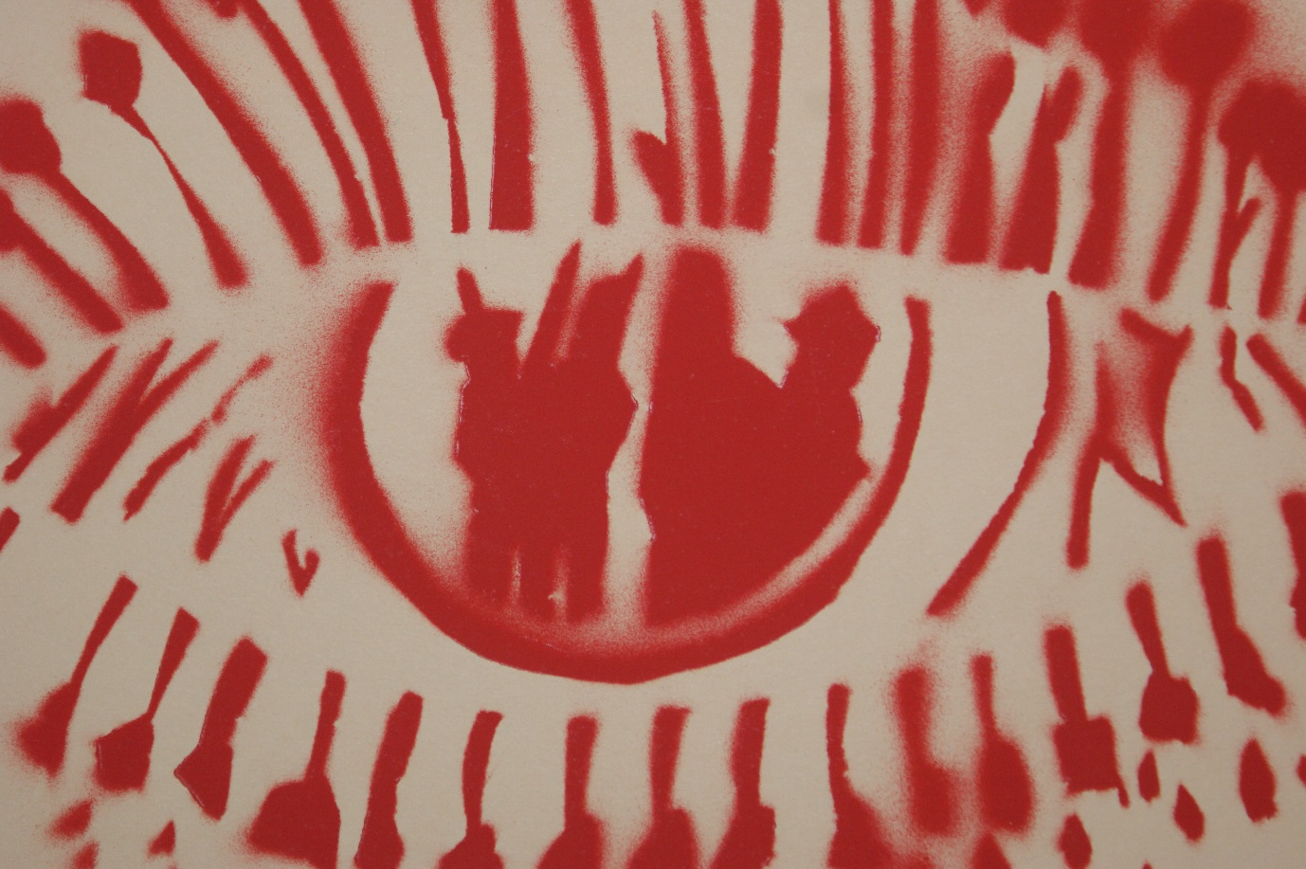

It shows how some strong visuals can keep replaying in your head and make you live in the past, unable to move forward. The eye is large by fear of the reoccurring and reliving of pain. The lashes are build of poppy’s, which symbolize the remembrance of the First World War and the respect for the men who passed away. In a way each poppy represents a certain amount of men who suffered and the eye a whole and unification of all the men. The poppy’s leak blood and tears, which also links to the fact that the blood on the battleground looked like a field of poppy’s, but at the same time the blood also fertilized the poppy’s and the men who passed away caused a field of poppy’s to bloom. In a way that is very ambiguous as something so beautiful and natural grew out of pain and misery. With the eye I also want to imply that not only men who went to war themselves, but their relatives and friends also suffered by the war and afterwards will still be traumatized by losing their loved once.

