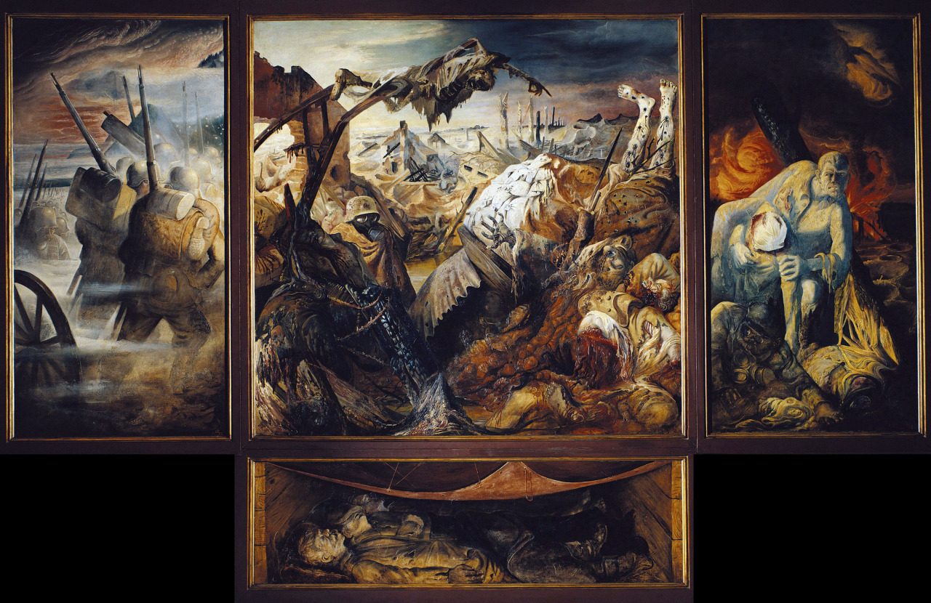
2. Art of WWI

This painting is by Otto Dix. Wilhelm Heinrich Otto Dix (2nd December 1891-25 July 1969) was a German painter and printmaker, noted for his ruthless and harshly realistic depictions of Weimar society and the brutality of war. It is named as “Der Krieg”(The War). This artwork consists of 4 paintings which share the same style of art. These images are based on his experiences of horror and perversity of war. The War shows men going into battle, it shows the aftermath of conflict, and it shows them returning from the field. The first right painting shows the young men going to the battlefield for the war. The painting in the centre represents the brutality of the war. The dying soldiers, decaying body, shell-shocked soldiers, and bombed-out landscapes and graves are shown using dark colours to represent the dark gloomy environment of the brutal war.

Dix manipulated the etching and aquatint mediums to heighten the emotional and realistic effects of his meticulously rendered images of horror. He stopped out ghastly white bones and strips of no man's land, leaving brilliant white patches; multiple acid baths ate away at the images, mimicking decaying flesh.

