Prisoners of War

During the War, a certain number of the POWs were accommodated in or around Varaždinske Toplice ( a small town 15 km southeast of Varaždin). Did they sleep in tents, stables, cottages? Were they Russians, Serbs, or Italians? The documents which have been found in the archives don't reveal us this basic information.
The AZK br. CLXX-202 and AZK br. CLXX 203 ( the Zagreb Bishopric Archive) documents give us interesting data connected with the life of the POWs. Some POWs working in agriculture were housed at private farms and the bishopric estate close to Varaždinske Toplice. They were obliged to comply strictly with the military orders.
The County Prefect of Varaždin sent a notice to the city authorities in Varaždinske Toplice about the violation of law detected in May 1916. It was confirmed to the military officials that some POWs often visited inns and other places where the alcoholic drinks could be served. As it was strictly forbidden to sell drinks to the POWs, it was necessary to warn again all the inn-keepers that the most severe punishment would be applied for such violation of law.
Another document gives us a description of some less severe illegality in the treatment of the POWs.
The Municipal authorities from Novi Marof ( a small town 20 km south of Varaždin) sent a letter to the Principal of the Bishopric estate and to the city authorities in Varaždinske Toplice on 18 July 1916.
The national government official found out that a municipality official invited the POWs to attend a Catholic Mass celebration with the population of the community in spite of the military order which prohibited such wrongdoing. The common Mass celebration was a source of a great deal of improper behaviour, and the church authorities were to be ordered to give a Mass to the POWs one or two hours beforehand.

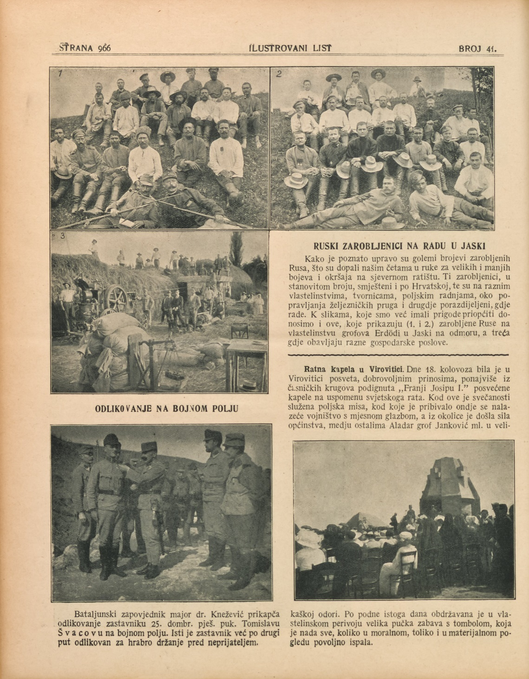

Russian POWs in agricultural labour in Jaska (25 km south of Zagreb)
Illustrated News from 9th October 1915

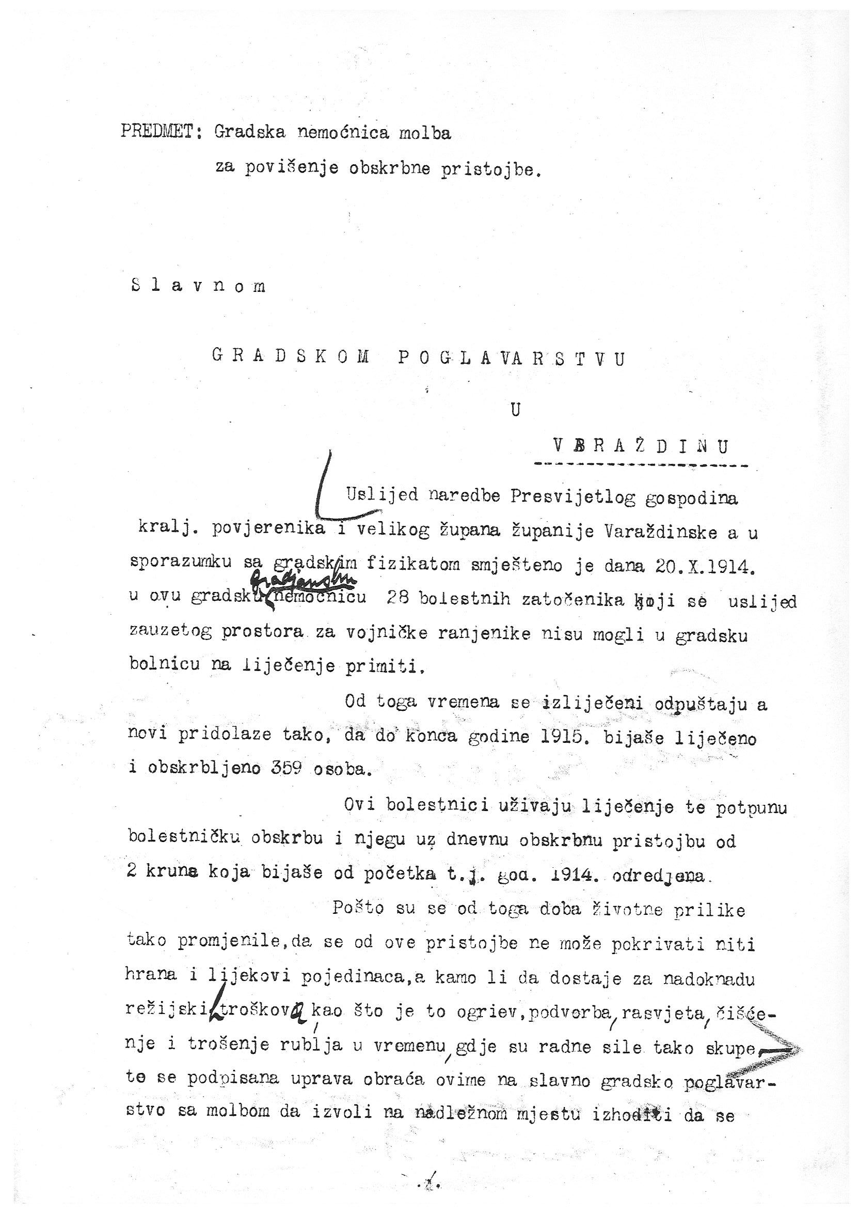

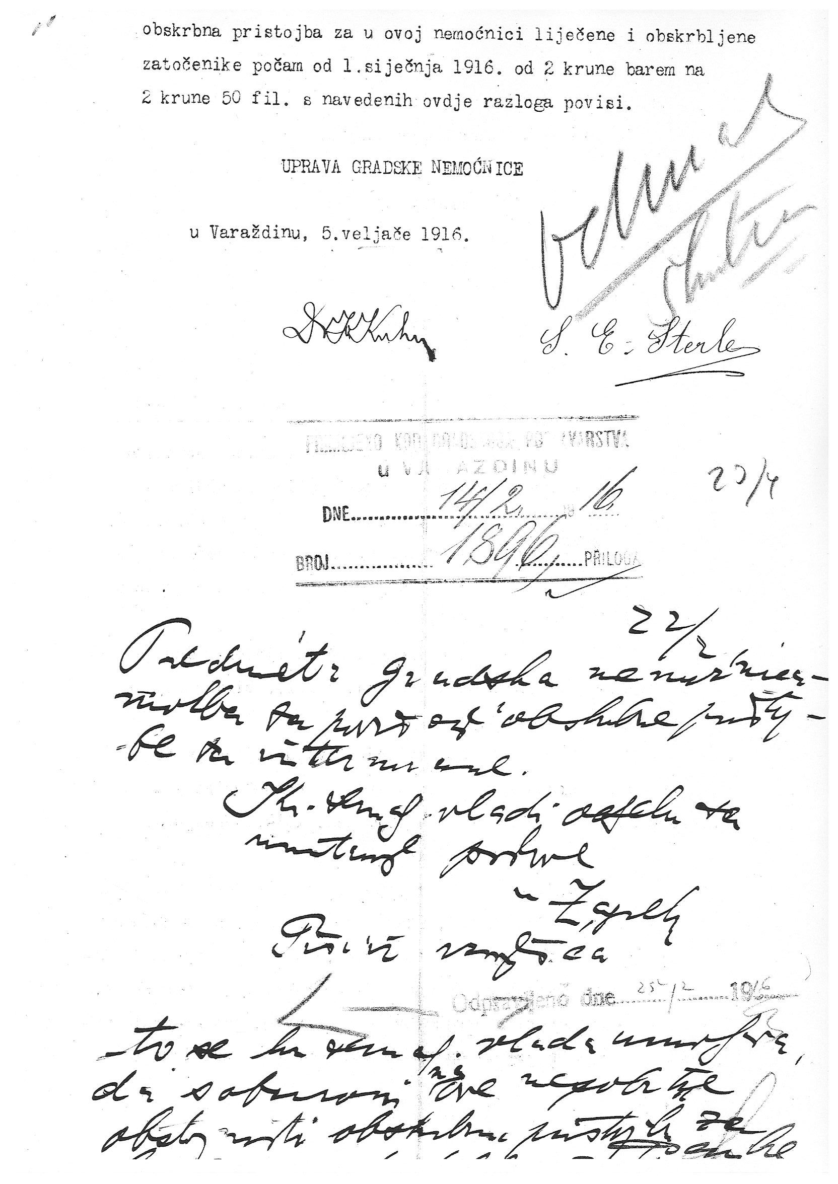

Subject: Auxiliary Hospital request for raising the hospital fees

To the City Government in Varaždin

Upon request of the Royal Commissioner and the Prefect of Varaždin County, in agreement with the city doctors, on 20th October 1914, 28 sick internees, who couldn't be placed into the military hospital due to overcrowding, were placed into this auxiliary hospital.
Since then and until the end of 1915, 359 people were treated and cared for.
Those patients were provided with treatment and complete hospital care with a daily fee of 2 crowns, which was determined at the beginning of 1914.
Considering life conditions have changed since then, so that this fee cannot cover neither food nor medication of an individual, let alone be sufficient for utility costs such as heating, personnel, lighting, cleaning and laundry, the Hospital Board addresses the City Government with a request that the hospital fees be raised from 2 to 2.5 crowns starting from 1st January 1916.

The Auxiliary Hospital Board,
In Varaždin 5th February 1916

As the War broke out in July 1914, the Austro-Hungarian police arrested a great number of suspicious subjects. Detention camps were established in almost all provinces of the Monarchy.
Near Koprivnica, a town 45 km east of Varaždin, there was established a camp for 6,000 internees.
The interned subjects were from the neighbouring counties to Serbia and belonged to the Serbian community. They were accused of disloyalty or treason, but never tried, and were forced to move far from the battlefield area. In October 1914, 1,768 internees arrived at the Varaždin railway station. At first they were taken into the home guard barracks, and then into private estates in the surrounding villages. They were forced to do all kinds of work in agriculture and brickyards.
This document is a request sent from the auxiliary hospital to the city government. 359 internees received medical care there before the end of 1915. It gives us insight into how the city government took resposibility to relieve the misery and suffering of the detainees.

