3/XI.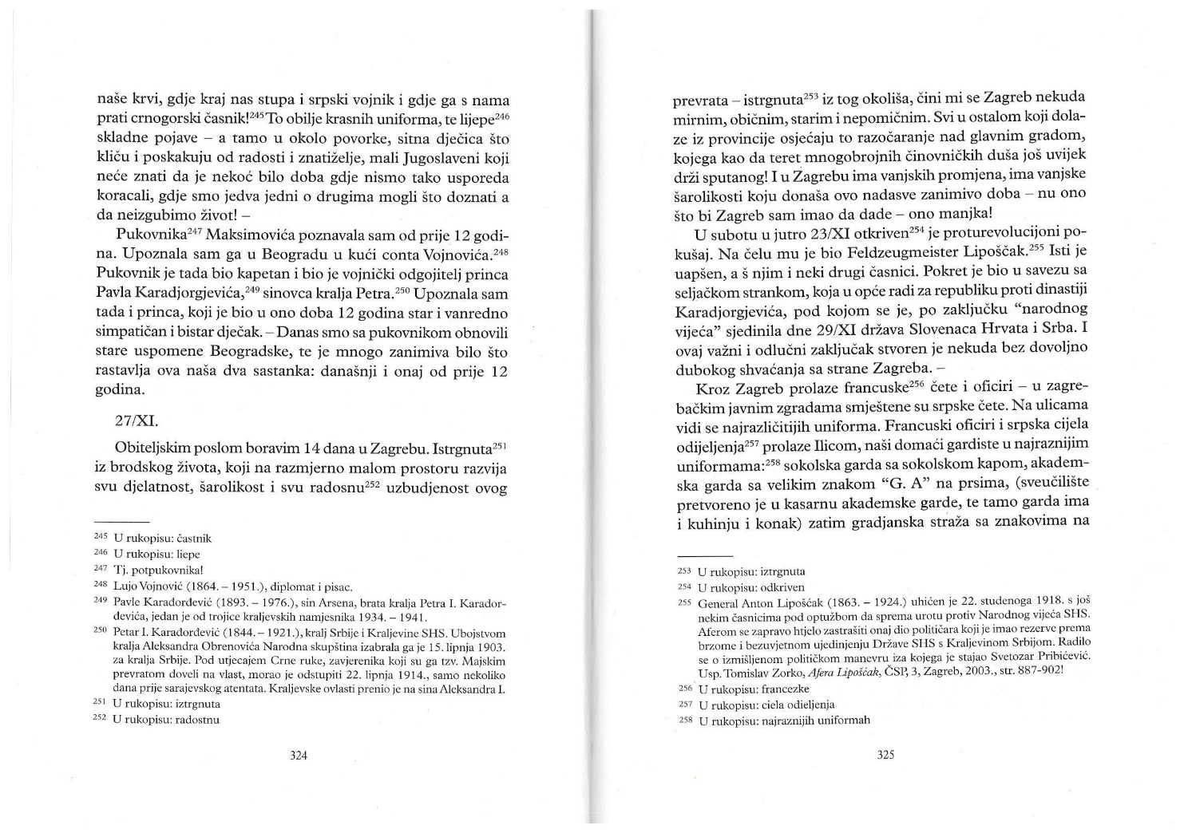
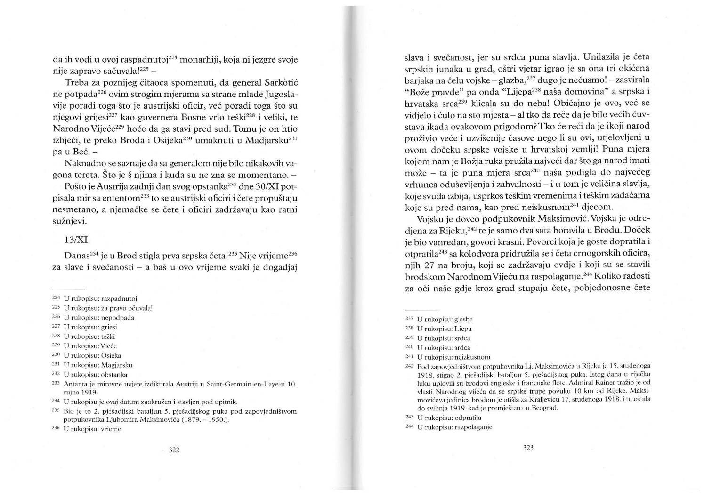

The troop arrived today in Brod. It is not the time for celebrations and festivities – but right at this time every event is exactly a celebration or a festivity, for the hearts are filled with joy. As the troop of Serbian heroes was entering the city, a strong wind was playing with the three decorated banners in front of the army – music not heardfor a long time! When songs „Bože pravde“ (Lord of Justice)(Serbian anthem) and „Lijepa naša domovino“(Our Beautiful Homeland)(Croatian anthem) started playing one after the other, Serbian and Croatian hearts cheered happily. This is usual, it had been seen and heard hundreds of times before – but who would have ever said there were greater emotions during that event? Who would have said that any other nation had experienced greater and more sublime moments than that one, welcoming the Serbian army in Croatia! The full measure by which God's hand provided us with the greatest gift that people can have – that full measure brought gratitude and enthusiasm into our hearts to the maximum – and this is where the greatness of celebration , which is at every corner, is coming from, despite the hard times and hard tasks that are ahead of us, just like ahead of inexperienced children.
The army was led by the lieutenant colonel Maksimović. It left Brod after only two hours because its main destination was Rijeka. The welcome was remarkable, speeches were beautiful. The troop of 27 Montenegrin officers who were staying there and offered their help to the Narodno Vijeće (National Council) joined the procession that was escorting the guests to the train station. What a joyful sight it was to watch the troops , victorious troops of our own blood, in our city where the Serbian warrior marches next to us and is escorted by a Montenegrin officer! This abundance of nice uniforms, these beautiful, harmonius appearances – and there, around the procession, small children are cheering and jumping curiously, little Yugoslavs who won't know that there were times when we didn't walk alongside each other , times when we could barely find out something about eachother without losing our lives!
I had known colonel Maksimović for 12 years before that. I met him in Count Vojnović's house in Belgrade. At the time the colonel was a captain and a military educator of Prince Paul of Yugoslavia, King Peter's son. At that time I also met the Prince, who was 12 years old then and was a nice and extremely bright boy. – Today the colonel and I exchanged many dear memories from our days in Belgrade, and realised that much had happened since our last meeting 12 years before.

Moji Zapisci – source analysis
This is an excerpt from the book „Moji zapisci“ (My Diaries) by Ivana Brlić Mažuranić p. 322 – 324 published in 2016. She was borni n 1874 in Ogulin into a well-known Croatian family of Mažuranić. Her father Vladimir Mažuranić was a writer, lawyer and historian. Her grandfather Ivan Mažuranić was a great politician (the Prime Minister of Croatia-Slavonia 1873 – 1880) and a famous poet. With the family she moved first to Karlovac, then to Zagreb. Upon her marriage to Vatroslav Brlić (a politician and lawyer) in 1892, she moved to Slavonski Brod and lived there for the most of her life. She became a mother of six children, and devoted all her work to her family and education. Her book „The Marvelous Adventures of Hlapić the Apprentice“ published in 1913 really caught the literary public's eye. In the book „Croatian Tales of Long Ago“ published in 1916, IBM created a series of new fairy
tales using names and motifs from the Slavic mythology. Her books of novels and fairy tales for children brought her the title of Croatian Anderson. Her husband Vatroslav Brlić was a member of the Croato-Serb Coalition, elected as MP for Slavonski Brod in 1906 and was member of the Croatian Parliament until 1918. The Croato-Serb Coalition (Hrvatsko-Srpska koalicija) was the dominant party in Croatia-Slavonia from 1906 until the end of the Monarchy 1918. In the last election in Croatia in December 1913 it gained 48 seats out of 88. The Croato-Serb Coalition was established in 1905 and represented the interests of the majority of Croatia's intelligentsia, both Croat and Serb. The Croato-Serb Coalition's inaugural declaration stated that it stood for the equality of Croats and Serbs, constitutional rule, civil liberties, uch as universal male suffrage, local autonomy. It ultimate goal was the unification with Serbia, but in meantime it wished to prepare the people for that.
Vatroslav Brlić was elected as the leader of the National Council for Slavonski Brod in September 1918 (self proclaimed political body which took all responsibility and power in the city in the last months of the war). This excerpt describes the overall political mood among the political elite in Croatia in 1918. In spite of the pro-Yugoslav sentiment among the political publici n Croatia, it shouldn't be neglected that the overall attitude of the population in Croatia was rather complex and much less clear than could be perceived judging by the election outcome. The voting rights in Croatia were very limited; since 1910 only 220,000 men were eligible to vote in elections. It was about 6%.

Volja Naroda, br.19 iz 1918. godine

The celebratory atmosphere of Zagreb

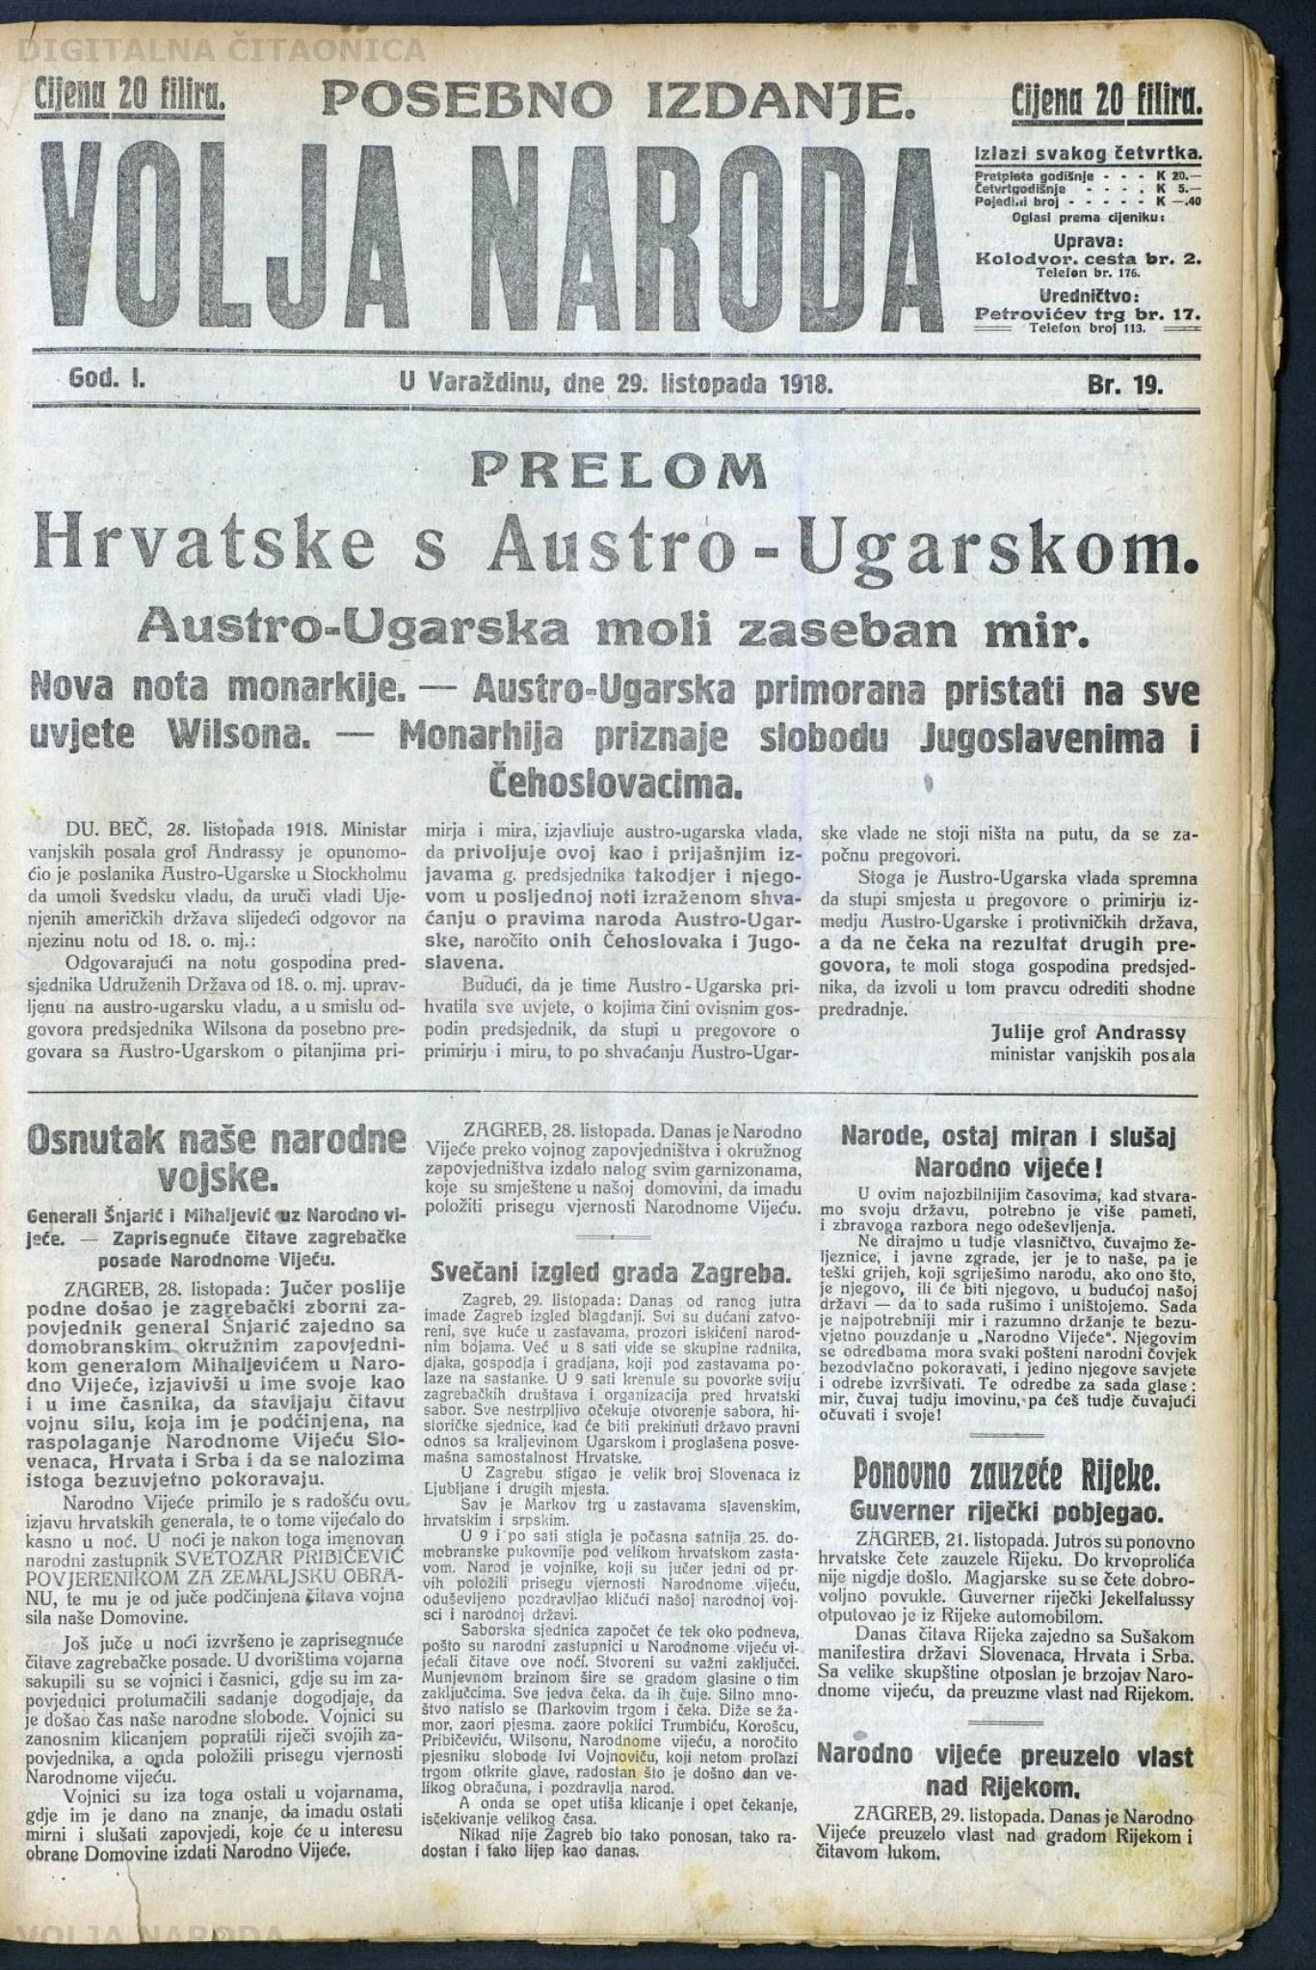

Zagreb, 29th October: Since the early morning today Zagreb had a festive look. All the shops were closed, all the houses wearing flags, the windows decorated in national colors. By 8 o'clock you could see groups of workers, students, citizens that were headed for meetings. By 9 o'clock the processions of all Zagreb's associations and organizations set off towards the Croatian Parliament. Everyone is impatiently awaiting the opening of The Sabor, the historic session, when the state legal ties with the Kingdom of Hungary will be terminated, and an overall independence of Croatia will be declared.
A large number of Slovenians from Ljubljana and other places had arrived to Zagreb.
The whole St Mark’s Square was wearing Slovene, Croatian and Serbian flags.
By 9.30 the honorable Company of the 25th Home Guard regiment carrying the great Croatian flag arrived. The people cheerfully greeted the soldiers that were the first ones who took the oath of fidelity to the National Council yesterday.
The Sabor session will begin around noon, since the national representatives in the National Council deliberated all night. Important conclusions had been made. At the speed of light gossips spread through the city about those conclusions. A great number of people squeezed into St Mark’s Square, waiting. Murmur rose, songs echoed. Cheers were celebrating Trumbić, Korošac, Pribičević, Wilson, the National Council and especially the poet of freedom Ivo Vojnović who was just passing through the square bare-headed, happy that the day of great confrontation arrived, greeting people.
And then as the cheering was silenced, the anticipation of the big moment continued.
Never had Zagreb been as proud, as cheerful and as beautiful as it is today.

Volja naroda - Source analysis

The new local newspaper, „The Will of People“ (Volja naroda), was published from July 1918 to April 1922 in Varaždin. Dr. Hinko Krizman, the owner and publisher, was a prominent member of the Croato-Serb Coalition and later the minister in the national Yugoslav government. The newspaper strongly supported pro-Yugoslav causes.
This article describes the event when the Croatian Parliament (Sabor) met in Zagreb on Oct 29, 1918 and decided, on the basis of the right to national self-determination and the Croatian statehood right, to break all state and legal ties between Croatia and Austria and Hungary.
Croatia, Slavonia, Dalmatia and Rijeka were declared an independent state which joined the common national and sovereign State of Slovenes,Croats, and Serbs.

