Protest in favour of the war

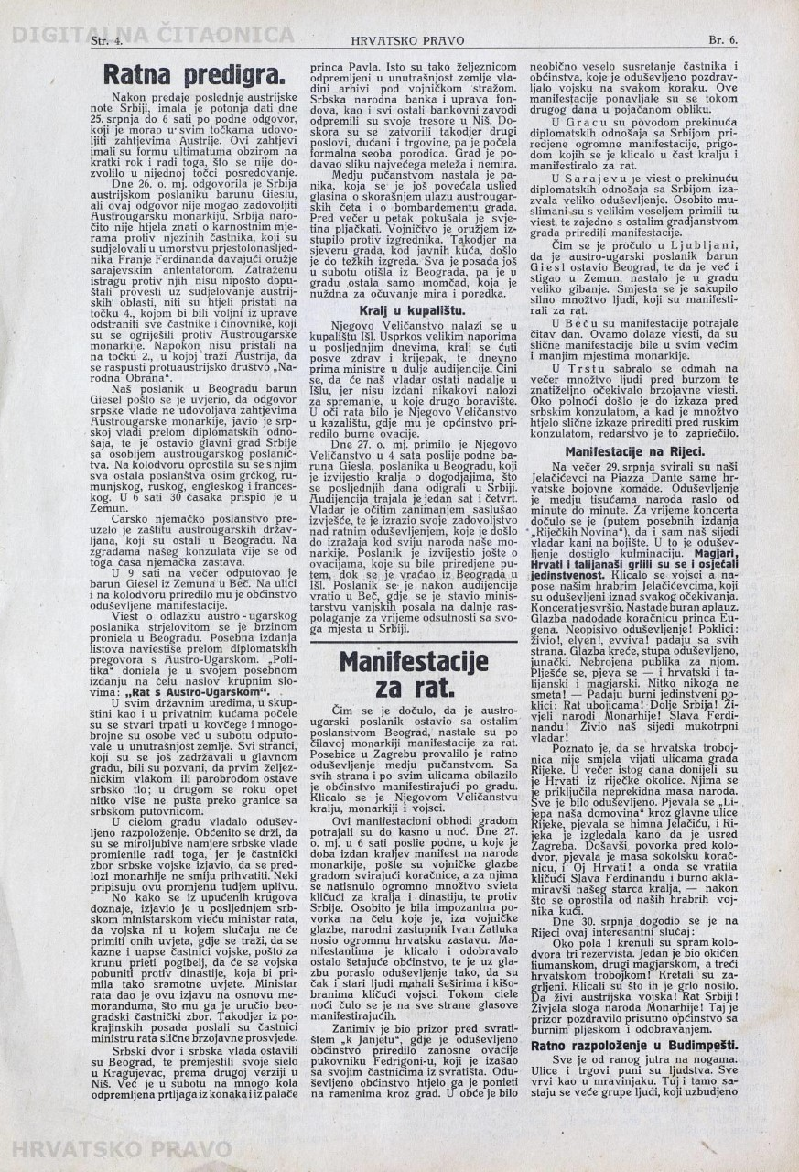

As soon as it was heard that the Austro-Hungarian representative had left Belgrade along with the rest of the embassy, pro-war manifestations broke out throughout the monarchy. The war enthusiasm flared up especially well among the townspeople of Zagreb. From all sides and on every street the masses protested. Cheers were heard for His Excellency the King, the monarchy and the army.

Those manifestations lasted until the dead of the night. On July 27th at 6 o’ clock in the afternoon on the day that the king has issued his manifesto for the people of the monarchy, military marching bands paraded through the town followed by a mass of people cheering for the King and the dynasty and also condemning Serbia. A procession which particularly stood out was the one led by the people’s representative Ivan Zatluka carrying an enormous Croatian flag behind a marching band. The protesting masses cheered on and approved of by passers-by who were so moved by the music that even the older citizens were waving their hats and umbrellas hailing the army. The voices of the protesting crowds were heard throughout the night. An interesting sight could have been seen in front of the “K Janjetu Inn” where the thrilled townspeople organized ecstatic ovations to the colonel Fedrigoni who exited the inn with his officers. The enthusiastic townspeople wanted to carry him on their shoulders through the town.

It was peculiar how joyful was the meeting between the officers and the townspeople who greeted the military with great excitement at every turn.

Those events were repeated during the second day with a greater intensity.
In Graz, on the occasion of the cessation of diplomatic relations with Serbia, massive events in which people hailed the King and cheered for the war were organised.
News about the cessation of relations with Serbia caused ardour among the people in Sarajevo.
Muslims have received that news with particularly great joy and organised events along with the townspeople.
As soon as it had been heard in Ljubljana that the Austro-Hungarian representative, Baron Giesl, had left Belgrade and already arrived in Zemun a great reaction was ensued within the town. A mass of people promptly gathered and cheered for the war.
In Vienna similar events lasted the entire day. Similar events were also organised all over the monarchy.
In Trieste, a mass of people gathered in front of the marketplace and awaited the forthcoming news. Around midnight a public display of dissatisfaction was held in front of the Serbian embassy. When similar proceedings were in the making in front of the Russian consulate, the authorities stepped in.

PROTESTS IN FAVOR OF THE WAR – Source Analysis
This is an article from the newspaper „Hrvatsko Pravo“ (Croatian Right) issued on 1 August 1914. It was the mouthpiece of the Pure Party of Rights.
The true leader of the Croatian states' rights movement at the beginning of the 20 century became Josip Frank. One of the most important element of the ideology of Josip Frank and his followers, known as the Frankists, was their anti-Serb position.
The Compromise (or Ausgleich) of 1867 reorganized the Austrian Empire into the Austro-Hungarian Empire. The Habsburg Monarchy was divided into two halves; Austrian and Hungarian. Croatia-Slavonia was part of the Hungarian half and Dalmatia and Istria belonged to Austrian. The relationship of Croatia-Slavonia and Hungary was formalized in the1868 Croato-Hungarian Compromise in which Croat statehood was reduced to a bare minimum. Under its provisions, Croat political nationhood and its symbols were officially recognized and the Sabor (the parliament) retained control over the internal affairs of Croatia-Slavonia, but all concerns that are the prerequisities of genuine statehood, such as external affairs, finances, defence, and trade, were subject to joint parliament in Budapest, in which Magyars predominated. Moreover, the Croatian Ban (the prime minister of Croatia-Slavonia) was nominated by the prime of Hungary and appointed by the King.
For decades Croatian politicians and parties failed to enlarge autonomy of Croatia within Hungary. At the beginning of the 20 century, Hungarian abuse of the Croatian constitution accelerated the spread of Slav nationalism.
The new generation of intellectuals which entered the political arena were convinced that the Croat could no longer survive within the Habsburg Monarchy and that their future could only be assured within a South Slavic state which would include Serbia and Montenegro. The new political ideology, labelled as the New Course, was the best epitomized in the establishment of the Croato-Serb Coalition in 1905 which would dominate Croatian policy until 1918.
The Frankists represented the opposite pole of the political spectrum. They believed that Croatia's fortune could be realised only within the imperial framework, and that it was therefore in Vienna's interest to establish a Croat unit within the Monarchy, embracing all of the Habsburg South Slavic possessions. The Frankist sought to convince the Viennese camarilla that the tentative rearrangement of the Monarchy would bring about a satisfied Croatia, which would in turn become a bulwork against Hungarian pretentiousness and Serbian irrendentism.
Frankists incited a wave of emotional anti-Serbianism for years in Croatia and this artical probably exaggerated the intensity and the extent of the protests. However, all other newspapers also reported about the demonstrations against the assassination in Sarajevo but it is impossible to estimate the magnitude of the events.

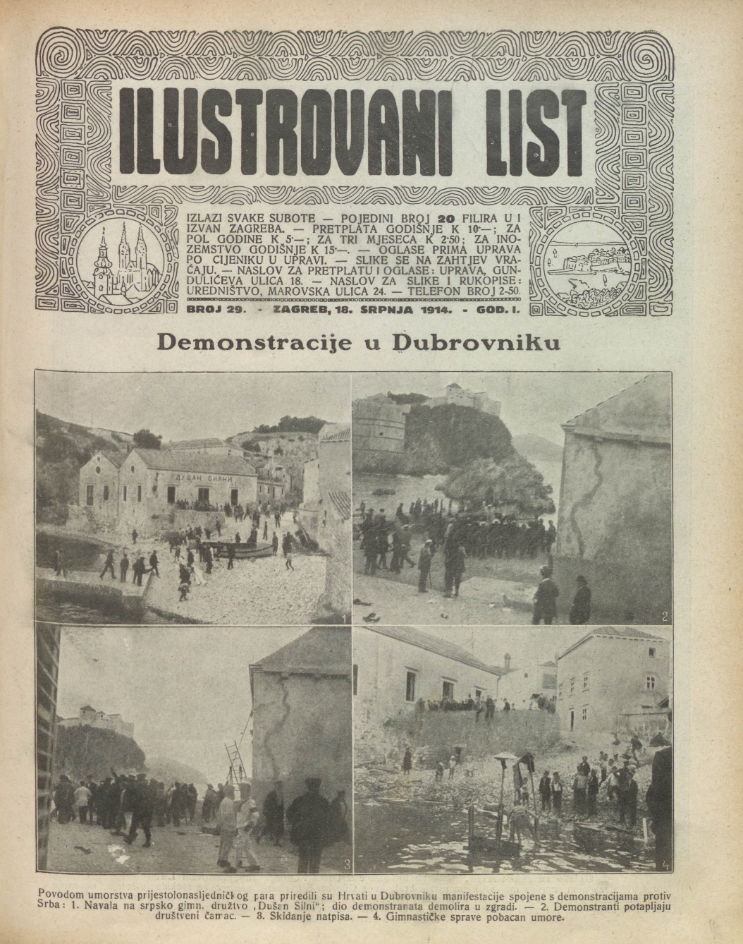
Dubrovnik
1. Crowds in Dubrovnik demolish the building of the Serb athletic society „Dušan Silni“ (Dušan the Mighty). Dušan Silni sport societies were popular in Serbia but such associations were established also in the Austro-Hungarian cities to promote Serb national causes.
2. Demonstrators sink the small ship that belonged to Dušan Silni.
3. Removal of the inscription Dušan Silni.
4. Gym equipment is thrown into the sea
Photo was published in the Illustrated News on 18 July 1914.

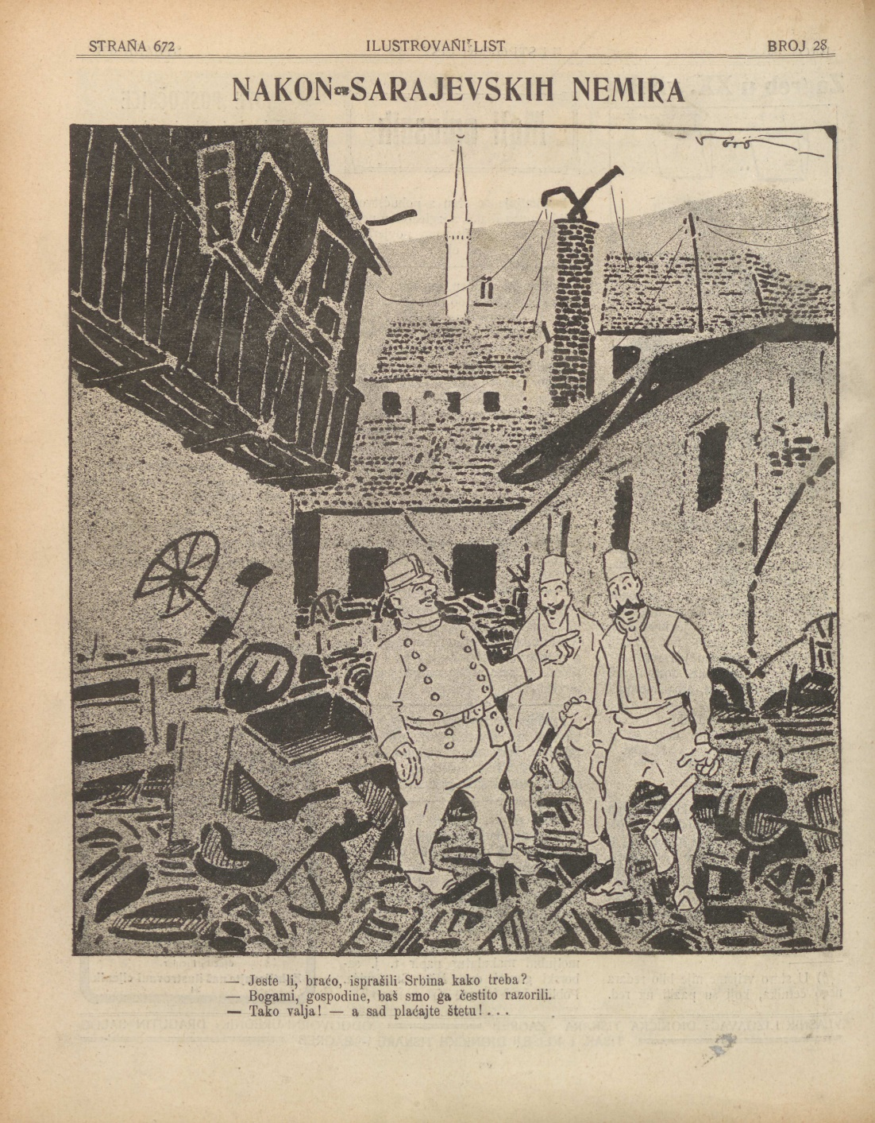
Sarajevo
- Brothers, have you properly beaten up the Serb!
- Yes, indeed, sir, we have really smashed them!
- Way to go! and now pay for the damage!

This is the back cover of the Illustrated News published in 11 July 1914.
The Illustrated News was the first national circulation which sistemstically published photo reports on 24 pages. The newspaper was published every Saturday from the January 1914 to the December 1918. This poster refers to the events in Sarajevo after the assassination of the Archduke Franz Ferdinand. The Muslim crowds in Sarajevo demolished and looted the shops and other properties which belonged to the Serbs. The city police authority was passive and reluctant to stop the violence and impose order. Some observers even could say that the authority encouraged the destruction of the property. When the enraged mob finished the job, the police cynically try to restore order.

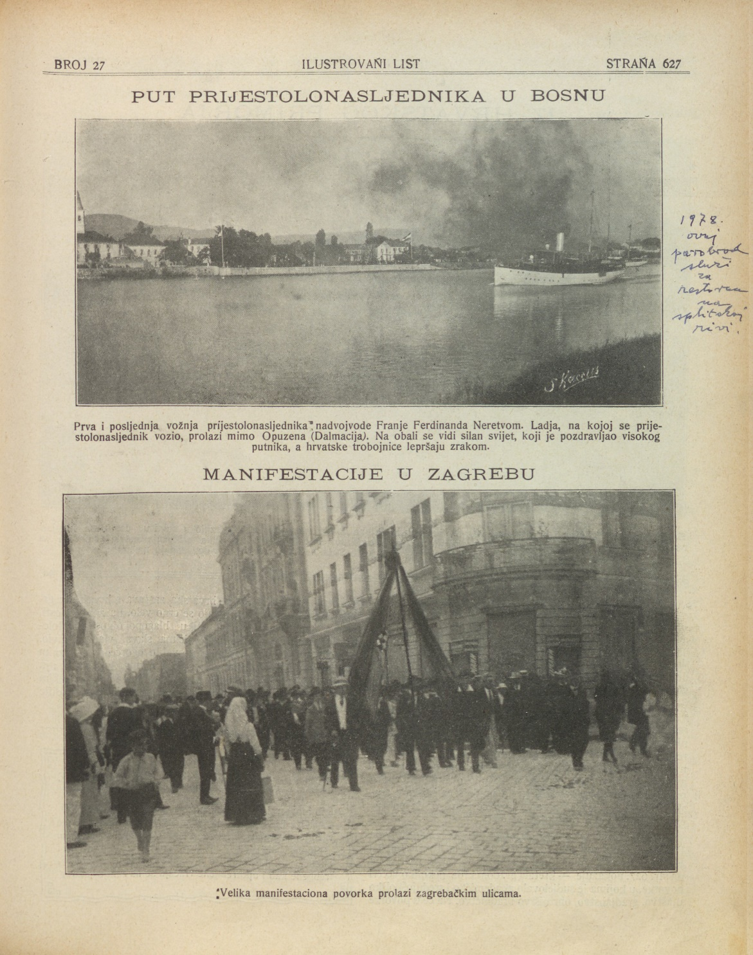

Zagreb
Protest in favour of the war in Zagreb pictured in the Illustrated News on 4 July 1914.

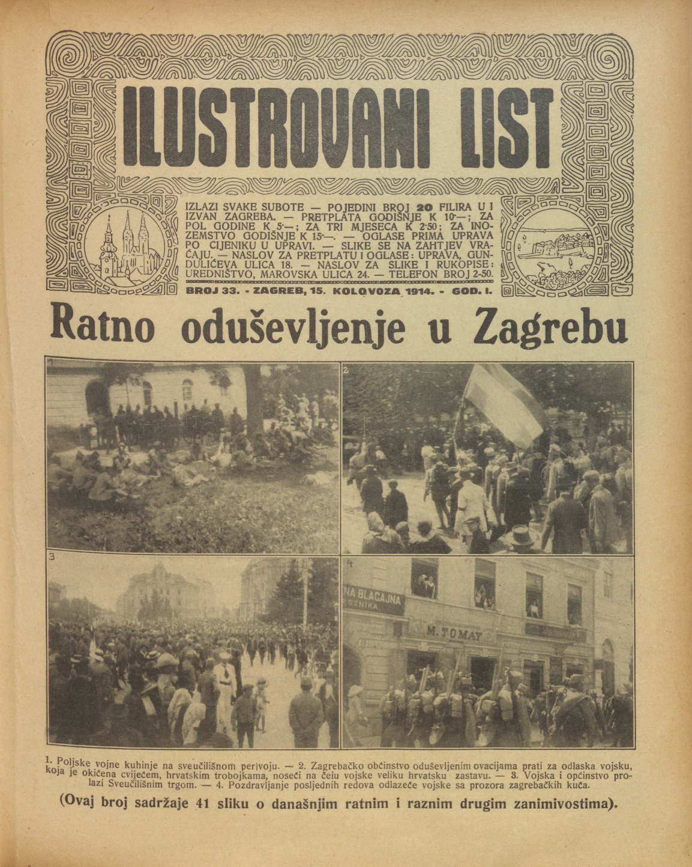

War enthusiasm in Zagreb
1. Military field kitchen in the university park.
2. Citizens of Zagreb give ovation to the soldiers going to the train station.
3. Citizens and the soldiers on the main square in Zagreb.
4. Soldiers were greeted from the windows as the march toward the train station.
The Illustrated News on 15 July 1914.

