Module 4: Source analysis (Poland)

Resource 1
Original :

Rząd Narodowy

Wybiła godzina rozstrzygająca! Polska przestała być niewolnicą i sama chce stanowić o swoim losie, sama chce budować swoją przyszłość, rzucając na szalę wypadków własną siłę orężną. Kadry armii polskiej wkroczyły na ziemie Królestwa Polskiego, zajmując ją na rzecz jej właściwego, istotnego jedynego gospodarza - Ludu Polskiego, który ją swą krwawicą użyźnił i wzbogacił. Zajmują ją w imieniu władzy naczelnej Rządu Narodowego. Niesiemy całemu narodowi rozkucie kajdan, poszczególnym zaś jego warstwom warunki moralnego rozwoju.

Z dniem dzisiejszym cały Naród skupić się winien w jednym obozie pod kierownictwem Rządu Narodowego. Poza tym obozem zostaną tylko zdrajcy, dla których potrafimy być bezwzględni.

Komendant Główny Wojska Polskiego
Józef Piłsudski

Translated:

National Government

The time has come! Poland is no longer a slave and wants to decide about her fate, built her own future, introducing her own army. The Polish army marched on polish lands, regaining them for their proper, essential and only owner - polish people, whose blood enriched them. They are getting it back in the name of supreme power of National Government. We bring to the whole nation uncuffing, when the opportunity for moral development shall be brought to its particular layers.

Today, the whole nation should gather in single camp of National Government. Beyond the camp only the traitors would remain, to whom we can be absolute.

National Commander of the Polish Army
Józef Piłsudski

Source analysis

The source I am going to analyse is strictly connected to the issue of World War One. Through this work I will reflect on values and limitations of the speech which origins are as follows: it was delivered by Józef Piłsudski to the whole nation at 6 VIII 1914 (Krakow). Piłsudski made it in order to show the polish people that the time for war has finally come. There is no longer space for divisions - we, as a nation, shall be united. Poland should be free, unchained from "slavery". What is more, the audience of this speech is also crucial. The speech was delivered to the whole nation. The leader wanted to reach each and every one of polish people. He also emphasised that only those who will join his camp will have a chance for freedom, those who should refuse will be treated as traitors and punished.
Being a speech, Piłsudski's discourse has a very persuative tone and the language used is highly egzaggerated. The desire to persuade the polish people is clearly visble and the phrases used are marked with emotions. Thus, while speaking of liberty Piłsudski emphasises such words as "no longer a slave” and "nation uncuffing". On the contrary, while criticising those, who would like to oppose the national government he names them “traitors” and promises to be absolute” while dealing with them.
Knowing all about the origins of the speech, being acquainted with its puropse and content, we shall move to the values of it. The speech can offer the reader the insight in the personal opinion of Piłsudski on the condition of polish country and its army. We can also acknowlegde the motives that lay beneath his words (willingness to rule the whole country and deal with the traitors) and know what idea was planted in polish people. After reading the speech we know more about the motives that run public actions, the motives why the country wanted to be unslaven. The indisputable value of this source is a chance to see the thoughts of a society (Piłsudski's camp) gathered in one man's speech. We can see what the public was told: Poland should no longer be a slave, the time has come for polish people to take action, the national government is the only way to regain freedom. Also, apart from the social issues, we might get a closer look on the personal engagement and emotional affection of Piłsudski to the ideas shared in the speech.
Therefore, several limitations of this source exist. Firstly, we know only about the current situation, and are not able to see the results of the presented politics. The speech does not offer us the variety of views – on the contrary, we can only see the current events from one point of view. It also does not show the public opinion, only the leaders imagination of how the things should be done. The motives are explained, but we cannot be sure if they are the real ones, or if they are just made up to persuade the soldiers to keep fighting. What is more, the language used in this speech is also a limitaton, due to its emotionality – being objective is constricted. Used phrased are indicating certain problems, completely critcising one side and highly gloryfying the other, making it hard to decide by oneself on the pros and cons of each side.

Resource 2
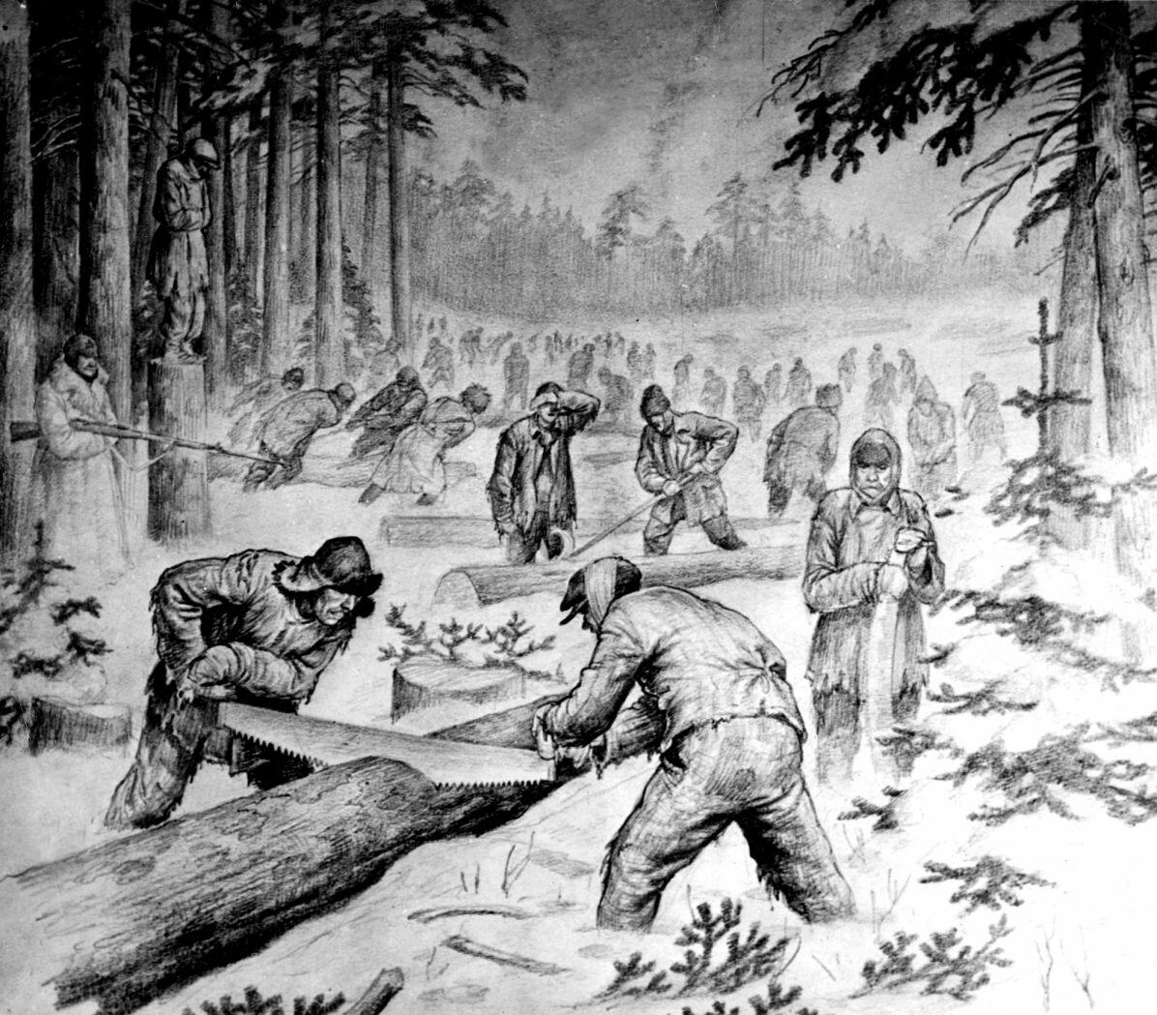
Working gulag's prisoners (n.d.). In Newsweek.pl. Retrieved June 15, 2017, from http://www.newsweek.pl/historia/gulag-wiezniowie-zsrr-zekowie-na-syberii-newsweek-pl,artykuly,276236,1,1,1.html
This is a drawing made by unknown author after the first world war. The picture presents working prisoners of Soviet Union’s gulags in the cold winter around Siberian area. This drawing was found on a polish website Newsweek.pl but it was probably published for the first time in an early XX-century’s newspaper. The author created this picture for those people who live beyond the gulags but should know how did the work conditions look like in there.
The author of it decided to show the hard conditions of work in Russian gulags where Soviet Union’s enemies were forced to labor in mines, buildings or feelings . This hard physical work was developed in unsanitary conditions leading most of the employees to death, the prisoners were destitute of most of common basic human rights and treated worse than animals. The cruel punishments for them were chicanes and tortures.
The author of the picture created the actual mood of the work in gulags by showing the exertion in prisoners posture and facial expressions. The Soviet guard is holding the weapon and controlling hard-working captives. The hanged man on the left is a symbol of those who decided against being used. What is significant the picture presents befogged workers set on the background which means that there was an enormous number of them.
There are several values of the presented source. The very first is that it gives a sense of a specific scene of working exhausted prisoners and the guard ready to immediately shoot the first defiant. The picture also offers the information on the environment and inform public opinion as cartoonists often respond to popularly held views. Moreover the author could be a eyewitness of the work in gulags and he showed the scene of it very accurately . In another case, he could be one of the prisoners so he wasn’t sure about his future. There was a possibility that this man would be killed by the Soviet guards so he tried to create the realistic picture of living in gulags. However it is limited as we cannot see beyond the ‘’lens” and the picture is staged. It can reflect the purpose of an author instead of reflecting the public opinion. Another limitation of the picture is that it can play on exaggeration and stereotypes and be one-sided. The author could be emotionally bounded with the scene he presented so the pictue would not be perceived as accurate. Source may be restricted to the view point and experience of an author who could have been one of the working prisoners.

Resource 3
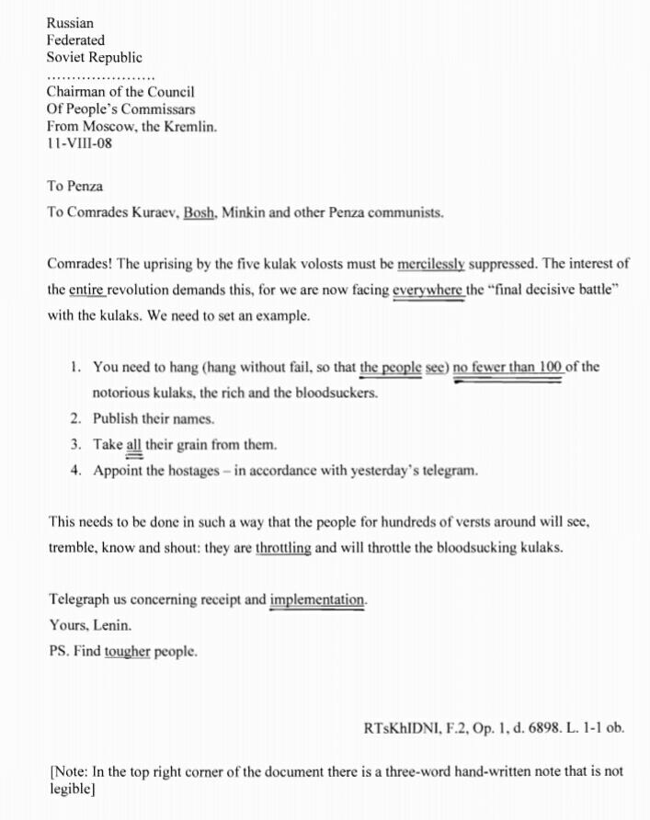
The presented source is the telegraph to Penza Communists from Vladimir Lenin, the politician who became the leader of Vladimir Lenin’s Cabinet which was the government of the Russian Soviet Federative Socialist Republic during the World War I.
The source shows that the telegraph was written before the World War I, (as mentioned in the source 11-VIII-08) although was highly connected with this episode and the future of Russian Federated Soviet Republic, including its inhabitants- kulaks.
He writes it in Kremlin in Moscow on the territory of Russian Federated Soviet Republic where he is observing the situation of kulaks and analysing their behaviour which leads him to make a decision and contact with his collaborators from Penza. Then he asks them for help in fulfilment the plan of intimidation the kulaks from Russian Federated Soviet Republic.
The source is taken from the Lenin Collected Works from MIA: V.I. Lenin Library. This website contains the collection of all the Lenin’s speeches, letters, articles comments etc. organized and scanned altogether with help of David J. Romagnolo.
Lenin, the cruel future leader writes to his ‘Comrades’ – communists. He presents his idea of intimidation the kulaks. He explains that the revolution of five of them must be scotched. He wants to end the battle between kulaks and the government so he creates a plan which provides a final solution to the conflict. Lenin describes his plan which assumption is that all the people who see the hanging, robbed and humiliated notorious kulaks would be suggested to treat them as the pests of the community and decide inhibit their development which acts against them. He tries to use the propaganda. Lenin also expects the recipients who are Kuraev, Bosh, Minkin and other cooperators from communist town Penza to help him with creating the implementation of his plan. He is sure that those people are loyal to him and wouldn’t disappoint him in the idea of defeating the kulaks.
The language of Lenin’s statement sounds very subjective. He uses adjectives like notorious, he describes kulaks as rich bloodsuckers. This means that he doesn’t want the government to maintain this group of people anymore. He gives the instructions about his plan. The telegraph includes the expectation of number of humiliated kulaks. The author emphasise that the treatment of them must be merciless and seen by the commonality. He focuses on this as the only possible way to win the decisive battle with kulaks and get rid of this burden. He decides to use propaganda against them.
This source contains values like the insight in to a Lenin’s personal negative opinion about kulaks’ situation in Russian Federated Soviet Republic. He was one of the greatest kulaks’ enemy and wanted to defeat them. The telegraph contains the names of his collaborators (Kuraev, Bosh, Minkin) and the data about the place and time of delivery and receiving so the nowadays reader may compare the idea and opinion of kulaks with the real episodes from their history and society’s negative attitude to them as to freeloaders . This telegraph indicates the affect of the kulaks’ behaviour on the representative of government. We can assume that this telegraph was one of the reasons why kulaks were the aims of all the state repression. As I mentioned before, the expression in use of language of Lenin represents his mad idea of merciless beat of useless inhabitants. He hates them and wants the whole society to feel the same kind of apathy.
On the other hand the individual opinion of Lenin can also be called as limitation since this source doesn’t contain the general view of the government. The reader can just assume that the representative individual like Lenin shares the idea of defeating kulaks with the whole government. We also do not know the answer to his telegraph, which could accept his plan or not. The telegraph was written in a certain time before Lenin achieved the supremacy. This means that his words would sound completey different after a several years. He also might try to persuade hiss audience which were the communists from Penza who were expected to help Lenin accomplishing his plan. This is why he used the subjective tone and called kulaks the bloodsuckers. He knew that the description of the situation with kulaks in the negative way may affect that the communists understand and share his attidude to those infhabitants. However we are not supported with the materials from different point of view- we do not know the kulaks’ perception and the perception of the community which could be different than the Lenin’s one.

Resource 4
SPEECH DELIVERED AT A MEETING OF SOLDIERS OF THE IZMAILOVSKY REGIMENT APRIL 10 (23),1917

Comrade soldiers! The question of the state system is now
on the order of the day. The capitalists, in whose hands the
state power now rests, desire a parliamentary bourgeois
republic, that is, a state system where there is no tsar, but
where power remains in the hands of the capitalists who
govern the country by means of the old institutions, namely:
the police, the bureaucracy, and the standing army.
We desire a different republic, one more in keeping with
the interests of the people, more democratic. The revolu-
tionary workers and soldiers of Petrograd have overthrown
tsarism, and have cleaned out all the police from the capi-
tal. The workers of all the world look with pride and hope
to the revolutionary workers and soldiers of Russia as the
vanguard of the world’s liberating army of the working class.
The revolution, once begun, must be strengthened and car-
ried on. We shall not allow the police to be re-established!
All power in the state, from the bottom up, from the remot-
est little village to every street block of Petrograd, must
belong to the Soviets of Workers’, Soldiers’, Agricultural
Labourers’, Peasants’ and other Deputies. The central state
power uniting these local Soviets must be the Constituent
Assembly, National Assembly, or Council of Soviets—
no matter by what name you call it.
Not the police, not the bureaucracy, who are unanswera-
ble to the people and placed above the people, not the
standing army, separated from the people, but
the people themselves, universally armed and united in the Soviets,
must run the state. It is they who will establish the necessary
order, it is they whose authority will not only be obeyed,
but also respected, by the workers and peasants.
Only this power, only the Soviets of Soldiers’ and Peas-
ants’ Deputies, can solve the great question of the land in
a non-bureaucratic way and not in the interests of the land-
owners. The land must not belong to the landowners. The
peasant committees must take the land away at once from
the landowners, while carefully guarding all the property
against damage, and seeing to it that grain production is
increased in order that the soldiers at the front be better
supplied. All the land must belong to the whole nation, and
its disposal must be the concern of the local Soviets of
Peasants’ Deputies. In order that the rich peasants—who
are themselves capitalists—may not wrong and deceive the
agricultural labourers and the poor peasants, it will be
necessary for the latter either to confer, to combine, to
unite separately, or to set up Soviets of Agricultural
Labourers’ Deputies of their own.
Do not allow the police to be re-established, do not let
the state power or the administration of the state pass into
the hands of the bureaucracy, who are non-elective, undis-
placeable, and paid on a bourgeois scale; get together, unite,
organise yourselves, trusting no one, depending only on
your own intelligence and experience—and Russia will be
able to move with a firm, measured, unerring tread toward
the liberation of both our own country and of all humanity
from the yoke of capital as well as from the horrors of war.
Our government, a government of the capitalists, is con-
tinuing the war in the interests of the capitalists. Like the
German capitalists, headed by their crowned brigand Wil-
helm, the capitalists of all the other countries are carrying
on the war only for a division of capitalist profits, for domi-
nation over the world. Hundreds of millions of people, al-
most all the countries in the world, have been dragged into
this criminal war. Hundreds of billions of capital have
been invested in “profitable” undertakings, bringing death,
hunger, ruin, and barbarism to the peoples and staggering,
scandalously high profits to the capitalists. There is only
one way to get out of this frightful war and conclude a
truly democratic peace not imposed by force, and that is
by transferring all the state power to the Soviets of Work-
ers’ and Soldiers’ Deputies. The workers and poor peasants,
who are not interested in preserving the profits of the capi-
talists and robbing the weaker nations, will be able to do
effectively what the capitalists only promise, namely, end
the war by concluding a lasting peace that will assure
liberty to all peoples without exception.
Pravda No.30, April 12, 1917
Published according
Signed:
N. Lenin to the text in Pravda

Source analysis

The source I am going to analyse is strictly connected to the issue of World War One. Through this work I will reflect on values and limitations of the speech which origins are as follows: the speech was delivered by Vladimir Lenin at a meeting of soldiers of the Izmailowsky Regiment (at April 10, 1917). The purpose of this speech was to persuade the soldiers about the harmful effect which capitalism has on people and their doings. Lenin made it in order to make the soldiers aware to what extent capitalism is a threat to humanity; made it because he believed that the capitalists are governing the country not the way he would like it to be ruled; made it because he wanted the war to be ended not the way that the profits would benefit a narrowed group of people, but instead reach every human being, claiming that we all are equal. Lenin said the speech in front of the soldiers which was equally important as the thoughts included in it. He delivered the speech to soldiers, to the working people, not the high class. He therefore wanted to assure them that their effort won't be forgotten and that their actions matter. Lenin was persuating these young men to fight for their country and for all people, to end the government of capitalists, to gain an opportunity to live in the world with "democratic peace" and "liberty for all peoples without exception".
Being a speech, Lenin's discourse has a very persuasive tone and the language used is highly exaggerated. The desire to persuade the soldiers is clearly visible and the phrases used are marked with emotions. Thus, while speaking of liberty Lenin emphasizes such words as "interests of the people" and "the workers and poor peasants". On the contrary, while criticizing the bureaucracy, he accuses them of "bringing death, hunger, ruin, and barbarism". There is no support for the thoughts presented by Lenin, no data or statistics included in the speech.
Knowing all about the origins of the speech, being acquainted with its purpose and content, we shall move to the values of it. The speech can offer the reader the insight in the personal opinion of Lenin on the government in Russia during World War One, the world peace and how to achieve it. We can also acknowledge the motives that lay beneath his words (democratic way of ruling, equality for people) and know what idea was planted in his supporters' heads. After reading the speech we know more about the motives that run public actions, the motives why the soldiers were fighting. The indisputable value of this source is a chance to see the thoughts of a society (socialists) gathered in one man's speech. The position of opposition is visible, the motives of fighting the government occur (liberating all people, ending capitalism, ending war in a democratic, peaceful way, without force usage). We can see what the public was told: that society is good, that working is good, that capitalism is harmful and capitalists are thieves, depriving common people from higher benefits. Also, apart from the social issues, we might get a closer look on the personal engagement and emotional affection of Lenin to the ideas shared in the speech.
Therefore, several limitations of this source exist. Firstly, we know only about the current situation, and are not able to see the results of the presented politics. The speech does not offer us the variety of views – on the contrary, we can only see the current events from one point of view. It also does not show the public opinion, only the leaders imagination of how the things should be done. The motives are explained, but we cannot be sure if they are the real ones, or if they are just made up to persuade the soldiers to keep fighting. What is more, the language used in this speech is also a limitation, due to its emotionality – being objective is constricted. Used phrased are indicating certain problems, completely criticizing one side and highly glorifying the other, making it hard to decide by oneself on the pros and cons of each side.

Resource 5
Declaration of Russia respecting Poland 14 VIII 1914r.

Poles. - The hour has sounded when the sacred dream of your fathers and your grandfathers may be realized. A century and a half has passed since the living body of Poland was torn in pieces, but the soul of the country is not dead. It continues to live, inspired by the hope that there will come for the Polish people an hour of resurrection, and of fraternal reconciliation with Great Russia. The Russian Army brings you the (p.66) solemn news of this reconciliation which obliterates the frontiers dividing the Polish peoples, which it unites conjointly under the scepter of the Russian Tsar.
Under this scepter Poland will be born again, free in her religion and her language. Russian autonomy only expects from you the same respect for the rights of those nationalities to which history has bound you. With open heart and brotherly hand Great Russia advances to meet you. She believes that the sword, with which she struck down her enemies at Grunewald, is not yet trusted. From the shores of the Pacific to the North Sea the Russian armies are marching. The dawn of a new life is beginning for you, and in this glorious dawn is seen the sign of the Cross, the symbol of suffering and of the resurrection of peoples.

Tsar Nikolai II 25 XII 1916r.
Russian ukase
“Creating an independent Poland from the three separate segments”

Analysis
The origins of the sources were Russian announcements during the First World War about the Poland. The first one is a Declaration of Russia respecting Poland from 14 VIII 1914 published by Nikolai Nikolaevich Romanov in Russia. The second one was an ukase by Tsar Nikolai II from 25 XII 1916 Russia.
The first source was a governmental declaration that revealed the opinion about uniting Poland under the scepter of the Russian Tsar. It’s purpose was to make Poles trust Russian plans that for Poland have been showed in a form of promises and a dream come true. It evoked past and key events from the Polish history to persuade Poles to Russia’s plans. It also had an aim to motivate Poles to fight for their autonomy by talking about swords at Grunewald. It was a Russia’s great promise of polish autonomy controlled by the tsardom.
The second one is a statement of Tsar that is also a promise of independence and a reveal of Tsar’s opinions and plans. He as a representative of Russia wanted to unite Poland, an independent country from three segments, which were those occupied areas.
These sources has value for historians studying the First World War especially the attitude of Russia as it shows evolution of views- how in a time of two years Russian tsardom has changed intentions and the idea of uniting Polish nation. These are valuable because both statements come from the exact time of First World War and the authors of the statements were people in power. However because these documents are public statements of two Tsars - Nikolai Nikolaevich Romanov (1914) and Nikolai II (1916) it has a limitation of only one - Tsars’ perspective on situation with Poland or of unknown secondary authors that had influence on Tsars’ opinion. Also the short time difference between apparition of documents may suggest that these have been just a part of campaign encouraging Poland to adopt Russia’s conditions of uniting the country.

Resource 6
Source analysis – “Calm” part of the soldier’s diary
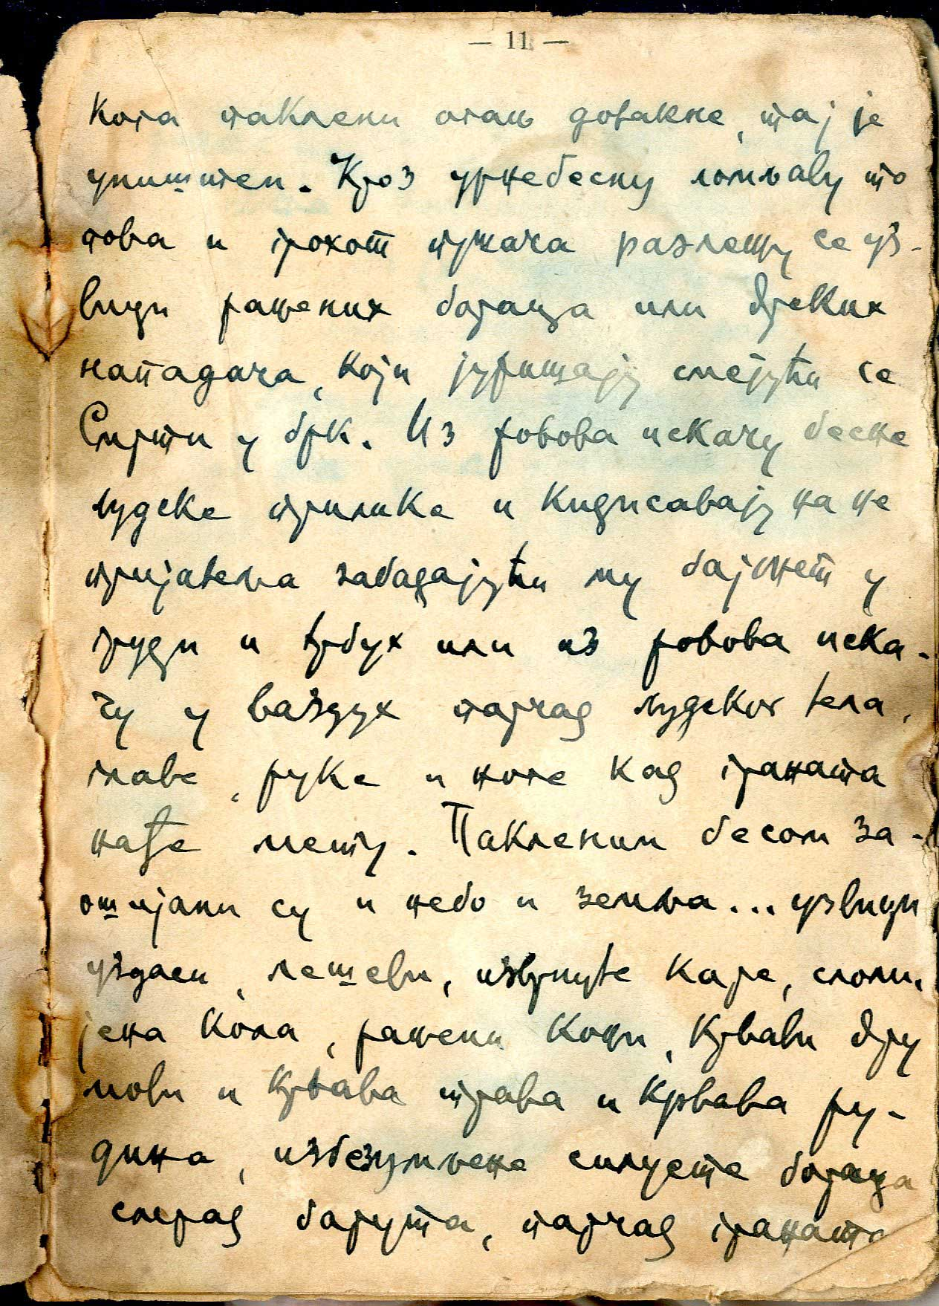

Translation: Those struck by inferno fire are destroyed. Through thundering gun and cannon fire, you can hear shouting of wounded soldiers or bold attackers, storming and laughing at death. From trenches angry human figures are jumping out and charging at the enemy stabbing him with bayonet into his chest and stomach, or pieces of human bodies, heads, arms and legs are jumping into the air when a shell hits its target.
Bibliography: British Library, Calm - part of a soldier's diary. Retrieved at 08.05.2017 form https://www.bl.uk/collection-items/calm

The source I am going to consider is “Calm” – part of soldier’s diary. The origin of the source is the diary written by the unknown soldier, between 1914 and 1918 during World War One. In the following passage the author is vividly describing one of the battle of WW1. Its purpose is to depict the reality of world war and show personal reflection about the action taken by armies. A value of the document is that it shows in detail important historical event. On the other hand, it presents only personal point of view and consequently, might be not reliable or objective.
This document is valuable because of its content. It was written just after or during the event, so it presents in detail what truly happened during the battle and how the battlefield looked from the perspective of the soldier – “pieces of human bodies, heads, arms and legs are jumping into the air when a shell hits its target”. The extract enables us to become familiar with the historical background and weapon used during WW1 (cannons, guns, bayonets). What is more, the following diary entry is an eye witness account, so that the relation presented might be candid and honest. The diary was written by an individual, not a member of the government, so the source is not a part of governmental, rigged propaganda and presents the real situation of the battle. The source offers insight in to a personal view of the soldier who was participating in the battle and probably taking part in making decisions. Due to subjective and personal point of view, we can gather information about soldier’s perspective and perception of the battle.
Because the document was written by single person it shows only individual opinion, not a general view or public perspective. The relation might be distorted and biased because of personal involvement and usage of emotional language. Personal point of view in this extract may lead to misinterpretation, omissions and emphasizing the data. The tone of this diary entry, emotional and metaphorical expressions used (for example: those struck by inferno fire) are the limitations of this source because they do not present objective and neutral relation, so that this document must be compared with other primary source to get the full and complete description the event. Another key limitation of the source is that the author of the diary is unknown, so it is impossible to justify his opinion, match him to particular army and side of the conflict. The motivations and beliefs of this soldier stay unknown so it would be risky to fully rely on this description.
To sum up, “Calm” – part of soldier’s diary is a primary source which can be very valuable because it presents personal point of the soldier and vividly describe the battlefield. Unfortunately, the source doesn’t provide the general view on the situation so can be biased and unreliable.

Resource 7
Source analysis – Russian propaganda poster
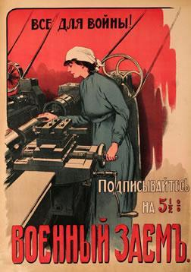

Translation: “Everything for the War! – Subscribe to the 5 1/2% War Loan”.
Bibliography: World War I Propaganda (2011). Russian Propaganda During WW1. Retrieved at 20.06.2017 form https://worldwaripropaganda.wordpress.com/2011/01/24/russian-propaganda-during-wwi/
The source I am going to consider is Russian propaganda poster of the period of World War I. The origin of the source is a poster made between 1914-1918. Its purpose was to convince Russian society to subscribe war loans and shape people’s world view. A value of this document is that it shows how the propaganda during WW1 was used to influence people’s minds. On the other hand, it doesn’t present actual political and social situation of the country and current time.
This document is valuable because it presents by what means did Russian government manipulated the society to achieve certain goals. The poster depicts the worker machining a cannon bore for the war effort. By significant worlds ” Everything for the War! – Subscribe to the 5 1/2% War Loan” the intender of this piece of propaganda wants to persuade Russian society that war is now the most important thing and they should even sacrifice their goods for war aims. This primary source gives insight to governmental point of view and shows how they shape people’s philosophy. From that source historians can conclude that main means of Russian propaganda during WW1 were slogans and pictures.
However, all values of this source are at the same time its biggest limitations because the poster is a part of governmental propaganda and it doesn’t present actual or real situation. Presented poster was made to persuade people and influence their minds. Tone, language and expressions which were applied here were used only to cause certain effect and improve Russian situation during the war. The source does not present either public opinion or actual state of affairs.

Resource 8

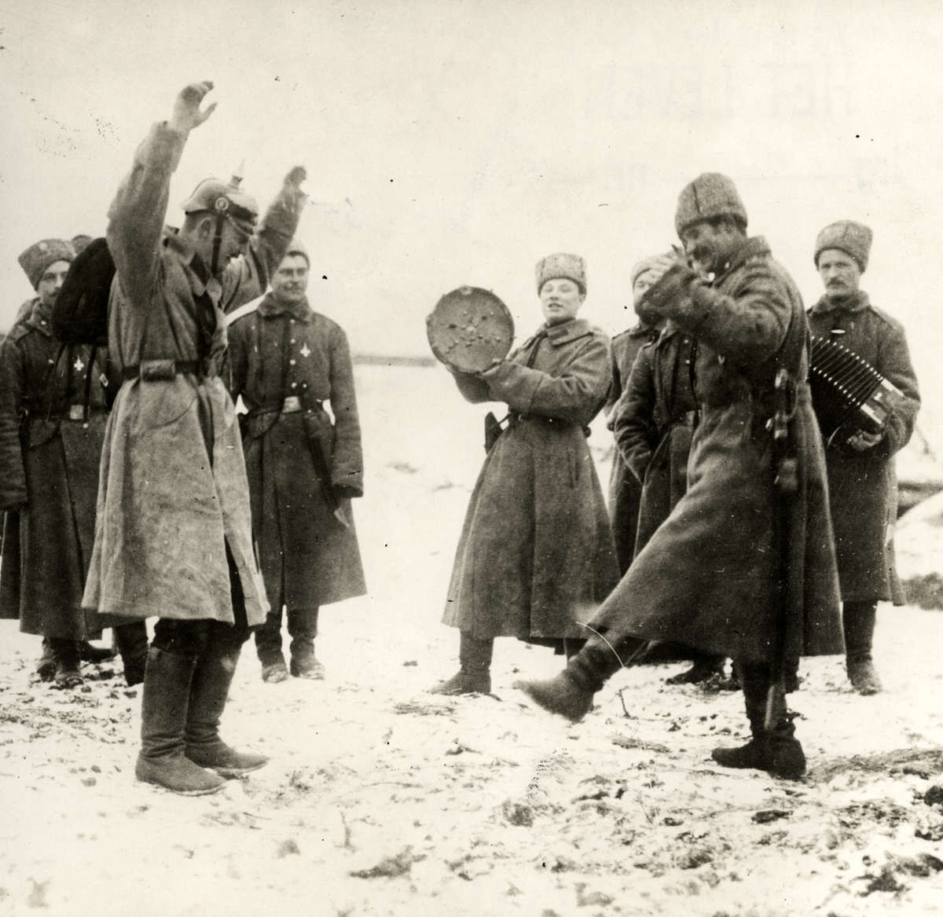

Analysis of the History Source
The picture was taken by an anonymous Russian photographer in 1915, with the precise date and place remaining unknown. Photograph depicts a group of Russian soldiers dancing and playing instruments and the main purpose of it being taken was most probably as a embracer. The picture serves as a contrast to any war picture, which shows the soldiers during fights of just after them. On those, they seem terrified and mentally exhausted while on this one, they look relaxed and playful. The soldiers portrayed on a photograph are very likely not to have had experienced any horrifies of war yet. The limitation of the sources is that neither its precise purpose, nor date and place where was it taken are known and almost all of its content can by based only on speculations. However, it still serves a great value for a historian trying to learn more about Russia during World War 1 as it depicts typical clothing for Russian soldiers and their way of spending free time. When it comes to moral values, as an loose interpretation, I think it shows the change in the perception of war in the eyes of its participants.

