Art Trip to Museum

Max Backman
His movement is New Objectivity, this can be seen in a lot of his artworks, such as the one below. Much of his artwork was influenced by his traumatic experiences of World War One. This can be seen in his artworks such as The Night (1918-1919) after first world war ended. New Objectivity is a movement in German art which arose in 1915-1920 as a reaction against expressionism, it offered a return to unsentimental reality and a focus on the objective world, as opposed to the more abstract, romantic, or idealistic tendencies of Expressionism.

Arthur Segal
Romanian artist who moved to berlin, and afterwards to Switzerland due to ww1. He was heavily influenced by impressionism and neo-impressionism. Most of his artwork used bright colors combined with dark shading and a lot of highlighting. However, during the war, he started painting in darker colors, just like in the artwork below. Most of his art was impressionism. Impressionism can be considered the first distinctly modern movement in painting. Developing in Paris in the 1860s, its influence spread throughout Europe and eventually the United States.
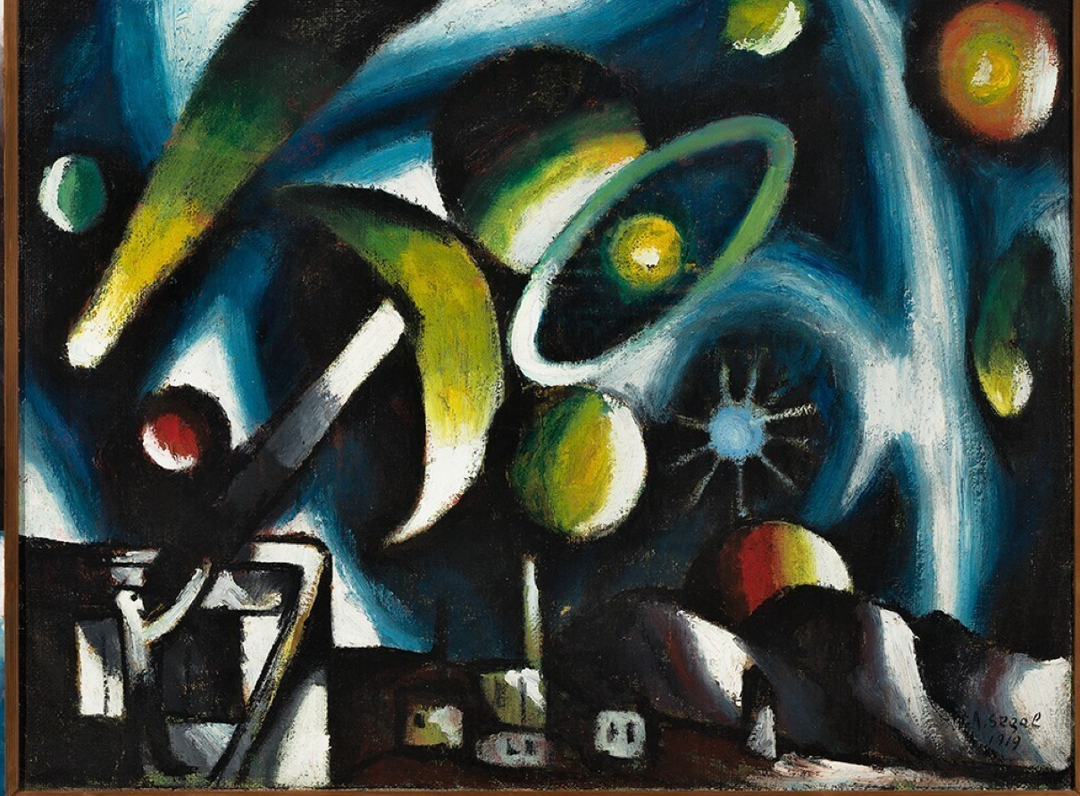

Franz Marc
He was one of the key figures of German expressionism movement. With the outbreak of WW1 in 1914, Marc was drafted into the German Army as a cavalryman. Most of his artwork is natured based, such as the painting Blue Horses, he used bright primary colors in his work which date back from 1910 to 1914. Some of his following work became a bit darker, and some even expressed violence such as the painting Fighting Forms. Expressionism began in 20th century in Germany, Expressionist artists sought to express the meaning of emotional experience rather than physical reality. Expressionism was developed as an avant-garde style before the First World War.

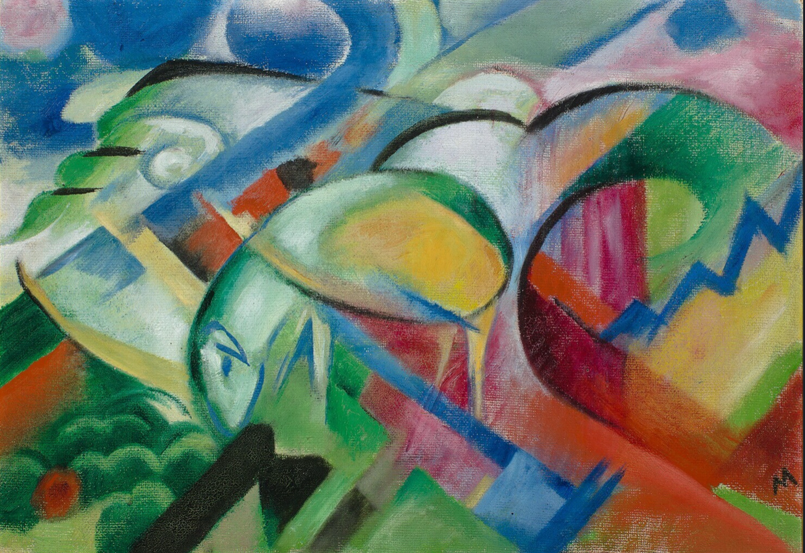
(Das Schaf) Fighting Forms

