ERASMUS + KA 219 Energy For Life

Benefit of water in Frontenac (France)

2nd and 3rd Grades

Geography:
- what are the main benefits out of water in our region?
- What does water represent as a benefit?
- Some elements of geology
- Natural qualities of the soil and sub-soil as well as good means of transport

Curricular aspects:
- Observe and describe your environment
- Get some scientific information to confirm hypothesis
- Learn specific vocabulary
- Analyze consequences on human activity

Planification of the tasks

step | N° of lessons | observations
- Explore the surroundings and describe the different aspects of water around. | 2 | At first a visit in the village was made by 2nd graders.  Then some researches started.
- Build a kind of encyclopedic knowledge on some aspects after the visit around. (books, dictionaries, encyclopedia, internet…) | 2 | A great curiosity among pupils about the traces we found in some rocks (fossils).  Some aspects of the link between the culture of vineyards and the presence of water and the quality of the soil were hardly studied. (too difficult)
- Visit of two classes to the main river, Garonne. | 1 | Understand how water allowed transport of goods and justified most of past settlements.
 | 1 | A presentation of the visit was designed by pupils through posters (mostly) and a short video. It was presented to families in the last days of June.

- What the surroundings revealed to pupils.
We mostly explored the natural cliff where we practice climbing, looking for fossils.

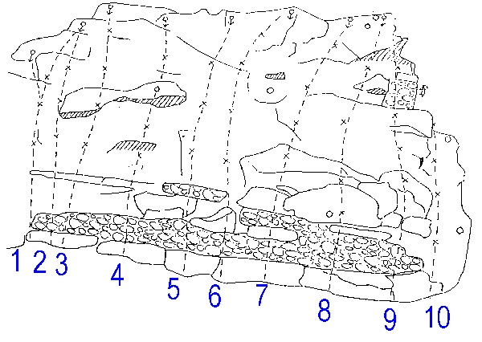
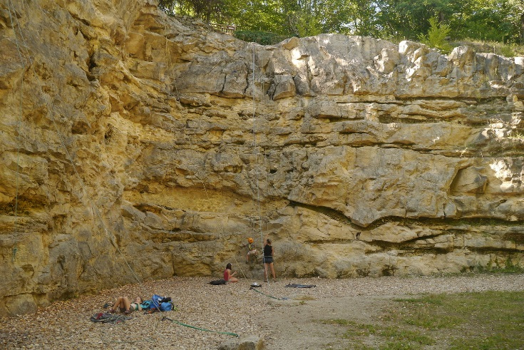

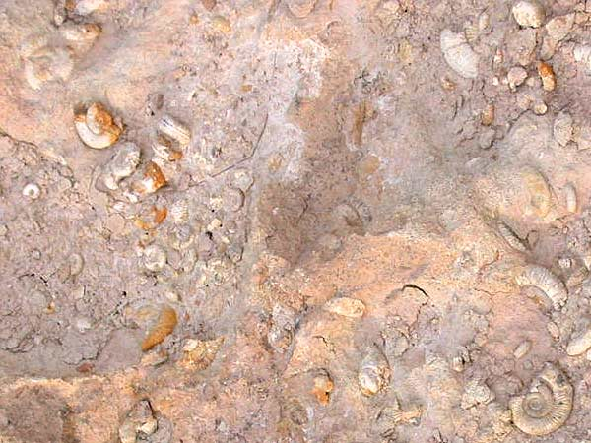
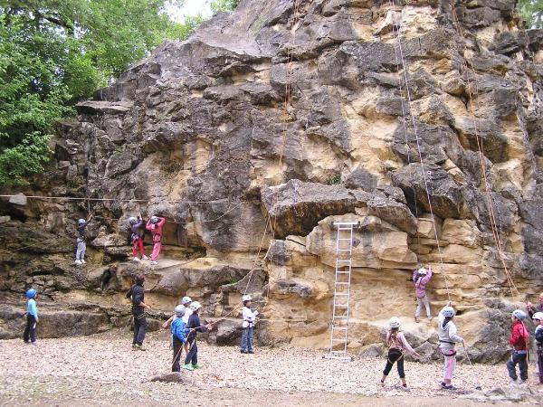

- Some ammonites were found and needed to be justified and explained.

Most of information was too complicated for young pupils and they mostly got some examples of typical landscapes in Gironde where some traces of ancient sea could be found as in Frontenac.
A special point was the name of our region “Entre-Deux-Mers” and lead us to the relationship of water with vineyards.
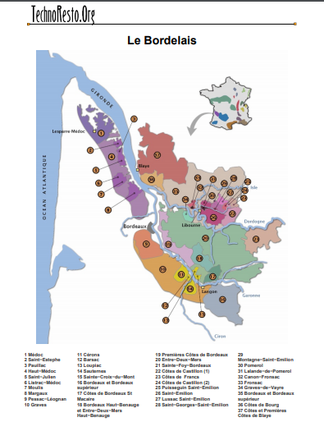
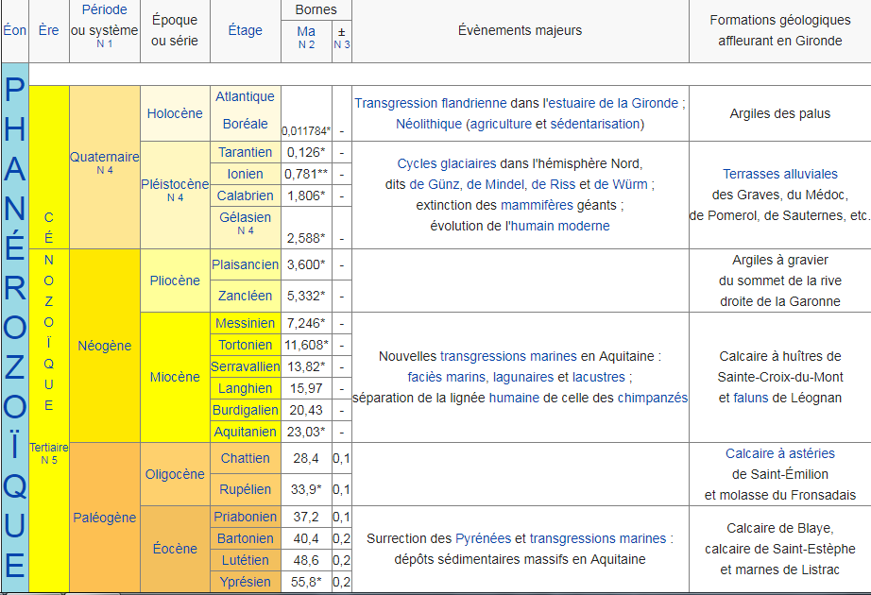
- Mid-June and the visit to Couthures-Sur-Garonne and an association which explains the role of the river in the economy and the aspect of our region. Pupils could attend workshops and have a boat trip to discover the river.

