ERASMUS + KA 219 Energy For Life

Danger of the subsoil in Frontenac (France)

1st 2nd and 3rd Grades

Geography: identify the characteristics of the surroundings
Sciences: geology (a first approach of)

Curricular aspects:
- Observe and describe your environment
- Represent it
- Learn some specific vocabulary
- Know some characteristics of different landscapes

Planification of the tasks

step | N° of lessons | observations
- Identifiy the problem and explain it. | 1 | The subsoil was described by the mayor as the main danger in our school after our investigation on floods.
- Survey among families on the danger of subsoil.
- Get documents on the subject and analyze them. | 2 | Work is shared between classes (2nd and 3rd grades)
- Presentation of a simple synthesis. | 1 | Information must be understood by 1st graders.
- Gathering of the 3 classes to evaluate the acquired knowledge on the subject. | 1

- Posters were the starting-points of discussions among pupils
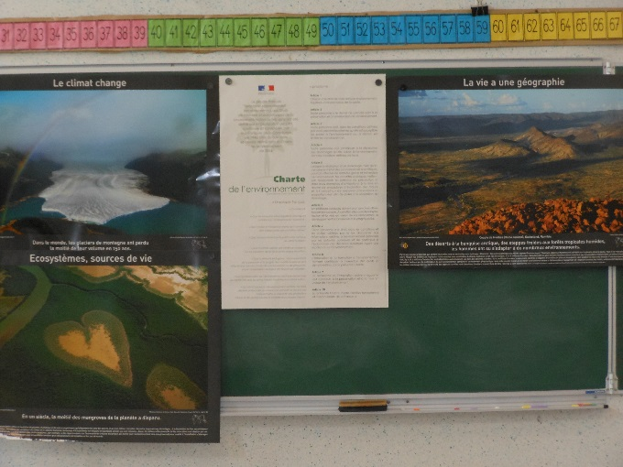
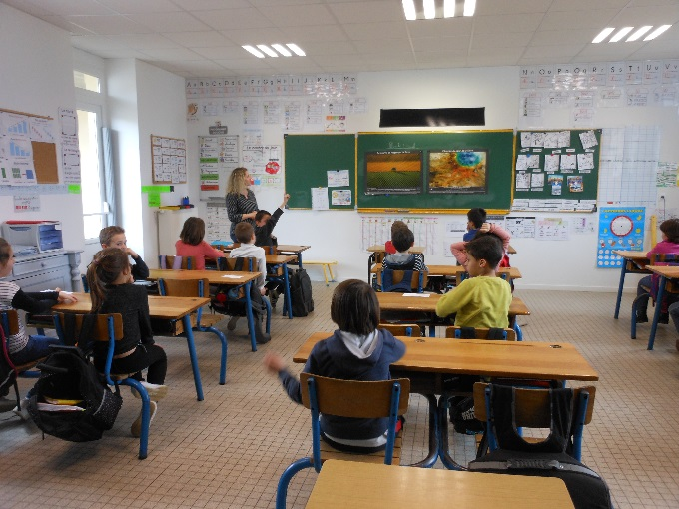

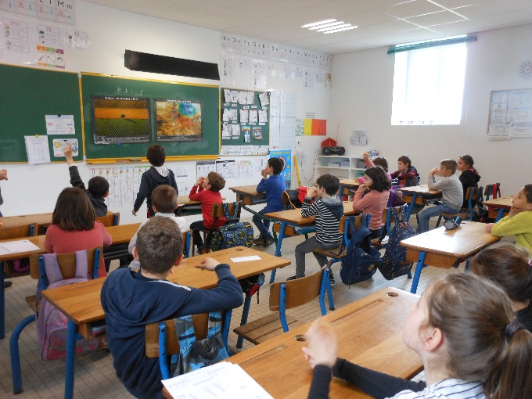
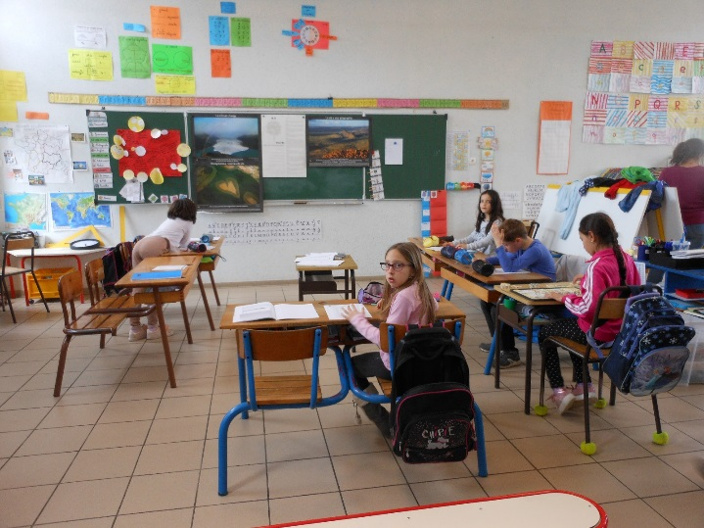

- Survey among families : some told stories they heard when they were children, most of the families who answered told us about quarries and one sent pictures of vineyards. Pupils investigated on that basis.

A PowerPoint presentation was then prepared by 3rd graders.

- The first information was about quarries that are exploited in open-air now but which used to be in the subsoil in the past.
Some of them are still used to grow mushrooms now.

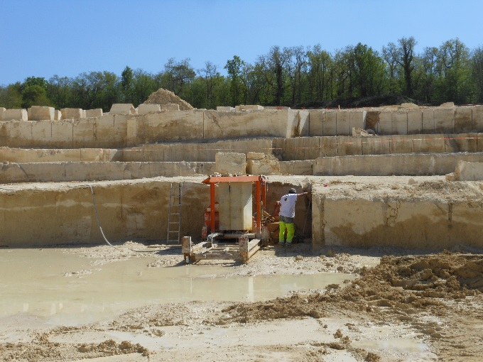
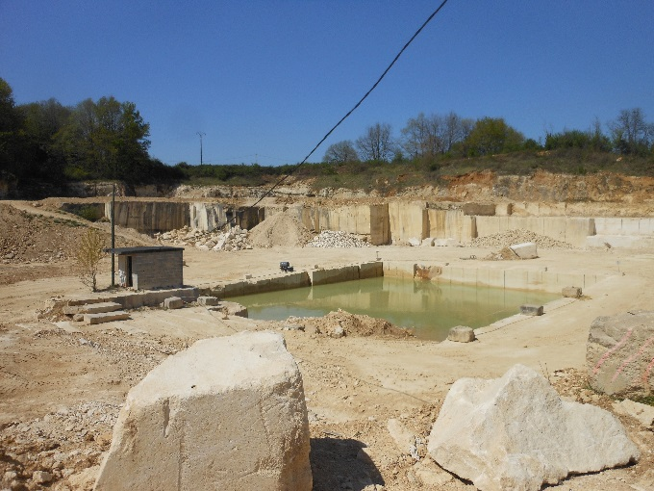

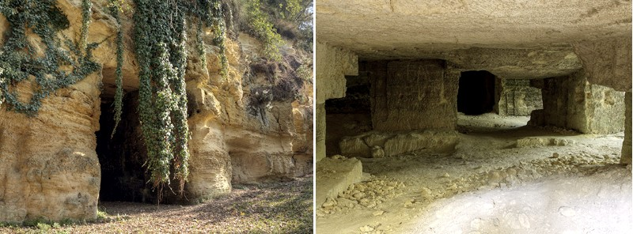

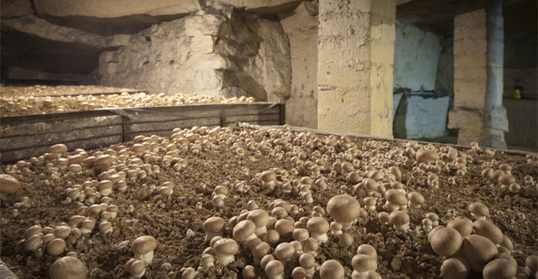

Some pictures were more spectacular when showing the collapse of the soil that is typical of our region but luckily quite rare!

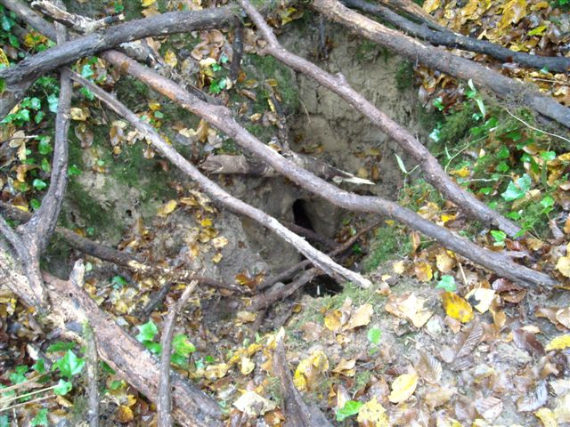
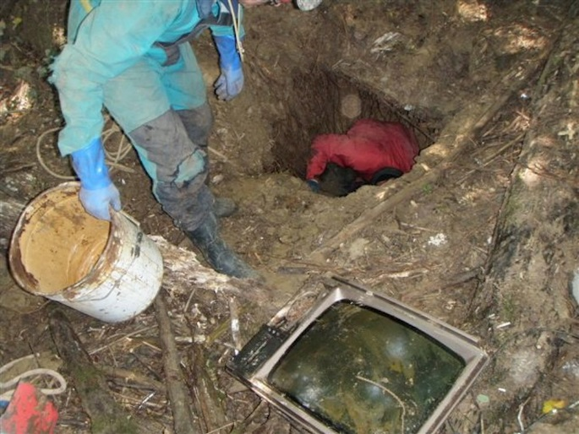
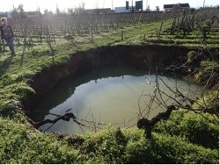

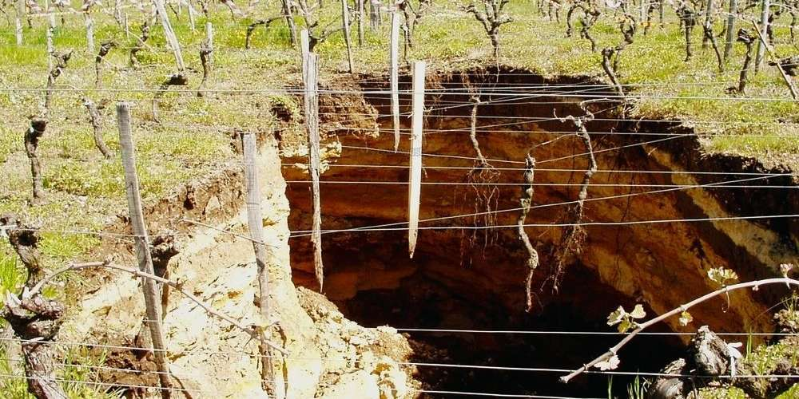

- The map of the risks helped us to realize which areas were mostly concerned.

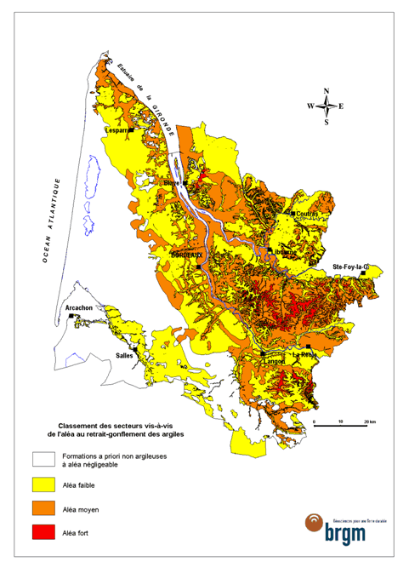

Frontenac and the surroundings

- Evaluation in each class: multiple choice questionnaires.

