MECE
MAKE EUROPE COUNT EVERYWHERE
Erasmus+ project
2017-2019

1st exchange: Ostend – Belgium
8th – 15th of November 2017

Participating schools:

-Albertus Magnus Gymnasium, Ettlingen, Germany
-Clevedon School, Clevedon, United Kingdom
-Koninklijk Atheneum Centrum, Ostend, Belgium

MECE
MAKE EUROPE COUNT EVERYWHERE
2017-2019

who – what - where – when?

THURSDAY – 9th of November 2017

-08.25 – 12.00: where? in the ‘grote studie’ (large study-room on the first floor)
what? 08.25 – 10.05: * gathering
* welcome
* introduction of the program
* getting to know each other
* guided tour Koninklijk Atheneum Centrum
10.05 – 10.20: coffee break
10.20 – 12.00: presentations students

-12.00 – 13.10: where? in the ‘grote studie’ (large study-room)
what? lunch break (sandwiches provided by Koninklijk Atheneum Centrum)

-13.10 – 16.45: where? B1 (OLC) + B3 (PCroom)
what? 13.10 – 14.50: * dividing of the students into groups: see list of departments
* enhancing the e-twinningplatform MECE, how to make an account
14.50 – 15.05: coffee break
15.05 – 15.55/16.45: About making the Twinningvilles Magazine:
some principles about journalism: texts and images/graphics
forming pools of journalists TwinningVilles Magazine

Evening: free evening for the students with the hosting family
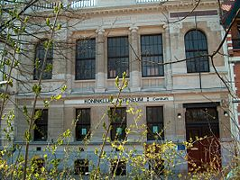
free evening for the staff

FRIDAY – 10th of November 2017

-08.25 – 12.00: where? in the ‘grote studie’ (large study-room)
what? 08.25 – 10.05: * expo logo-contest; inauguration of the designs
* lessons about European institutions
10.05 – 10.20: coffee break
10.20 – 12.00: lessons about European institutions

-12.00 – 13.10: where? in the ‘grote studie’ (large study-room)
what? lunch break (sandwiches provided by Koninklijk Atheneum Centrum)

-13.10 – 16.45: where? B1 and B3 (computerrooms, exc. B3 13.10-14.00) and large study-room: dividing in the taskgroups
what? 13.10 – 14.50: * working on the magazine; redaction teams; design, layout and editing contents; timeschedule for the rest of the project
14.50 – 15.05: coffee break
15.05 – 15.55/16.45:
* city-exploration of Ostend (students)
* meeting (teachers)

Evening: free evening for the students with the hosting family
dinner for the staff only at Apero Fish Palace offered by Koninklijk Atheneum Ostend a typical Ostend restaurant/brasserie at 18.30 http://www.apero-fish-palace.be/

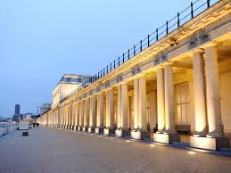
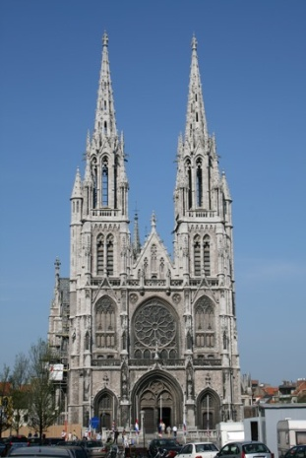
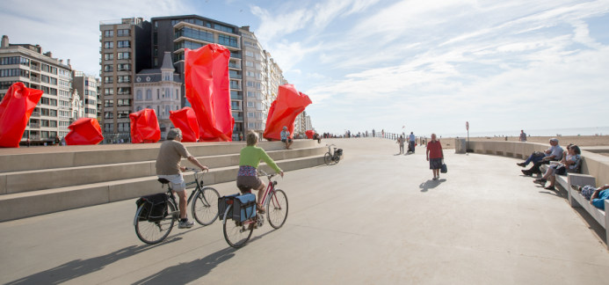

SATURDAY – 11th of November 2017

MIDDELKERKE - Day of Peace

-08.30: luxurious breakfast in ‘Hotel Continental’, Zeedijk, Middelkerke offered by the municipality of Middelkerke in co-operation with the Province West-Vlaanderen.
-00.00-11.30: short walk on the sea-dike; pageant of commemoration
-11.30-12.30: reception offered by the municipality of Middelkerke

-12.30-14.00: lunch (lunch brought from home) in ‘De Ril’; drinks offered by the Twinning Committee

-14.00-16.00: ‘billenkar’-circuit along cartoon-locations in Middelkerke
-16.00-17.00: reception at the town-hall of Middelkerke with testimonies and old photographs provided by the Twinning Committee; journalist teams in action to cover Middelkerke.

Evening: free evening for the students with the hosting family
free evening for the staff
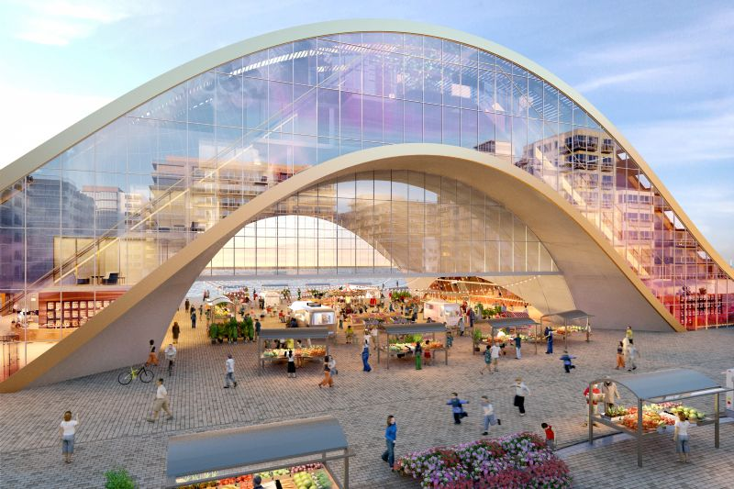
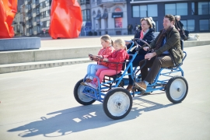

SUNDAY – 12th of November 2017

Free day for the students with the hosting family.
Excursion for the teachers in the afternoon & dinner (to be concretised: Ostend ,,The Raft. Art is (not) Lonely’’ or Flanders’ Fields (Ypres Salient) or…)

MONDAY – 13th of November 2017

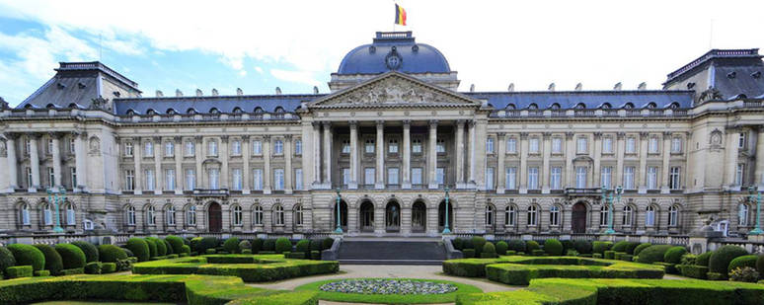

BRUSSELS – capital of Europe

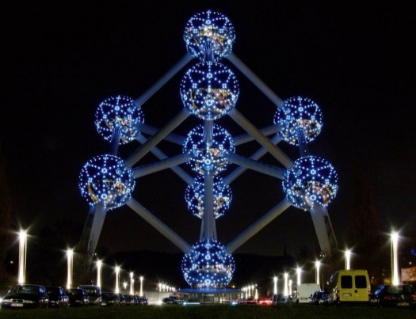
-8.25: departure by bus at school
-10.45-12.30: the European Parliament: visit of the Hemisphere
-12.30-13.00: lunch
-13.00-14.00: The House of European History (audioguide)

-14.00-16.00: visit of the city of Brussels in smaller subgroups: in the search of ,,Manneken Pis’’.
-16.00: departure by bus
-17.30: estimated arrival at school

Evening: free evening for the students with the hosting family
free evening for the staff
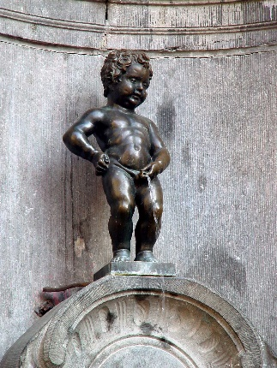
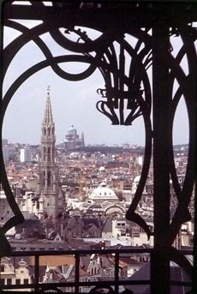
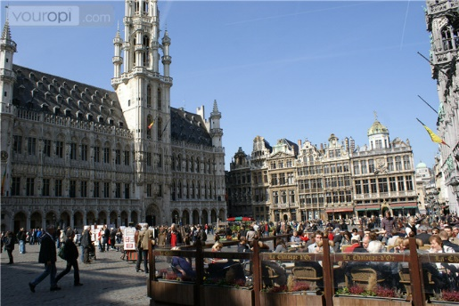
TUESDAY – 14th of November 2017

BRUGES - UNESCO world heritage

-8.30: railwaystation Ostend– departure train at 8.40
-9.00-10.00: first part of the guided walk (divided in two subgroups)
-10.00-10.45: Bruges, seen from the canals (boat trip)
-10.45-12.00: second part of the guided walk (divided in two subgroups)

-12.00-15.45: lunch and free time for shopping, reunion at the station of Bruges
-16.04: railwaystation – departure train back to Ostend
-16:19: estimated arrival in Ostend

-19.00-23.00: farewell dinner at Koninklijk Atheneum Centrum with students, parents, officials and staff.
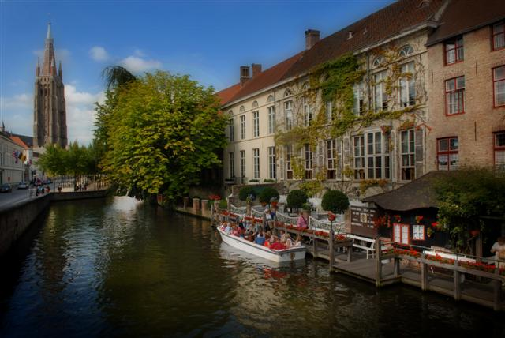
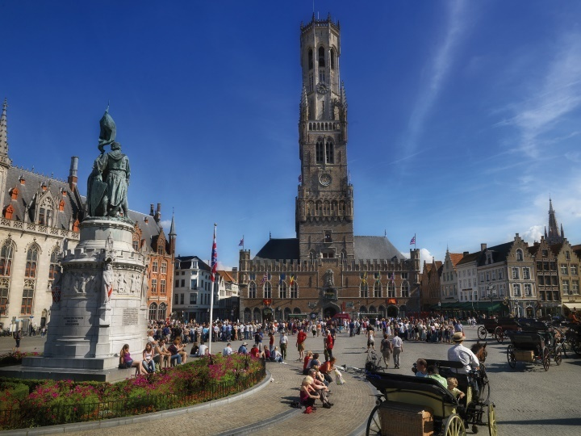

WEDNESDAY – 15th of November 2017

-08.40: Railway station Ostend departure of the German delegation
-hour to be fixed: departure of the English delegation (3pm, departure Eurostar from Brussels Midi)

