Feijoada (Beans Stew)
500 g red beans
400 g pork ribs
100 g bacon
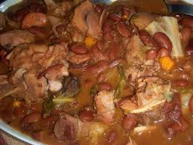
1 pork foot
1 pork ear
1 blood sausage
1 chorizo
1 cabbage
1 onion
3 cloves of garlic
4 tomatoes
0,5 dl tomato pulp
1 dl olive oil
1 bay leaf
Salt and pepper

Cooking Method:
- To prepare this “feijoada” recipe, choose the beans and put it to soak in water from one day to the next. Arrange the pork ribs, the bacon, the pork foot and ear and season it with salt and leave it overnight in the fridge.

- On the day, bring the beans to boil in salty water and with 2 tablespoons olive oil and bay leaves, set aside. Pass the meat over water and boil it along with the chorizo. As the meat is cooked, remove from the water and cut into small pieces. Finally, separate the cabbage leaves, wash them and boil them in salty water. Remove them and place them in cold water.

- Peel and wash onion and garlic and chop them finely. Wash and “concassé” the tomatoes, remove the skin and cut them into cubes. In a saucepan, heat the rest of the olive oil, add the onion and the garlic, and cook until the onion is transparent. Then add the tomato and the tomato pulp and let it cook.

- Add the cooked meats, the beans and some of the broth where the ingredients were cooked and let it cook a little. Then add the cabbage and the chorizo, let it rinse, season to taste, remove from heat and serve with white rice.

