Hello it’s Chloé, I will talk about what I usually eat, my favorite food and what I don’t like or hate.
I’m crazy about Tex-Mex food like fajitas, tacos or chili con carne but I love Asian food too, like sushi and shrimp fritter. I love fruits especially watermelon or persimmon but I don’t really like meat but I sometimes eat it like in chili con carne for example. I think the dish I hate the most is paella or seafood. In everyday life I eat dishes composed of pasta or rice or potatoes with vegetable like carrots or spinach and sometimes eat meat like chicken or steak. And for the dessert I love panna cotta or religieuse (a typical French pastry).
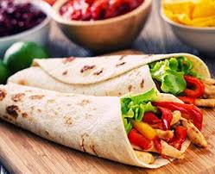

Religieuse Fajitas

