Sweet Rice
Ingredients:
- 1 large cup “carolino rice”
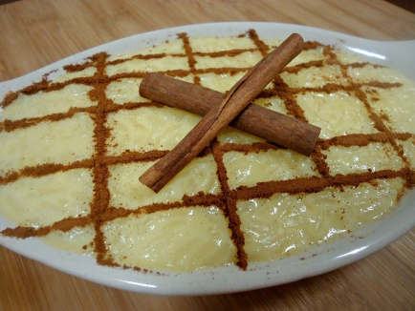
- 1 + 1/2 large hot water
- 3/4 cup sugar
- 2 lemon zest
- 1 stick of cinnamon
- 2 + 1/2 cup of warm milk
- 1 tablespoon vegetable margarine
- Cinnamon
- Pinch of salt
Preparation:
- Wash and bake the rice in hot water, add a pinch of salt. Let the rice completely absorb all the water, if the rice is still not cooked, add a little more hot water, and let it always cook on a low heat.
- Add the sugar, lemon zest, cinnamon, milk and vegetable butter to the pot and stir well until all ingredients are completely incorporated.
- Continue to stir constantly for another 6 to 8 minutes, finish as soon as it begins to thicken.
- Separate the yolks and mix them a little. Remove 1 to 2 tablespoons of the rice from the pan and add the egg yolks stirring quickly.
- Remove the lemon zest and cinnamon. Pour the egg yolks into the pan and stir for another 2 to 3 minutes.
- Garnish with ground cinnamon.

