Gizzards
Ingredients:
500 g gizzards
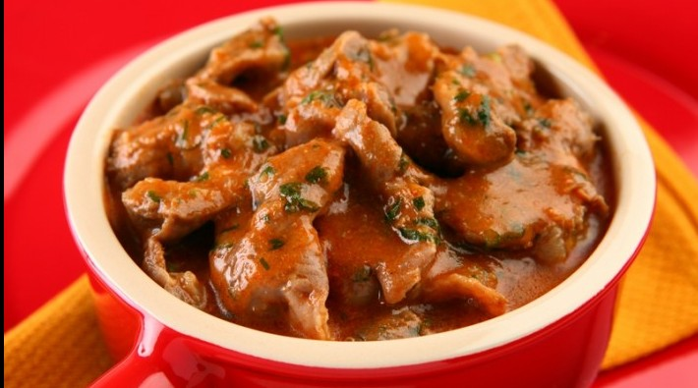
White wine
Beer
2 onions
2 Bay leaves
Tomato paste
Olive oil
Salt
Hot sauce

Preparation:
The gizzards are thoroughly washed and cut into small pieces. In a frying pan, sauté the onion and add some water, wine and beer.
Then the cut gizzards are added, as well as the bay leaf and the tomato paste. Season with salt and pepper to taste.
Cook until the gizzards become tender. If it is the case, correct the seasoning during the confection.

.

