MIGAS WITH PORK RIBS FRIED Á MODA ALENTEJANA

- 900 g of pork ribs cut into pieces
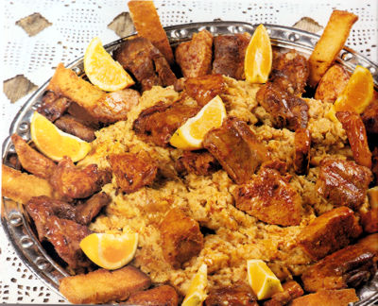
- 5 garlic cloves, crushed
- 1 tablespoon full of sweet pepper
- 100 g of lard
- 1 sliced ​​sausage of Alentejo meat
- 1 farinheira Alentejana cut in slices
- 500 g ​​Alentejo bread (finely sliced)
- Orange wedges
- Pich of salt

Preparation:

1. Season the pork ribs with a little salt, the crushed garlic and the sweet pepper. Mix well and let in seasoning from one day to the next.
2. In a large saucepan, light the lard and let it heat well. Fry the farinheira slices on both sides and remove to a plate. Fry the chorizo ​​slices evenly and remove with a skimmer for a dish.
3. In the remaining fat, add the chunks of garlic and the garlic. Let it fry in medium heat until the meat is well done. After the frying pork ribs, remove it to a dish and reserve the fat.
4. In an anti-sticking skillet, put the fat you reserved and let it heat up. Add the slices of bread and hot water needed to break the bread. Stir until it becomes a mush. Let it fry well until it is very dry and starst to curl like an omelet. Let it fry on both sides until it is golden crust.
Serve the crumbs with the pork ribs, the sausages and the orange slices.

