Hi it’s Laura, I will tell you about my eating habits: what I like and what I don’t like.
Firstly, I’m a vegetarian so I don’t eat meat except fish or sea food, I eat a lot of Sushi I LOVE that but it’s too expensive. When I go to Macdo or other fastfood I take a fish burger or vegetarian burger.
I like all the fruits but I particularly enjoy raspberries, but on the other hand I don’t appreciate grapefruit.

When I ate meat, I rarely ate (almost never) “raclette” but now I don’t eat it because I’m a vegetarian and it’s too fat, not healthy and because I HATE cold meat (ham...).

I love to eat sweet things like desserts for example French pastry with fruit pies,”brioche”, “Pain perdu”, crumble,....
But my favorite is the Paris Brest (look at the photo).

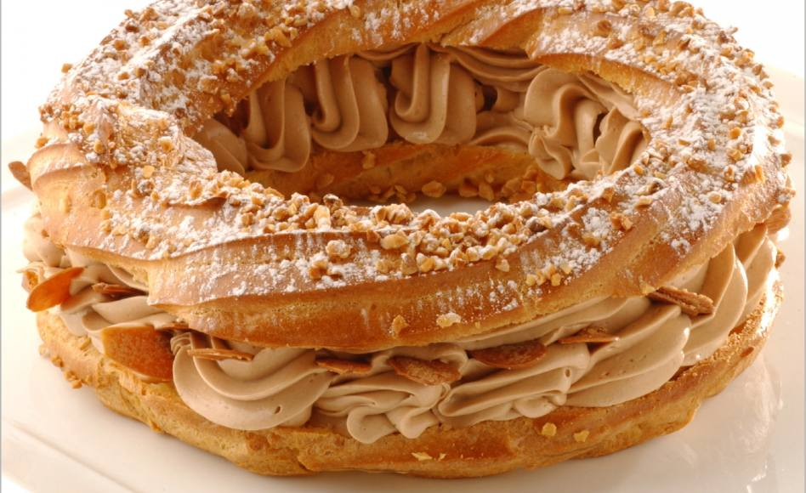
It is composed of choux pastry, creamed praline cream and almonds.

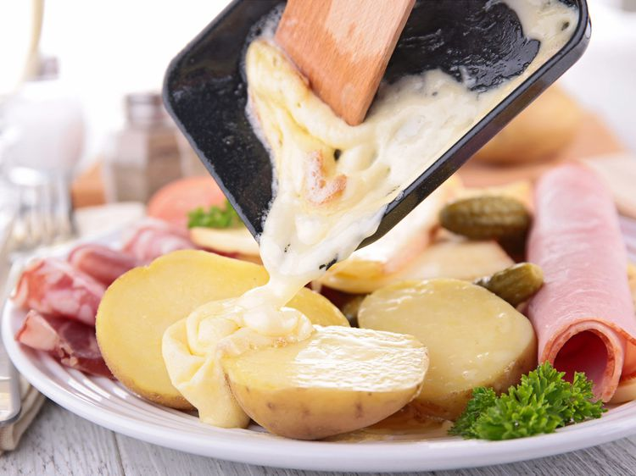
It represents the wheel of a bicylette.
RACLETTE

