My favorite starter is Piemontaise :
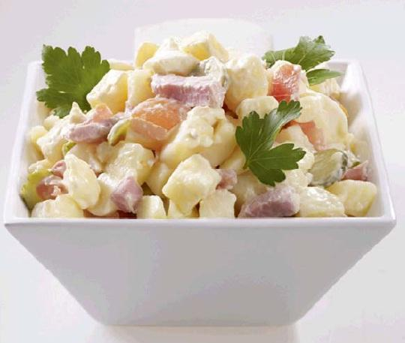
A salad composed of potatoes, mayonnaise, gherkins, ham and tomatoes

I love eating pasta with carbonara sauce:
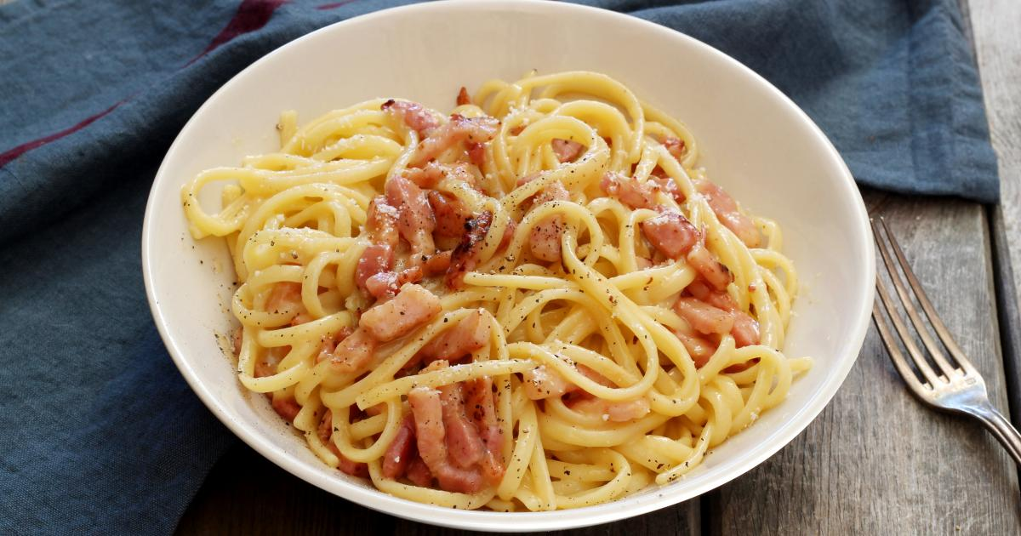

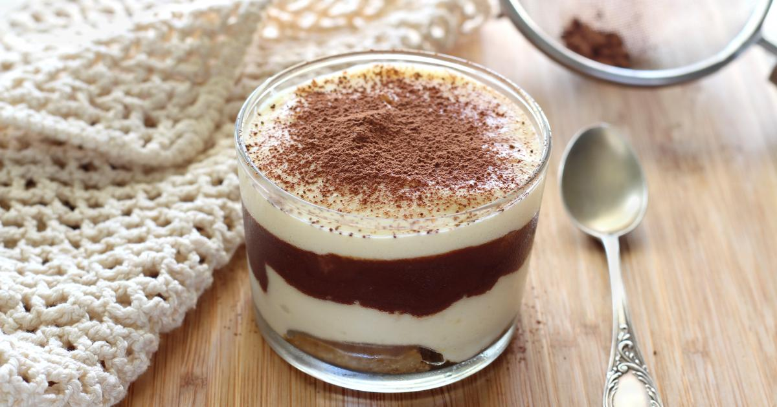
My favorite dessert is Tiramitsu :
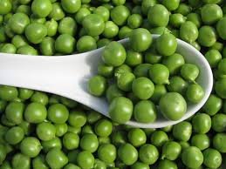
I hate peas :

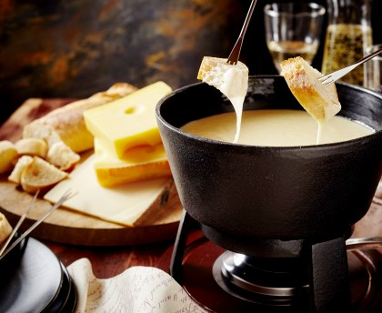
And fondue savoyarde :

A dish composed of melted cheese and bread

And baba au rhum :
