My favorite foods
My favorite foods are chili con carne, sushis, Asian food, chicken-potatoes and Brésielienne.
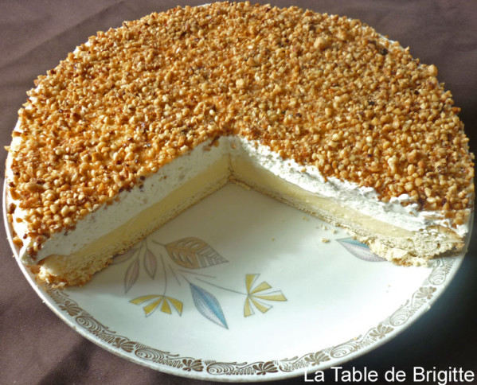
I am fond of pizza, kebab, vegetables, steak, chips and salmon.
I hate cheese and fish.
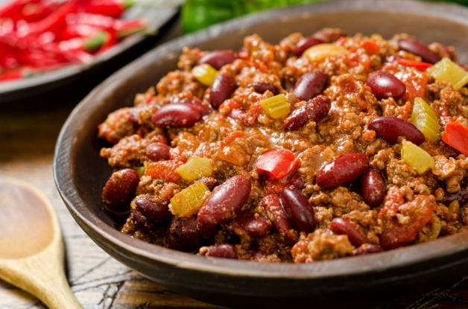

brésilienne
Chili con carne

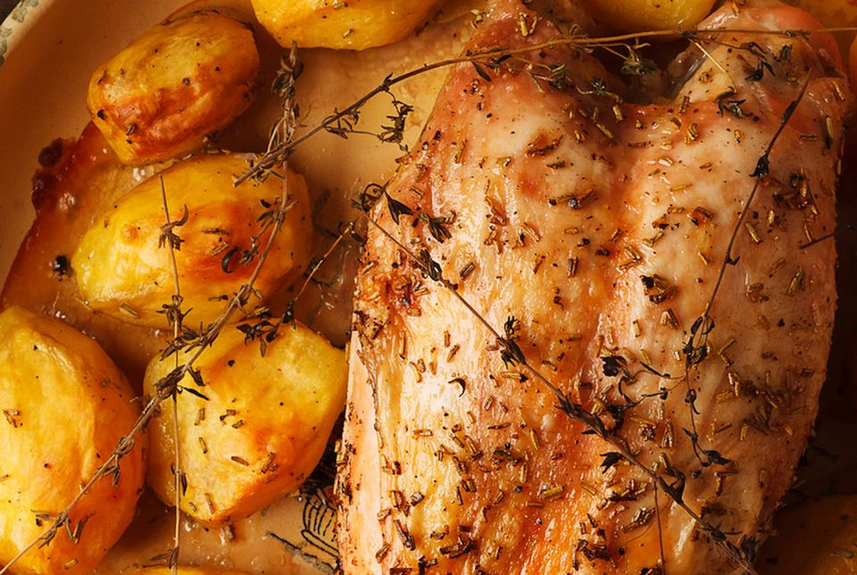
Chicken-potatoes

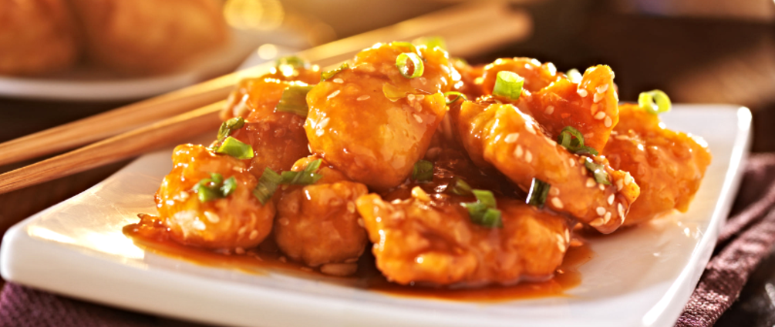

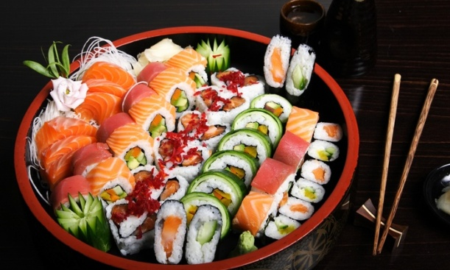
Asian food

