Feijoada (Beans stew)
500 g red beans
400 g pork ribs
100 g bacon
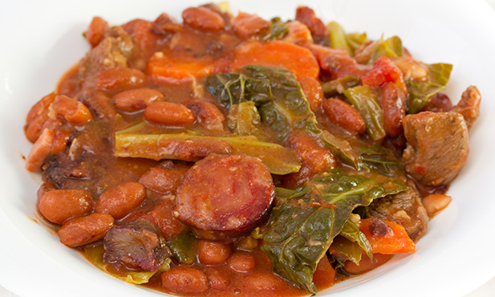
1 pork foot
1 pork ear
1 blood sausage
1 chorizo
1 cabbage
1 onion
3 cloves of garlic
4 tomatoes
0,5 dl tomato pulp
1 dl olive oil
1 bay leaf
Salt and pepper
- To prepare this “feijoada” recipe, choose the beans and put it to soak in water from one day to the next. Arrange the pork ribs, the bacon, the pork foot and ear and season it with salt and leave it overnight in the fridge.

- On the day, bring the beans to boil in salty water with 2 tablespoons olive oil and bay leaves. When cooked, set aside. Pass the meat over water and boil them along with the chorizo. As they are cooked, remove them from the water and cut them into small pieces. Finally, separate the cabbage leaves, wash them and boil them “al dente” in salty water. Remove them and place them in cold water.

- Peel and wash onion and garlic and chop finely. Wash and “concassé” the tomatoes, remove the skin and cut into cubes. In a saucepan, heat the rest of the olive oil, add the onion and the garlic, cook until the onion is transparent, then add the tomato and the tomato pulp and let it cook some more.

- Add the cooked meats, the beans and some of the broth where the ingredients were cooked and let it cook a little. Then add the cabbage and the chorizo, let it rinse, season to taste, remove from heat and serve with white rice.

