Duck Rice

Ingredients

- 1 duck (about 2 kg)
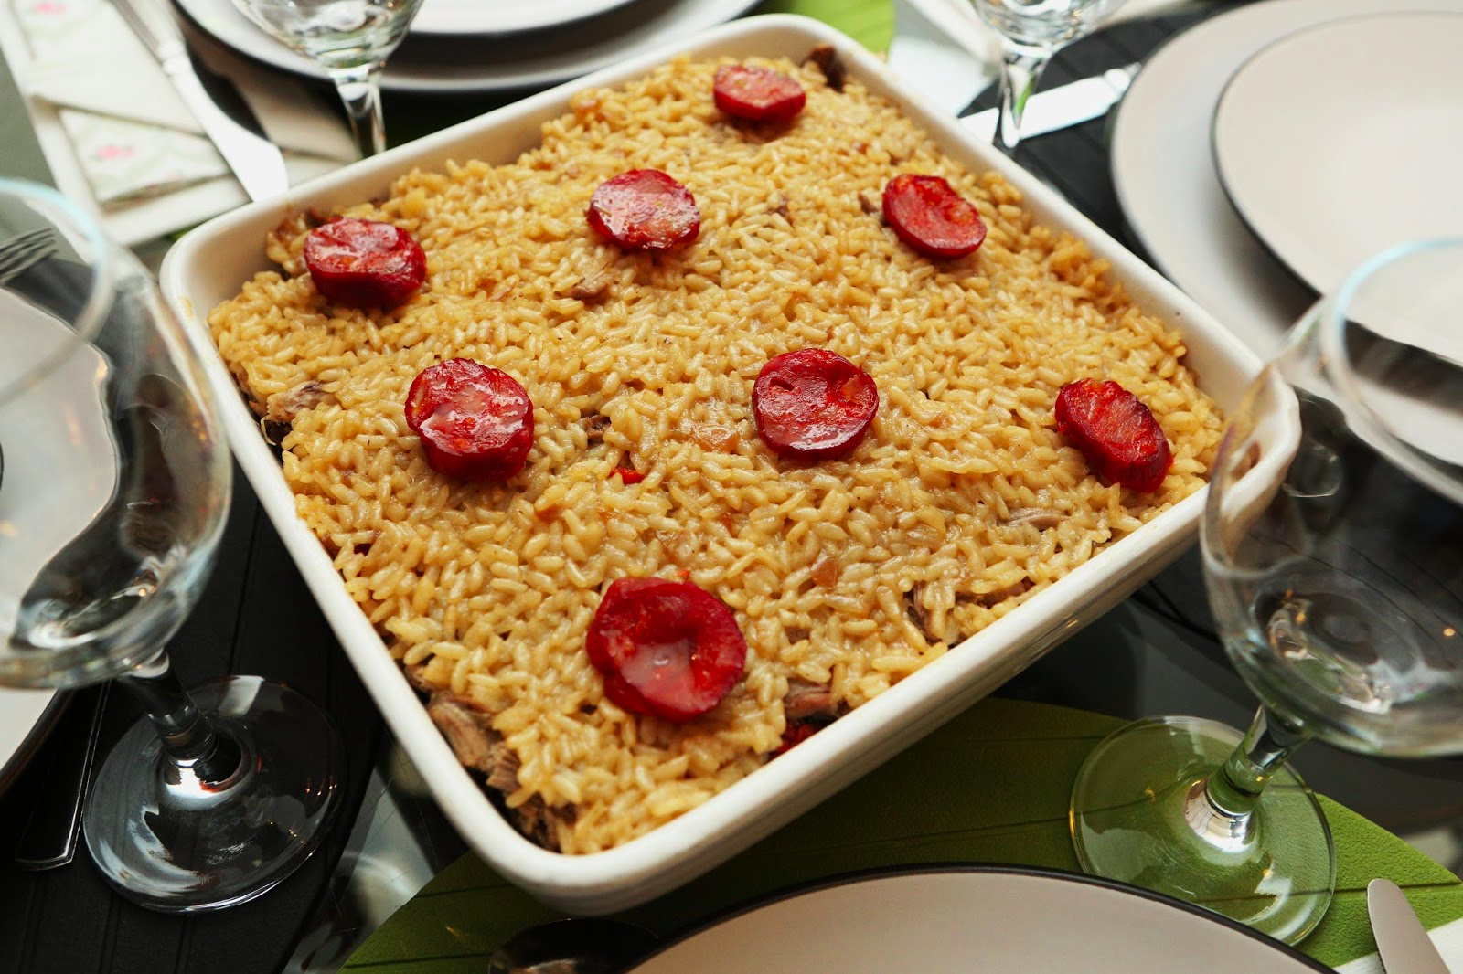
- 1/2 Portuguese chorizo
- 1 slice of ham
- 2 medium onions
- 1 clove of garlic
- 2 bay leaves
- 5 grains of black pepper
- 400 g rice
- juice of two lemons
- olive oil (to taste)
- salt (to taste)

Directions

1 - Prepare and season the duck with salt 12 hours before.

2 - Place the duck in a saucepan with 3 litters of boiling water, a peeled onion, the bay leaf and the grains of black pepper. Cook the duck about 30 minutes.

3 - Add the chorizo and ham slice. Bring to a boil over high heat. When starts boiling, reduce to medium-low heat and cook the duck for more 1 hour.

4 - When the duck is cooked, let cool slightly. Remove the skins and bones, flake it with a fork. Cut half of the chorizo in slices (for garnishing), and the rest in small pieces (cubes).

5 - Remove the top fat layer of the cooking water and reserve the water.

6 - In another saucepan, place the olive oil, one chopped onion and garlic clove, and one bay leaf. Sauté over low heat about two to three minutes.

7 - Add the rice, stir and fry it in the olive oil for about one minute. Pour the filtered lemon juice and duck cooking water (twice and a half the rice volume), stir and bring to a boil over high heat. When it starts boiling, season with ground black pepper, reduce to low heat and cook about 10 minutes.
8 - Preheat the oven to 180ºC.

9 - In a baking dish place a layer of rice, a duck layer and the chorizo cut​ in cubes, and finally, another of rice.
10 - Garnish with the remaining chorizo slices and bake for 30 minutes until golden.

11 - Remove from the oven and serve with a lettuce salad.

