Lamb Stew

Ingredients:
- Lamb in pieces
- Pinch of Salt
- Pinch of Pepper
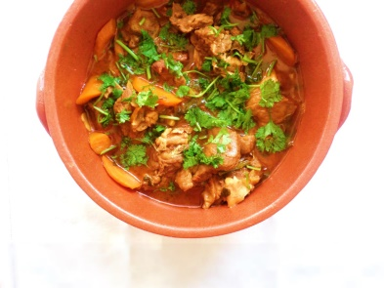
- Pinch of Flour
- Olive Oil
- 1 Onion
- 5 Garlic clove
- 1 Bay leaf
- 1 Cup of white wine
- 1 Teaspoon of paprika
- Water
- 3 Potatoes
- 2 Mint Leaves
- 1 “Alentejano” bread

1. Season the lamb with salt and pepper. Sprinkle with flour and seal in a pan with olive oil. When it has a good colour, set aside.
2. Mince 2 onions and 3 garlic cloves. Add to the pan and let it cook. Add 1 bay leaf and drizzle with white wine. Season with salt and let it cook.
3. Add the meat.
4. Sprinkle with 1 teaspoon of paprika and the remaining white wine. Cover the meat with water and let it cook for 30 min.
5. After 15 min join the potatoes and cook other 15 minutes.
6. Serve with slices of “Alentejano” bread and Mint Leaves.

