Pão de Ló de Alfeizerão – Portuguese Sponge Cake Alfeizerão Style

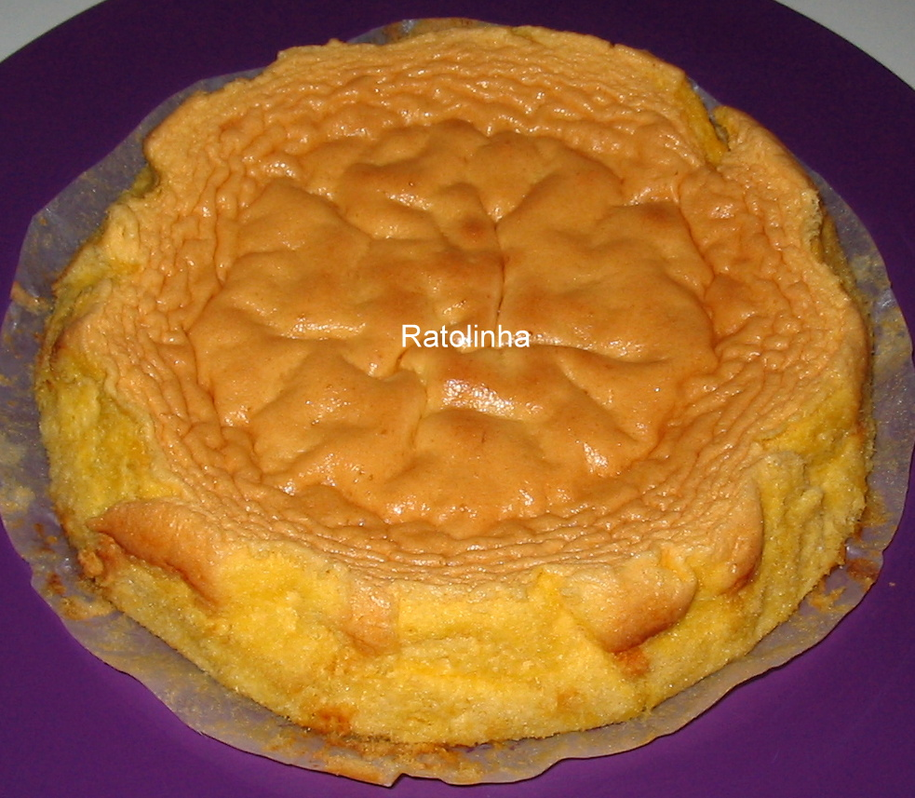
Ingredients:
4 eggs
8 egg yolks
1 and 1/4 cup granulated sugar
1 cup flour
1 teaspoon whiskey
Zest from 1/4 of 1 lemon
Butter or margarine for greasing pan

Cooking method:
Beat the eggs, egg yolks, sugar, with the lemon zest and the teaspoon of whiskey for about 10 minutes until light and fluffy and double the volume.
Fold in the flour gently until all incorporated.
Grease a cake pan very well or use and bake the cake at 320 F. for about 15-20 minutes. You may bake in a round cake pan which is lined with parchment paper.
Remove the cake slowly from the pan so it does not split open.

