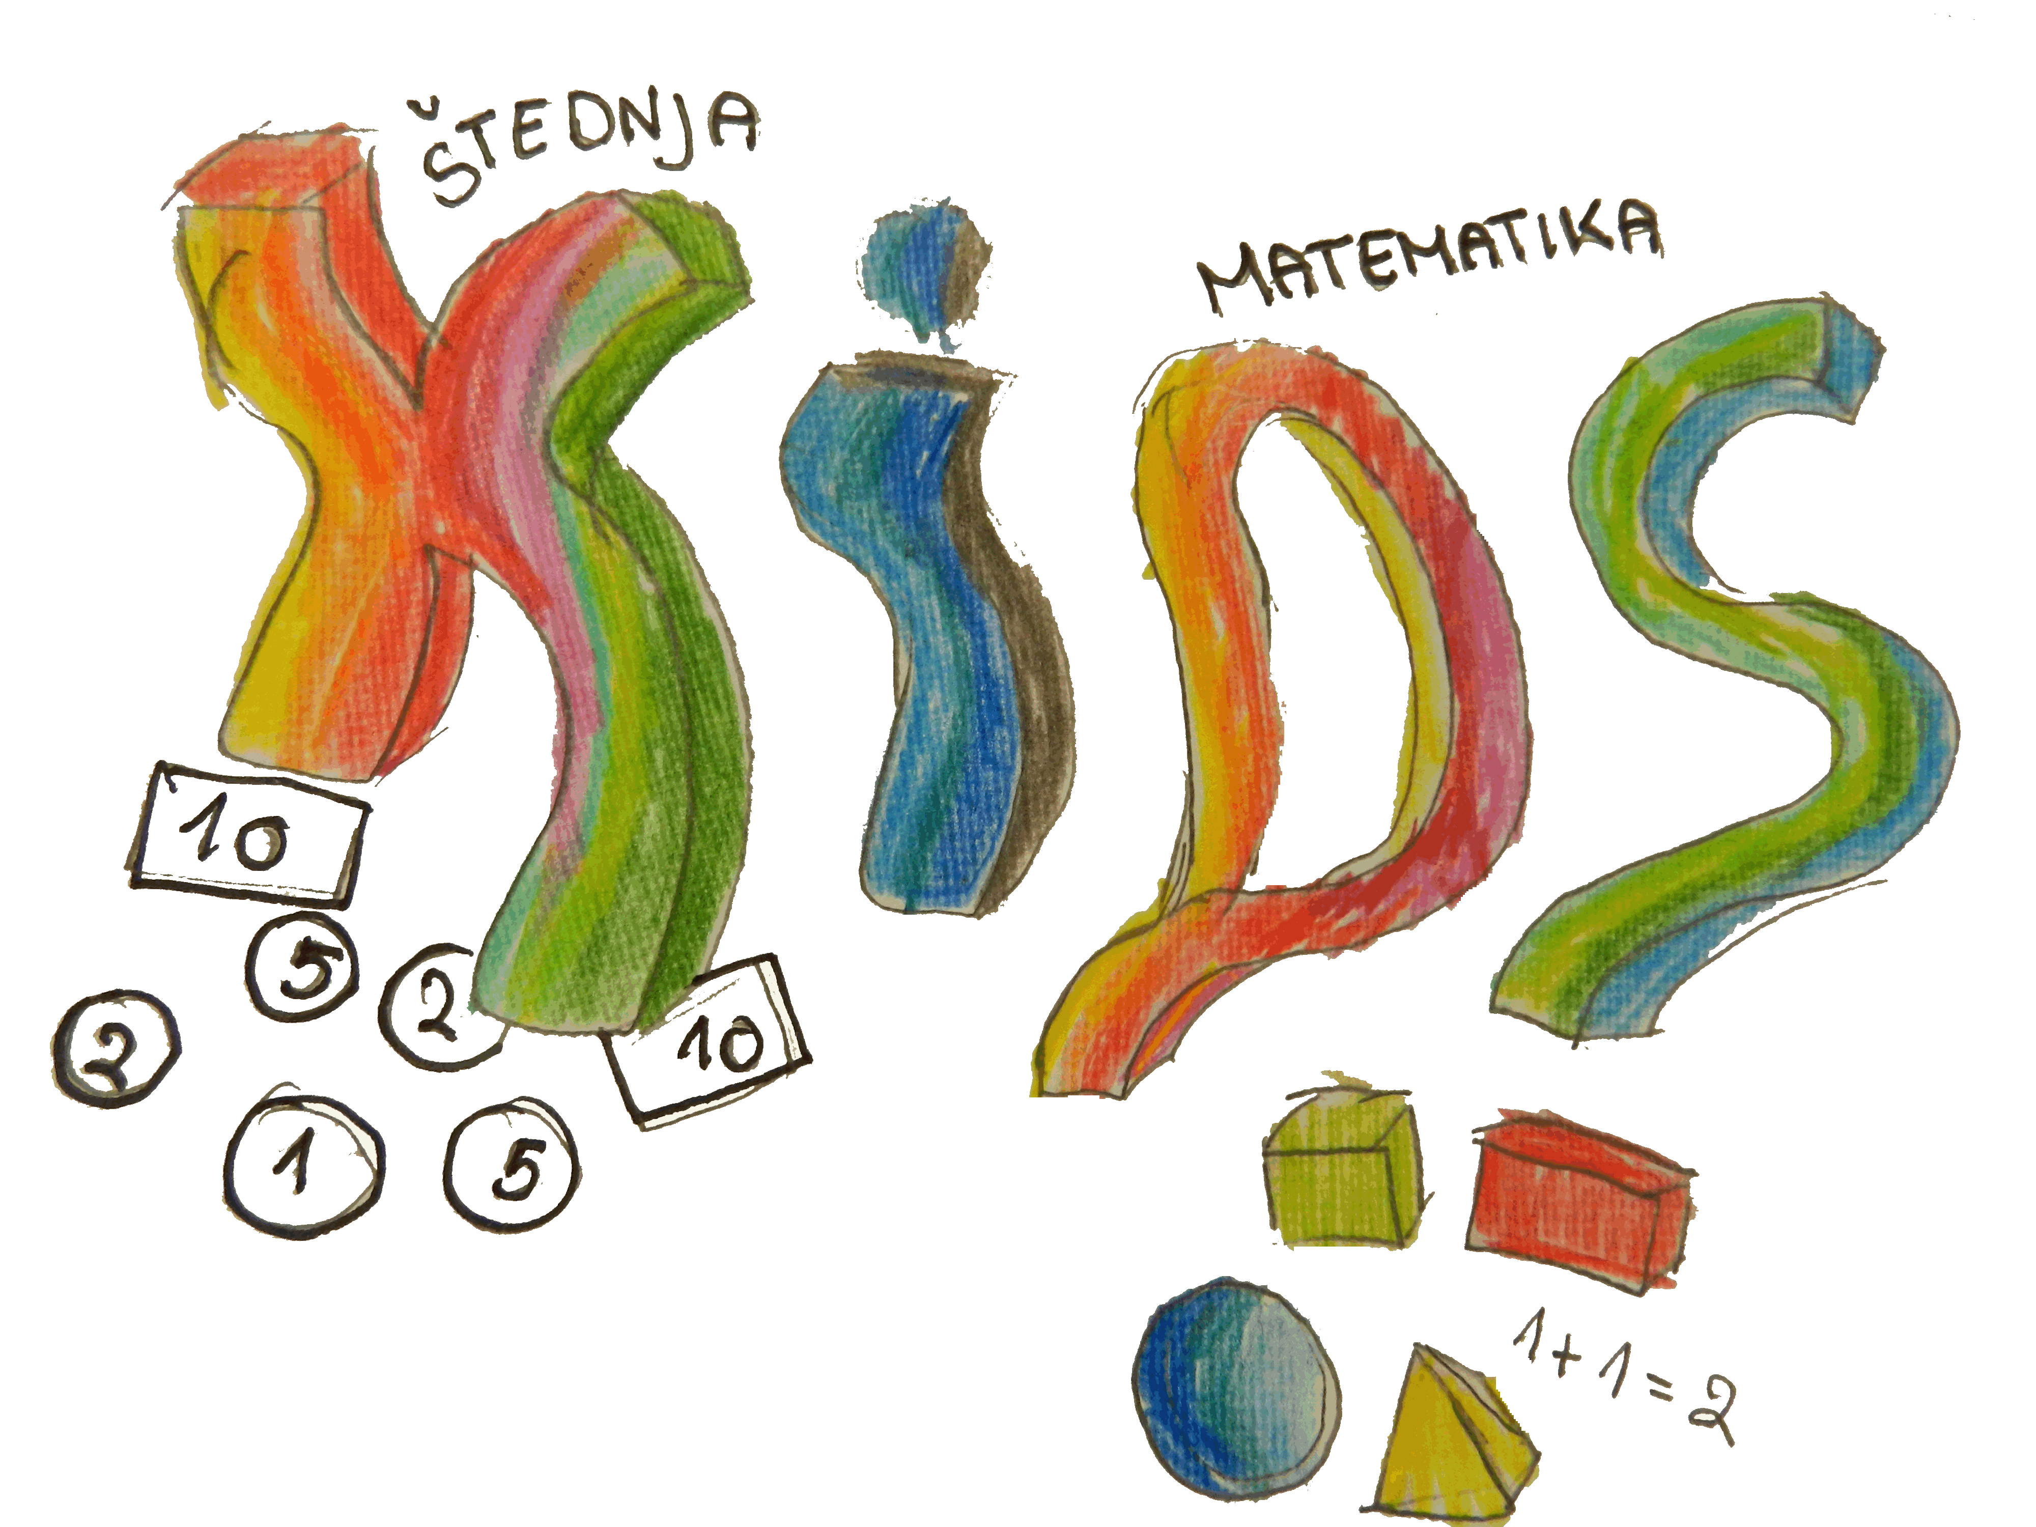

KEEP INVEST DONATE SPEND (KIDS)
WORKSHOP EVALUATION FORM
*1.Project workshop evaluation
 | Poor | Satisfactory | Good | Very good | Excellent
Workshop place

Content of workshop
Duration of workshop
Exchange of information on project content
Materials used
Whether workshop has reached its aim or not

2. Your comments and suggestions

*3. What did you like most?

*4. What did you like least?

5. What were your expectations and to what extent were your expectations met?

*6. How useful did you find this work?
Poor | Satisfactory | Good | Very good | Excellent

7. Any comments and suggestions

* Required

