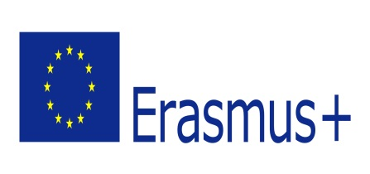

**INFORMATION PACK**

**KEEP INVEST DONATE SPEND (KIDS)**

**Key Action 2 Strategic Partnerships**

**Turkey, Croatia, Poland, Portugal, Romania**

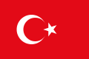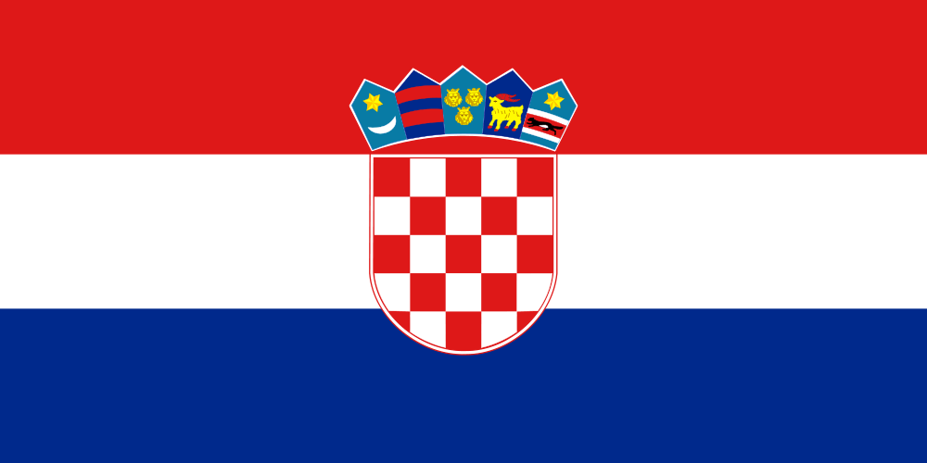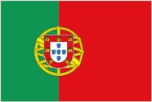

**February 11th-15th, 2015**

**Sarıkamış Kars-TURKEY**

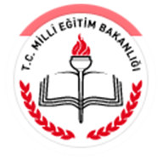

***Dear Participants,***

Soon you will take part in the kick off meeting “***Keep Invest Donate Spend*”**. Before coming over we would like to inform you about a few things. If after reading,you still have any questions, doubts or worries, please feel free to contact us.

**SUMMARY OF THE PROJECT**

Saving habit is most important part of our life. This is known as financial discipline or financial literacy. If you look at our earlier generations lifestyle, savings are very closely associated with their daily life. They had considered savings as the most important aspect of life and it helps them when they reach the old age. However, with the modern economics and globalization, young generation is forced to spend more money for their daily life and one cannot control them self if the environment itself promoting the lavish life.

Child learn from examples. If you team them something, you have to follow the process. Otherwise you will set a bad example for them, your teaching won’t be effective. If you follow what you are preaching them, they will follow you without any hesitation. It is not only for the finance, all other things they feel parents and teachers have to be an example. So our project includes not only parents education but also teachers on financial literacy.

In order to make our pupils, parents and teachers for financially literate we will organise some activities like:

-Creating a Facebook group and the website of the project

-Creating a moneybox

-Drama, hands on and class activities with parents and teachers, group games, interactive trainings

-Entrepreneurship fair

-Teaching where money comes from and different currency units

-Planting trees

-A visit to a local bank

-Sharing activities and organizing company for help

-Exchange of good practises

-Preparing pocket money diary

-Visits to supermarket, grocery, market, etc.

-Preparing the poster of the Project

-Family, teacher and pupil workshops on financial literacy

-Making a wish tree and paintings

-financial fairytales

-computer based applications, modules, virtual bank, computer games, digital quizzes, multimedia posters, memory games, videos, etc.

With all of these activities we would like to make our target groups gain good saving and spending money and sharing habits. In order to make this known by more people we will organise workshops including modules on how to be financially literate and how to teach our pupils and children to be financially literate.

**TRANSPORTATION**

**Arrival Day:** February 11th

**Departure Day:** February 15th

We will meet you at Kars Airport (the nearest) with a connecting flight in İstanbul.

**ACCOMMODATION:**

- While staying in Sarıkamış you will be accommodated in the hotel which belongs to Sarıkamış Hotel Management and Tourism Vocational High School.

- Each room has a bathroom.

- Bed-clothes are provided, so you don’t need any sleeping bags. Towels are provided as well.

- We do not suggest to drink water from taps. We will provide drinking water in the rooms.

- In the evenings, participants will have the opportunity to meet together in the lobby or outside the building.

You can have a look at the website and get more information about the school and accommodation. The hotel has just been renewed and the photos belong to previous rooms.

<http://sarikamisaotml.meb.k12.tr/>

<http://www.sarikamisturizmoteli.com/index.php/otelimiz>

**CLIMATE AND CUSTOM**

The weather in Sarıkamış is very cold and snowy as here is the coldest place in Turkey. It will be between -5 and -10 during the day. You can try skiing if you want ☺

For mosque visits it is advisable to wear suitable clothes and a scarf to cover your body and head as mosques are sacred places for Muslims.

The currency here is Turkish Lira. This means that for most of you, things

here will be cheaper than in your countries.

**HOME TASK**

**PRESENTATION OF YOUR COUNTRY, INSTITUTION**

a maximum **20 minute** presentation of your organization and country will be good in order to get to know each other and our countries.

I will send an activity table about our meeting later.

**SEE YOU SOON!**

**Yasemin ÖZDEN +90 505 6326496**