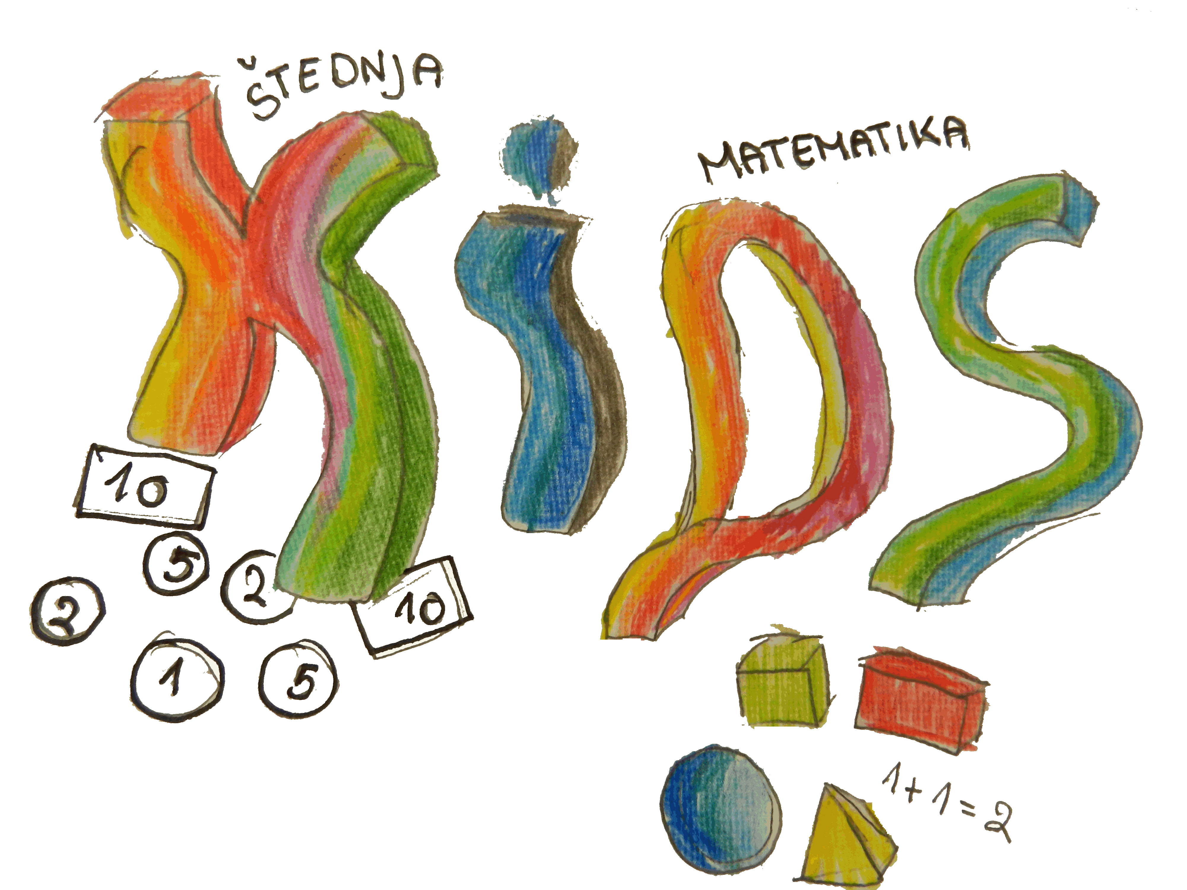
KEEP INVEST DONATE SPEND (KIDS)
PRETEST for WORKSHOP for TEACHERS

1. I have basic knowledge about planning income and expenditure.
A lot A little Not very much Not at all
2. I know income households and their origins.
A lot A little Not very much Not at all
3. I have knowledge about budget hole.
A lot A little Not very much Not at all
4. I know how to prevent the budget hole.
A lot A little Not very much Not at all
5. I know the services in a bank.
A lot A little Not very much Not at all
6. I have knowledge about capitalization.
A lot A little Not very much Not at all
7. I can make calculations about capitalization.
A lot A little Not very much Not at all
8. I know the details about credit and a loan.
A lot A little Not very much Not at all
9. I know the types of loans.
A lot A little Not very much Not at all
10. I know the difference between credit and a loan.
A lot A little Not very much Not at all
KEEP INVEST DONATE SPEND (KIDS)
POSTTEST for WORKSHOP for TEACHERS

1. I have basic knowledge about planning income and expenditure.
A lot A little Not very much Not at all
2. I know income households and their origins.
A lot A little Not very much Not at all
3. I have knowledge about budget hole.
A lot A little Not very much Not at all
4. I know how to prevent the budget hole.
A lot A little Not very much Not at all
5. I know the services in a bank.
A lot A little Not very much Not at all
6. I have knowledge about capitalization.
A lot A little Not very much Not at all
7. I can make calculations about capitalization.
A lot A little Not very much Not at all
8. I know the details about credit and a loan.
A lot A little Not very much Not at all
9. I know the types of loans.
A lot A little Not very much Not at all
10. I know the difference between credit and a loan.
A lot A little Not very much Not at all

