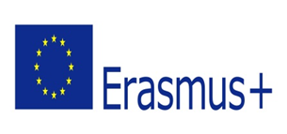
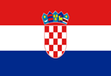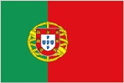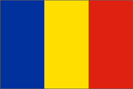
KEEP INVEST DONATE SPEND
PRETEST FOR THE ACTIVITY VISITING PAPER MONEY MUSEUM
1. I have knowledge on the history of money in my country.
A lot A little Not very much Not at all
2. I know the currencies used in Europe.
A lot A little Not very much Not at all
3. I am aware of the images on Euro banknotes.
A lot A little Not very much Not at all
4. I know some of the most emblematic characters in the world of paper money.
A lot A little Not very much Not at all
5. I can manage my own money in a healthy way.
A lot A little Not very much Not at all
6. I know the meaning and function of the word share.
A lot A little Not very much Not at all
7. I know the meaning and function of the word exchange bill.
A lot A little Not very much Not at all
8. I know the meaning and function of the word cheque.
A lot A little Not very much Not at all
9. I know the meaning and function of the word emergency money.
A lot A little Not very much Not at all
10. I know the meaning and function of the word stamped paper.
A lot A little Not very much Not at all

