The Roots of Europe

LET'S KNOW EACH OTHER WITH MUSIC

Dictionary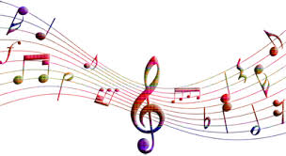

MUSIC

TURKEY 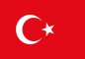 | MÜZİK
SLOVENIA 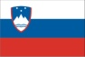 | GLASBA
ROMANIA 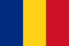 | Muzica
PORTUGAL 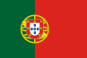 | Música
GREECE | Μουσική
POLAND | Muzyka
CZECH REPUBLIC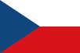 | HUDBA
SLOVAKIA 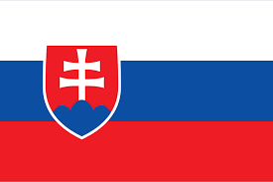 | Hudba
SPAIN 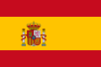 | música
ESTONIA | Muusika  Музыка

FOLK MUSIC

TURKEY | HALK MÜZİĞİ
SLOVENIA | LJUDSKA GLASBA
ROMANIA | Muzică populară
PORTUGAL | Música Folclórica
GREECE | Παραδοσιακή Μουσική
POLAND | Muzyka ludowa
CZECH REPUBLIC | Lidová hudba
SLOVAKIA | Ľudová hudba
SPAIN | Música popular
ESTONIA | Rahvamuusika  Народная музыка

OUT DOOR GAMES
TURKEY | DIŞARI OYUNLARI
SLOVENIA | IGRE ZUNAJ
ROMANIA | Jocuri în aer liber
PORTUGAL | Jogos ao ar livre
GREECE | Παιχνίδια στην αυλή
POLAND | Podwórkowe gry
CZECH REPUBLIC | Venkovní hry
SLOVAKIA | Vonkajšie hry
SPAIN | Juegos al aire libre
ESTONIA | Õuemängud  Игры на улице

SHOE

TURKEY | AYAKKABI
SLOVENIA | ČEVELJ
ROMANIA | pantof
PORTUGAL | Sapato
GREECE | Παπούτσι
POLAND | But
CZECH REPUBLIC | Bota
SLOVAKIA | Topánka
SPAIN | zapato
ESTONIA | King  Обувь

CLOTHES

TURKEY | GİYSİ
SLOVENIA | OBLEKA, OBLAČILO
ROMANIA | haine
PORTUGAL | Roupas
GREECE | Ρούχα
POLAND | Ubranie
CZECH REPUBLIC | Oblečení
SLOVAKIA | Oblečenie
SPAIN | Ropa
ESTONIA | Riided  Одежда

FOOD

TURKEY | YEMEK
SLOVENIA | HRANA
ROMANIA | mâncare
PORTUGAL | Comida
GREECE | Φαγητό
POLAND | Jedzenie
CZECH REPUBLIC | Jídlo
SLOVAKIA | Jedlo
SPAIN | Comida
ESTONIA | Toit  Еда

DESSERT

TURKEY | TATLI
SLOVENIA | POSLADEK, SLADICA
ROMANIA | desert
PORTUGAL | Sobremesa
GREECE | Γλυκό/ Επιδόρπιο
POLAND | Deser
CZECH REPUBL | DEZERT
SLOVAKIA | Dezert
SPAIN | postre
ESTONIA | Magustoit  Дессерт

Traditional Folklore
TURKEY | HALK OYUNU
SLOVENIA | TRADICIONALNA FOLKLORA
ROMANIA | Folclor tradiţional
PORTUGAL | Folclore tradicional
GREECE | Λαογραφία
POLAND | Tradycyjny folklor
CZECH REPUBLIC | Tradiční folklór
SLOVAKIA | Tradičný folklór
SPAIN | Folclore popular
ESTONIA | Traditsiooniline folkloor  Народный фольклор

DISHES

TURKEY | TABAKLAR
SLOVENIA | JEDI, HRANA
ROMANIA | Mâncăruri
PORTUGAL | Pratos
GREECE | Πιάτα
POLAND | Naczynia
CZECH REPUBLIC | Nádobí
SLOVAKIA | Riad
SPAIN | Platos
ESTONIA | Nõud  Блюда

SLIPPER

TURKEY | TERLİK
SLOVENIA | COPATI
ROMANIA | papuc
PORTUGAL | CHINELO
GREECE | Παντόφλες
POLAND | Pantofel
CZECH REPUBLIC | Trepka
SLOVAKIA | Papuča
SPAIN | Zapatilla
ESTONIA | Suss  Тапок

SKIRT

TURKEY | ETEK
SLOVENIA | KRILO
ROMANIA | Fustă
PORTUGAL | SAIA
GREECE | Φούστα
POLAND | Spódnica
CZECH REPUBLIC | Sukně
SLOVAKIA | Sukňa
SPAIN | Falda
ESTONIA | Seelik  Юбка

COUNTRY

TURKEY | ÜLKE
SLOVENIA | DRŽAVA
ROMANIA | Ţară
PORTUGAL | País
GREECE | Χώρα
POLAND | Kraj
CZECH REPUBLIC | Stát, vesnice, kraj
SLOVAKIA | ŠTÁT
SPAIN | País
ESTONIA | Riik  Страна

TRADITIONAL

TURKEY | GELENEKSEL
SLOVENIA | TRADICIONALNO
ROMANIA | Tradiţional
PORTUGAL | Tradição
GREECE | Παραδοσιακό
POLAND | Tradycyjny
CZECH REPUBLIC | Tradiční
SLOVAKIA | TRADIČNÝ
SPAIN | Tradicional
ESTONIA | Traditsiooniline  Традиция

NATIONAL

TURKEY | ULUSAL
SLOVENIA | LJUDSKO
ROMANIA | Naţional
PORTUGAL | Nacional
GREECE | Εθνικό
POLAND | Narodowy
CZECH REPUBLIC | Národní
SLOVAKIA | Národný
SPAIN | Nacional
ESTONIA | Riiklik  Национальная

INSTRUMENT

TURKEY | MÜZİK ALETİ
SLOVENIA | GLASBILO
ROMANIA | Instrument
PORTUGAL | Instrumento
GREECE | Μουσικό όργανο
POLAND | Instrument
CZECH REPUBLIC | Nástroj
SLOVAKIA | NÁSTROJ
SPAIN | Instrumento
ESTONIA | Instrument  Инструмент

SONG
TURKEY | ŞARKI
SLOVENIA | PESEM
ROMANIA | Cântec
PORTUGAL | Música
GREECE | Τραγούδι
POLAND | Piosenka
CZECH REPUBLIC | Píseň
SLOVAKIA | Pieseň
SPAIN | Canción
ESTONIA | Laul  Песня

DANCE

TURKEY | DANS
SLOVENIA | PLES
ROMANIA | Dans
PORTUGAL | Dança
GREECE | Χορός
POLAND | Taniec
CZECH REPUBLIC | Tanec
SLOVAKIA | Tanec
SPAIN | Baile
ESTONIA | Tants  Танец

FESTIVITIES

TURKEY | ŞENLKLER
SLOVENIA | POGOSTITEV
ROMANIA | Festivităţi
PORTUGAL | FESTIVIDADES
GREECE | Εορτασμοί
POLAND | Uroczystości
CZECH REPUBLIC | Slavnosti
SLOVAKIA | Slávnosti
SPAIN | Celebraciones.
ESTONIA | Pidu  Праздник

CELEBRATION

TURKEY | KUTLAMA
SLOVENIA | PRAZNOVANJE
ROMANIA | Sărbătoare
PORTUGAL | Celebração
GREECE | Γιορτή
POLAND | Uroczystość
CZECH REPUBLIC | Oslava
SLOVAKIA | Oslava
SPAIN | Celebración
ESTONIA | Pidustus  Празднование

FAMILIES

TURKEY | AİLE
SLOVENIA | DRUŽINA
ROMANIA | Familii
PORTUGAL | Famílias
GREECE | Οικογένειες
POLAND | Rodzina
CZECH REPUBLIC | Rodina
SLOVAKIA | Rodina
SPAIN | Familias
ESTONIA | Pered  Семья

HABITS

TURKEY | ALIŞKANLIKLAR
SLOVENIA | NAVADA
ROMANIA | Locuinţă
PORTUGAL | Hábitos
GREECE | Συνήθειες
POLAND | Zwyczaje
CZECH REPUBLIC | Zvyky, tradice
SLOVAKIA | Zvyky
SPAIN | Hábitos
ESTONIA | Harjumused  Привычки

CUSTOMS
TURKEY | ADET
SLOVENIA | OBIČAJ
ROMANIA | Obiceiuri
PORTUGAL | Costumes
GREECE | Έθιμα
POLAND | Zwyczaje
CZECH REPUBLIC | Zvyky, tradice
SLOVAKIA | Zvyky
SPAIN | Aduanas
ESTONIA | Kombed  Обычаи

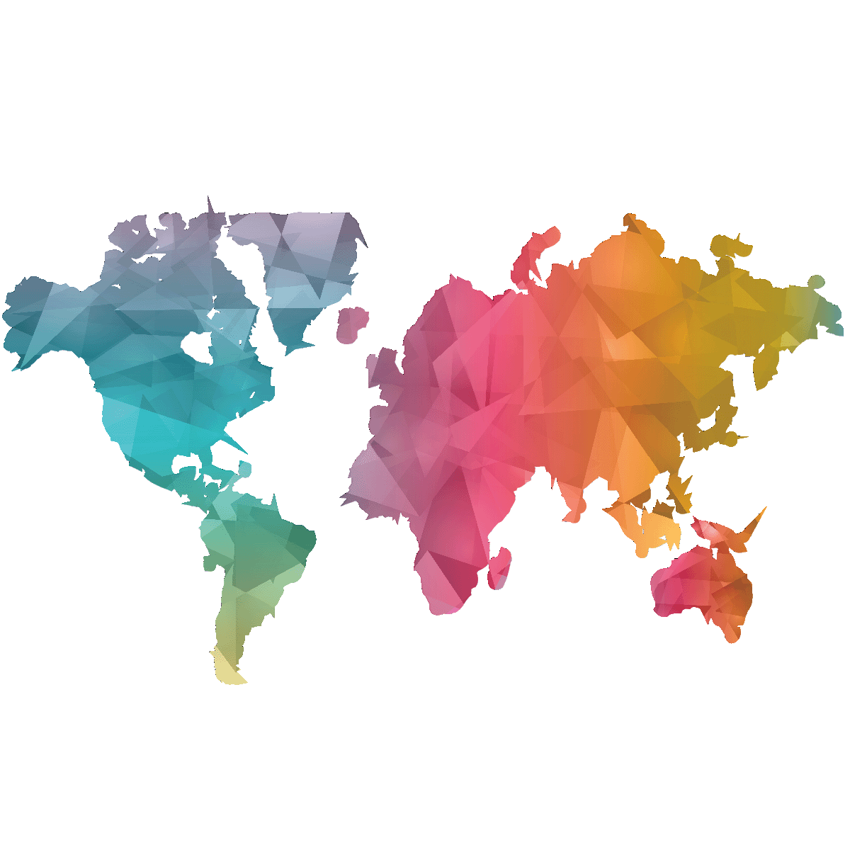

THANKS FOR COOPERATION

