OREHOVA POTICA – Slovenian sweet bread

Dough
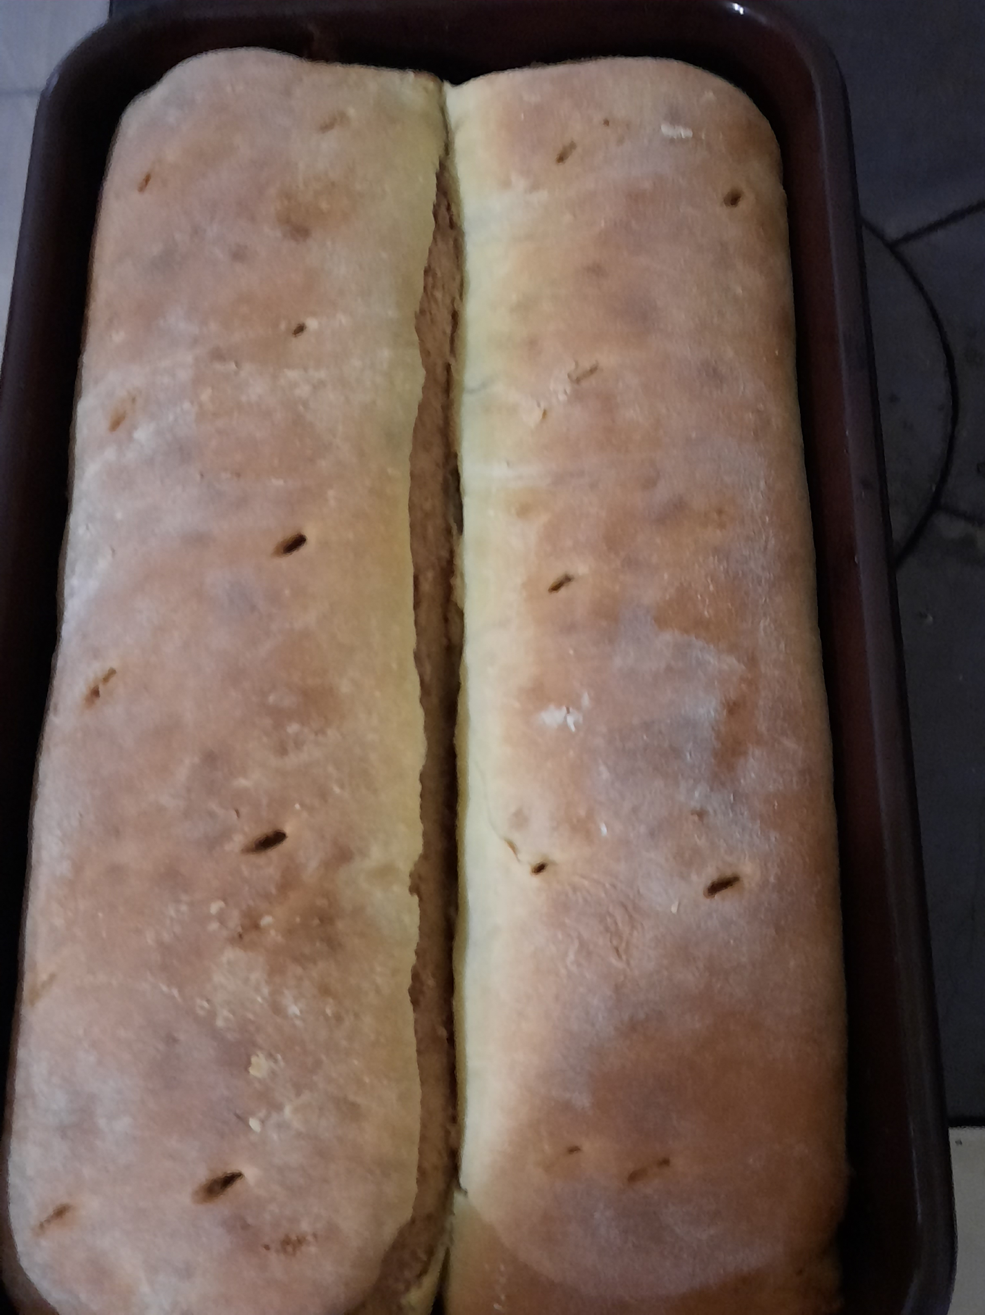
- 1 kg of flour
- 42 g of yeast
- 1,5 tablespoon salt
- 4 of egg yolks
- 12 dag of sugar
- 5 dl or milk
- 3 tablespoon of rum
- 10 dag of butter
- some lemon peel

Stuffing
- 70 dag of ground walnut
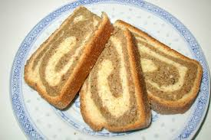
- 5 tablespoons of sugar
- 2 tablespoons of honey
- 2 dl of milk
- 3 dl sweet cream
- some tablespoons of rum
- some lemon peel
- 4 of egg whites

PROCESS(DOUGH);Crush teh yeast of spoon, add 2 tablespoons of flour, 1 tablesopoon of sugar and al little of hot milk. Mix everithing together and lat it rise. Sift the flour into the bowl. Make a hole in the middle and salt around it. Put yeast and mixture of lukewarm milk, butter and sugar in the pit and mix it. Then put the mixture into the flour and add the beaten egg yolks, rum and lemon zest. The dough is left for half an hour.
PROCESS(STUFFING); When the dough rises, we make the filling. Stream the ground walnuts whit hot milk and add honey,sugar and sweet cream. At the end, mix lightly the hard snow from egg whites. And the filling is finished.
Roll out the dough and stuff it whit stuffing and roll it into a roll. Grease the baking pan whit oil and put the roll in the baking pan.Leave to rise in baking pan for another half an hour. The risen rolls are first placed in a preheated oven at 180 degrees Celsius for about 45 minutes. When the potica is baked, take it out of the baking sheet and sprinkle whit powdered sugar and serve.
BON APPETIT

