Chocolate bursties
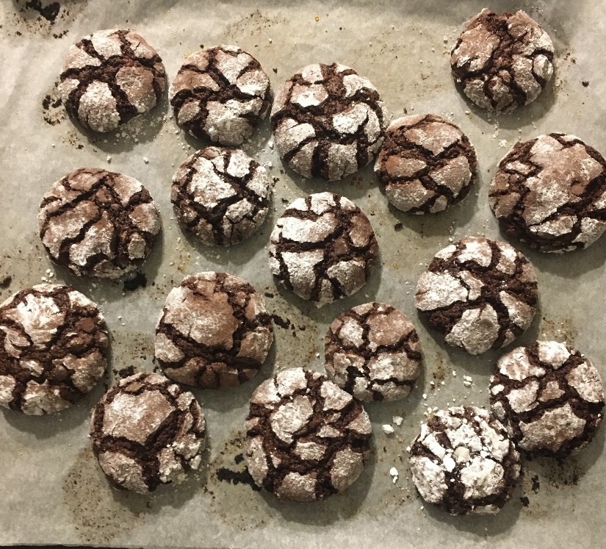
Ingredients:

• 200 g of dark chocolate

• 200 g of smooth flour

• 100 g of brown sugar

• 50 g butter

• 2 eggs

• a pinch of salt

• half a teaspoon of baking powder

• icing sugar

How to make it

1. Melt the chocolate and butter over steam, let cool slightly.
2. Whisk together the eggs and sugar. Add melted chocolate with butter. Mix, add salt and flour. Stir to mix the ingredients well. Place in the refrigerator, preferably overnight.
3. Preheat the oven to 180 degrees celsius. Line a baking sheet with baking paper. Take the mixture with a spoon and form balls. Roll them in powdered sugar, then place on a baking sheet and press, flatten with the palm of your hand to get the shape of a cookie and cause cracks.
4. Bake for 10 minutes, leave them on the baking sheet for a few minutes, then let them cool completely.

