Moons
Dough:
- 12 dag of sugar
- 12 dag of chocolate dust
- 12 dag of flour
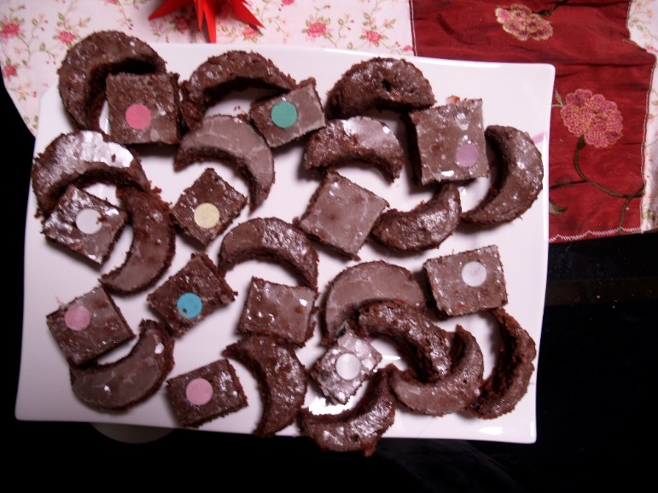
- 12 dag of butter
- 3 eggs

Frosting:
- 20 dag of icing sugar
- 1 spoon of rum
- Juice of 1 lemon

How to make it:

Mix butter, sugar and eggs (yolk + egg white) with a mixer, add the rest of the ingreedients for the dough and bake for ½ hours at 180 C. While it's baking, make a topping. When the dough is baked while still hot, pour the topping over it and wait for about 30 minutes for the topping to harden, then decorate it and cut as you wish (preferably in the shape of moons).

