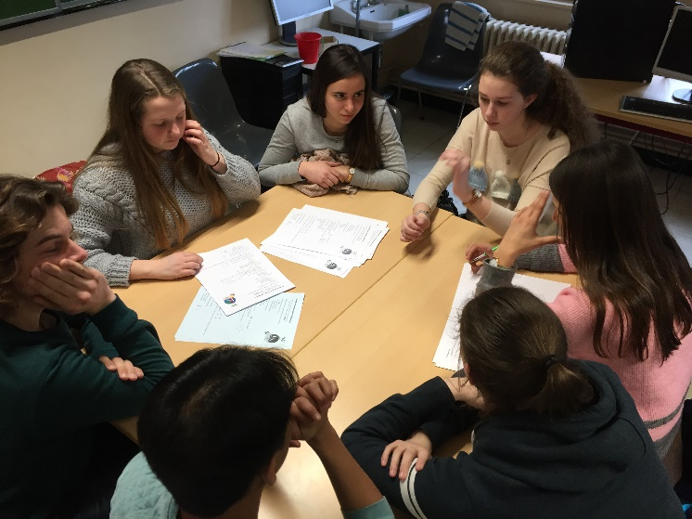
Think Tank „Earth Day 2018“

Definition of think tank
An institute, corporation, or group organized to study a particular subject (such as a policy issue or a scientific problem) and provide information, ideas, and advice
http://www.esthinktank.com/ find out more about this NGO – non-profit organisation
We have been working on sustainability for almost two years now in our Erasmus+ project “sustain.me”, integrating and cooperating with younger students and peers and thinking about sustainable solutions for problems our world is facing when it comes to
Food, waste, energy, clothing, transport, tourism, architecture etc…
In aid of this year’s Earth Day, on Sunday, , we want to open a “think tank” now on creative ideas of how to “green our school” and make it more sustainable.
Many approaches have been initiated, e.g. Respekt AG, vegetarian food as a permanent option in the school cafeteria, negotiations about sponsored water bottles for every JLS student.
But we can do more:
Just before Earth Day (20th April) we invite you to bring together more ideas, organize small workshops and initiatives, write letters to politicians to let them know about changes you demand for your (school) community.
Examples and questions you can “think tank”:
- Discussion on sustainable schools and education – changes needed?
- Awareness Mensa campaign: why should we all eat less meat?
- Cream workshop: students make, advertise and sell natural creams (Rö?)
- Why is there no official AKN stop at JLS (planned for decades), contact responsible officials, organize actions
- School garden?
- The World Future Council, Hamburg. What can we do to support them? (check out book)
- Active breaks
- Micro plastics! Let’s make a change in Hamburg, Germany!!! Do you knew they are banned in Great Britain!! (https://www.zdf.de/kinder/logo/problem-mit-mikroplastik-100.html)
- School and environment: educational musts

Participating:
12L students
6c students (8-9.30)
Interested 10th graders who want to take action

