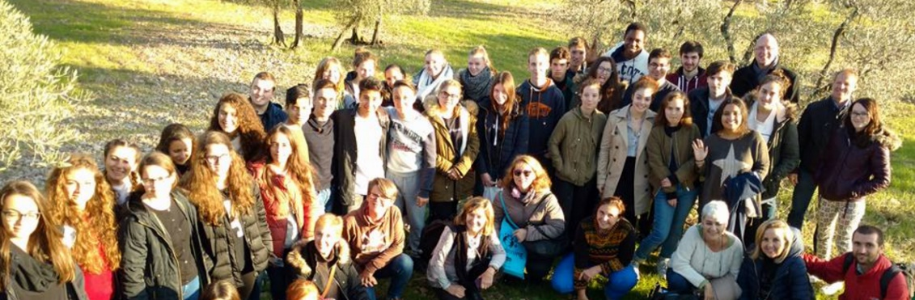
Sustainability Solutions Across Europe BIOTU·Saturday 19 NOVEMBer 2016
Imagine you live in Europe… or perhaps you already might live there. Maybe you live in one of its vibrant cities or in a cute town with windy streets. You most likely have access to a variety of ways of thinking, your form of government is relatively peaceful, and you are surrounded by cultures from around the world on a daily basis. The ever-rising global crises may have seemed as a distant issue in the past, but your connection to the outside world grows quickly. Regardless of your location, language, and lifestyle, you may recognize that you and your people hold great opportunities in front of you: to become better informed of the current global situations, to share constructive responses to common problems, and a tremendous chance to influence humanity’s future. Knowing this may help you recognize that your own sustainability—and that of your local community—is in none else but your own hands.
The question you may ask yourself is, what can you do? Your town probably has a well-structured recycling system. You tend to use public transportation and promote it constantly. You might even engage in a local community garden, support a charity of preference, or volunteer some of your time in the benefit of others. The word “sustainability” may still seem like a fashionable word that everyone talks about—but not many people really understand what it means. Furthermore, taking a look out into the world may seem like a daunting task. Despite all the work you already do, you might still feel saddened by the current circumstances, a sense of despair may cloud your actions, and no matter how much information you gather, your actions may not seem to suffice.
A year ago, an outstanding team of European public high school teachers devised an idea to implement sustainability education solutions across 5 countries in Europe: Belgium, France, Germany, Italy, and Spain. I was invited by one of its strongest advocates, Karin Lopez, to meet and collaborate with over 20 passionate public high school teachers from across Europe in the Lyceé Montmajour in Arles, France during the month of June, 2015. At the time, the teachers were anxious, ready, and had all of the necessary tools to move towards action. A year later, their inter-European program now has garnered the economic support from the European Union for its implementation.
The 5 public high school across Europe have created “sustain.me”, an ERASMUS+ Program that brings together teachers, students, schools and communities in a cross-cultural and inter-disciplinary program in France, Germany, Spain, Italy and Belgium. Their agenda includes weeklong visits in each of the 5 countries in a span of two years. Each visit tackles sustainability from a different angle: food, waste, architecture, fashion and travel. Among the questions they tackle are, what does sustainability mean and how does it affect us? What can European schools and students do to become more sustainable? What should public school teachers do to help their students pursue this?
Their first inter-school meeting took place last week once again at the stellar public high school of Lycée Montmajour in Arles, France. The hosts, a hospitable and welcoming conglomerate of staff and students in France, hosted over 20 international students and a dozen teachers from the other participating countries from November 7 – 11, 2016. The selected theme for this first visit revolved around food: its sustainability, sovereignty and waste. The host institution arranged a slew of activities and local outings; the local students and visiting participants had homework on critically comprehending food sustainability. I was invited as an external expert to inform, inspire and help connect sustainability with the program. Together, we had the task of helping foster solutions towards more sustainable food sources, one student and one school at a time.
Our first plan of action questioned the prime cause of climate change and water depletion worldwide: meat consumption. Local students had the task of researching the implications of excessive meat eating: studying the impact it has on human health, the local economy and the global environment. Despite the fact that all groups pointed towards meat reduction as a great necessity for improved sustainability, a general disbelief existed in student’s ability or willingness to reduce meat consumption. Less than 30% of participating students in the studies showed an interest in reducing meat consumption, despite all of the presented results and local support on behalf of the school cafeteria to do so. An outstanding gem surged to help clarify the situation. Jack, an exchange student from Australia, introduced himself as a vegan: a conscious decision made on his behalf to reduce his impact on his health and environment. He presented a shocking difference between the culture of veganism in his home country and the overriding meat-consuming culture in Europe. Despite not aiming to convert any of his fellow classmates towards becoming a vegan, he did present digital materials (www.nutritionfacts.org) and accompanying videos to help demystify false facts around veganism. In general, Jack added that he feels like a better person by not eating animals—acting as a more conscious global citizen by doing so.
The next days, sustain.me participants collaborated with local chefs to learn more about nutrition and conscious eating. Students learned from professional chefs on sustainable cooking practices, cooked their own “molecular cuisine” in the chemistry lab, and compared both food options. Participants also visited local fair trade and organic farms in the region to better understand where—and how—food is produced locally. In Mouriès, we visited a local olive grove and mill in an effort to spurt local production and reduce impacts found in transatlantic travel. Finally, students were informed about the local sustainability in Provence: studying the competitive advantages of the region, local food production maximizing local resources, rooms for improvement, and question the overall sustainability at a local level.
Halfway through the week, I presented our sustainability education work in the United States with BioTour and now in Mexico with BioTU. Throughout 9 years of crisscrossing both countries, working with thousands of children and youth to promote local actions, I affirmed the need to take easy steps, from an individual level to a societal sphere to effect a global change. I assured participants that sustainability entails promoting a change of mentality, especially by fostering a positive, productive way of thinking. With regards to meat consumption and local actions, I begged the students to question themselves, to research their impacts, and to take action. Furthermore, I ensured all of the participants that everyone alive today has a critical role to play—regardless of our local circumstances. Sustainability warrants more willingness to change and demands less comfort and sedation. The general feeling from students and participants was that they felt compelled to become further informed, inspired to change their habits, and with the necessary tools to take action.
Despite the fact that more time and dialogue with the students could have helped develop their projects and further the student’s initiatives, the results were impressive nonetheless. In France, the students will be working with local cafeteria to increase vegetarian and vegan options with sustainable food sources and products. Spanish students and teachers will increase their school-wide magazine to increase sustainable and fair trade on a local level. Sustain.me participants in Germany plan to implement more sustainability solutions across the educational curriculum by expanding their reach via their school magazine and with conferences with school coordinators. Italy will work across the board to reduce consumption of all types and will be discussed in next teacher meeting. Etwinning, a European Union online platform will serve as a way to interconnect and develop solutions across all schools in Europe. This interdependent digital platform will be used as the next steps forward until the upcoming Sustain.me meeting in February in Sevilla, Spain. Alongside, European students will be in touch with pen-pals in Mexico to share solutions, inspire action and promote results.
Together, participating students in each of the schools competed for the winning logo of sustain.me. The winning team developed a sound and concrete image of the project to define what these dozens of European students and teachers are doing to become more sustainable. The result: a beautiful tree intertwining its branches across the continents, symbolizing the growth of sustainable solutions to maintain the tree of life alive across the world. Bravo, sustain.me participants and leaders for initiating the discussion and fostering solutions in your schools and communities. It is an honor to be a small branch of your large tree to promote life in public schools across Europe.
Fernando Ausin-Gomez

