
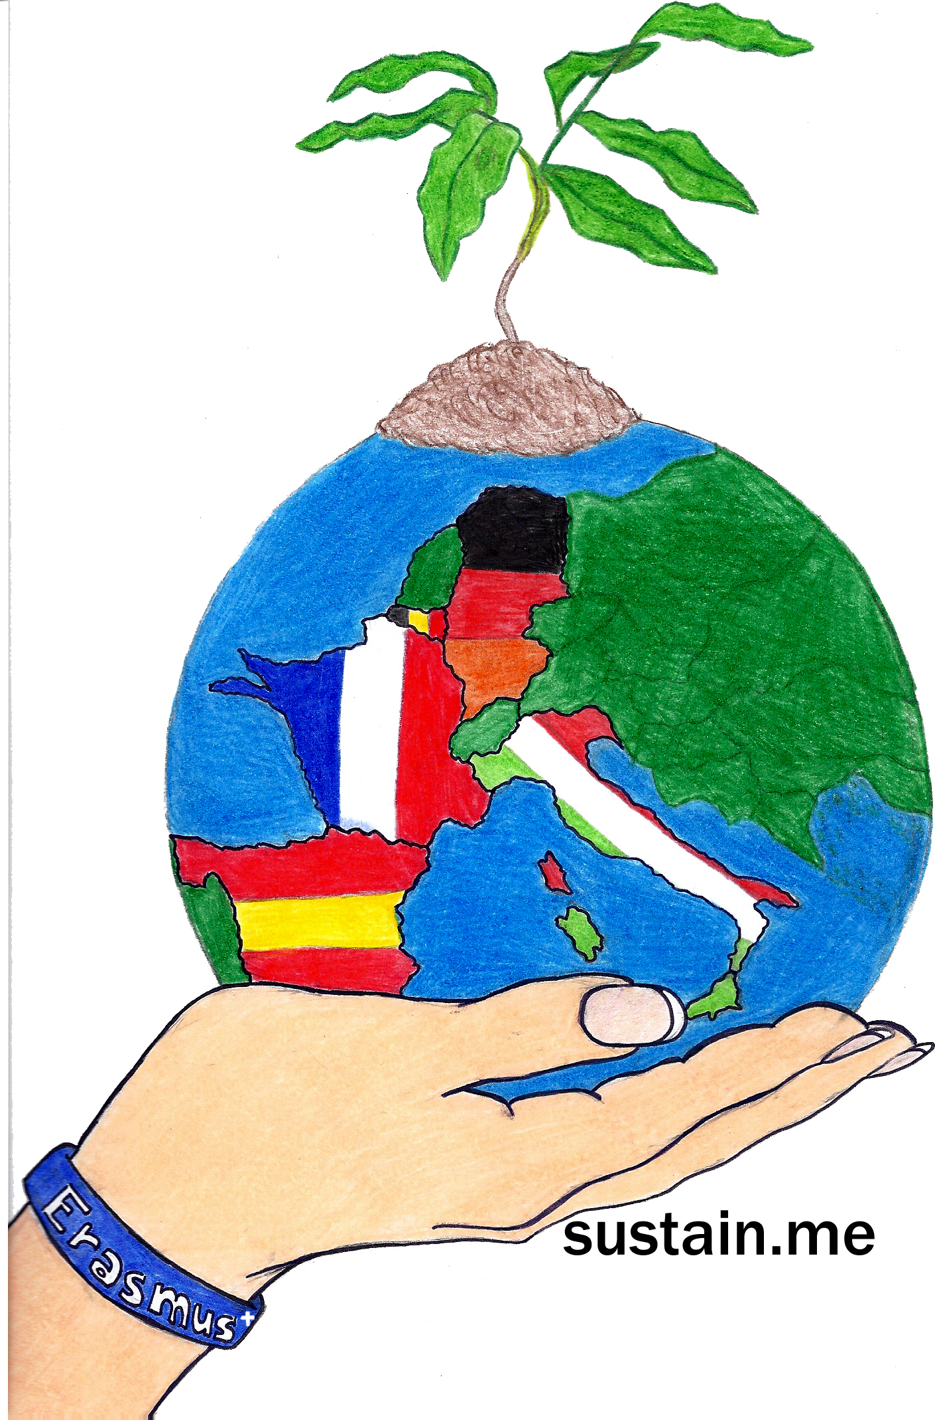
Sustain.me Hamburg May 2017 Evaluation Questionnaire Results

Monday | RESULT | SUMMARY
- Presentations of Schools | Interesting IIIIIIIIIIIIIIIIIIIIIIIIIIIII  Especially interesting about other types of schools IIIIIIIIIIIIIII  I've seen them before II  Difficult to follow IIII  Maybe something more interactive?/more questions and answers?/a little too long IIIIIIII | Delighted to see that the students are fascinated by each other's school systems!
- Presentations about Clothes (Hamburg) | Interesting, definitely learned more about my clothes/basis for week IIIIIIIIIIIIIIIIIIIIIIIIIIIIIIIII  Made me think/inspiring IIIIIIIIIIIIII  OK/too long II | Great!
- Presentations - various | Good, easy to follow, interesting IIIIIIIIIIIIIIIIIIIIIIIIIIII  Difficult to follow IIIIII  Some repetition IIII  Some seemed unprepared II  Too much in one day IIIIIIIII | Delighted the kids were, on the whole, so positive as it was a long morning of presentations!  But for future reference - we HAVE to break up the presentations over a few days, in my opinion...
- Art exhibition | Fantastic- unexpected IIIIIIIIIIIIIII  Creative/amazing IIIIIIIIIIIIIIIIII  Inspiring IIIIIIIIII  Not enough time III  Really cool seeing what other countries did II  Room very full IIIII | Great result!
- The vegan lunch | Tasty IIIIIIIIIIIIIIII  Good idea but bland IIIIIIII  OK III  I can understand why we did this but it was still hard IIIIIII  Vegan is just not me IIIIIIIIIIIIII | We can only try!
- Mini workshop (HERE STUDENTS GOT TO CHOOSE THEIR GROUP - SO NOT NECESSARILY ALL NATIONATIONALITIES WERE IN ONE GROUP - STUDENTS IDEA) | Challenging but good IIIIIII  Lots of fun/great ideas IIIIIIIIIIIIIIIIIIII  We could choose our own group IIIIII  I liked the small mixed groups IIIIII  Wardrobe Audit group - hard work but interesting IIII  Our Vine group should have been smaller III  Good IIII  Boring III | Most kids had fun, thankfully. Hopefully they came away from this more informed.

Tuesday | RESULT | SUMMARY
- Special visits from Ms Kassid & Ms Stridde | Learned a lot IIIIIIIIIIIIIIIIIIII  Listening to professionals was good IIIIIIIIIIIIIII  Interesting about their business IIIIIIIIIIIIIIIII  Hard listening to two intense presentations in one sitting/too long IIIIIIIII | Great to see that most kids endured the long presentations, basically due to fantastic contents!
- Packed vegan lunch | Great wrap IIIIIIIIIIII  Good idea IIIIIIIIIIII  OK IIIIII  No thanks IIIIIIIIIIIIII  Not very sustainable packaging (Capri Sun, plastic bags etc) IIII | Maybe the kids will be inspired to make thir own "tastier" vegan food?
- Discovering some of Hamburg by canoe (& painting on canvas) | (unexpectedly) Wonderful, lots of fun IIIIIIIIIIIIIIIIII  Good IIIIIIIIIIIIIII  WOW - architecture in Wilhelmsburg (sustainable building experiments) IIIII | Phew! A successful day where nobody drowned & all experienced interesting sustainable architectuire!

Wednesday | RESULT | SUMMARY
- Marolwe & talk with Ms Ott | Interesting IIIIIIIIIIIIII  Informative IIIIIIIIIIIIIIII  Expensive clothes IIIIII  Good to know get to know these stores (in Hamburg) IIIIIIII  OK-boring IIIIIIIII | Good to see positive results here. For some the input has been too much.
- Visiting some other stores in the area | Learned new things. IIIIIIIIIIIIIIIIIIIIIIIII  Inspiring - I'm going to buy second hand! IIIIIIII  Great experience interviewing different people in their shops/ all shopkeepers so nice IIIIIIIIIIIIIIII  Would like to revisit IIII  Pity some did the interviews in German (shop keepers were prepared to speak English) II  SpendaBel has inspired me III  Not necessary IIII | Delighted most kids had a positive experience - their presentations on their experience (back at school) there was short, sweet and inspirational.
- Up-cycling workshop (or other)  (HERE STUDENTS GOT TO CHOOSE THEIR GROUP - SO NOT NECESSARILY ALL NATIONATIONALITIES WERE IN ONE GROUP - STUDENTS IDEA) | Great/fun IIIIIIIIIIIIIIIIII  Good IIIIII  OK IIIIII  I liked that we could decide what to do IIIII  We could finish what we started III  Pity TWINE didn't attract lots of interest III | Am delighted that the student run workshops were, overall, a success. The best is that the visiting students can IMPROVE on what they felt didn't go well.

Thursday | RESULT | SUMMARY
- Red Cross experience | Interesting how the business works/Learned more about the Red Cross IIIIIIIIIIIIIIIIIIIIIIII  Clothes talk too short/not enough info on clothes IIIIIIII  Warehouse was cool (preparation for catastrophes etc) III  Interesting but shop floor room too small/Not much to see IIIII  OK-boring IIIIIII | Am surprised that the short presentation actually had a positive effect on the students - great!
- Afternoon at the Elbe | Fantastic, music & sun IIIIIIIIIIIIIIIIIIIIIIIII  Cool, lots of time to hang out with everybody IIIIIIIIIIIIIII  Nice for teachers & students III  Made more new friends here II | A successful day!

Friday | RESULT | SUMMARY
- Workshop with Mr Röhling | Great experience, made bio/organic cream IIIIIIIIIIIIIIIIIIIII  Fun IIIIIIIIIIIII  Useful information IIIIIII  Instructions were hard to follow III  Great as an expert III | Fantastic!
- Students teaching students | Good/fun/informative/innovative IIIIIIIIIIIIIIIII  OK IIIIII  Chaotic/Stressful/scary IIIIIII  Not enough student groups got to present II  Next time with 8th grade and not 6th (English problems) IIII  Students didn't ask questions II  The French were great II | This was difficult, the teaching kids were nervous, the students were nervous and unsure too. We just have to persevere.
- Presentations of various results | Good but next time it could be better II (how?)  Interesting III | HOW can we do a better job at presenting?!
- Why eTwinning WON'T be a problem to use in the future?! | Easy to use but NOT with mobile phone which is annoying. It's also annoying that we have to have a youTube account to save our own videos and make URLs to upload onto eTwinning. Snapchat & Instagram is better for students  Easy/No problem in future IIIIIIIIIIII  Good/safe platform for communicating III  I still have problems entering platform II  Because we have to use it! IIIII | Due to lack of time these last three questions weren't answered adequately.
- Feedback round/anything else? | Friday presentation from HR manager about business English was interesting IIIIIII  Great to meet everyone/make new friends. IIIIIII  Wonderful family IIIIIIII  Exciting/inspiring/life changing/interesting week IIIIIIII  breaks between presentations-in general IIIII

