Olive Schreiner

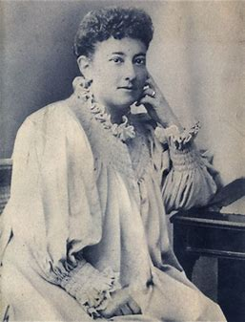
Olive Schreiner was a writer and feminist and one of the first campaigners for women’s rights. She was also a pacifist. She did not agree with British imperialism in South Africa. She opposed racism in whatever form, whether against Boers or Black people, both of whom were ‘underdogs’ in the early part of the 20th century.
Olive was the ninth of twelve children born in 1855 to a Wesleyan missionary couple at Wittebergen near Herschel in the Eastern Cape.
Olive was largely self educated and very bright. She would have liked to be a doctor or nurse, but lack of money and her own poor health (she suffered from asthma) prevented her from following either of those careers. She had various brief jobs as a governess and others, and eventually turned to writing as a way of staving off depression.
In 1883, she wrote The Story of an African Farm (1883) which dealt with the lives of three characters, first as children and then as adults who lived on a farm.
The characters displayed strong similarities to Olive’s own life and philosophy. Olive had rejected her parents’ Christian beliefs when she was 15 years old, and she rebelled against stereotypical images of women as dependent on men. It was revolutionary feminist writing for the time and the book became a best seller in Europe and the United States. It was praised by feminists who approved of the strong heroine who controls her own destiny.
She later wrote a number of political works - for example Trooper Peter Halkett of Mashonaland (1897) which attacked British imperialism and racism in South Africa and championed the causes of the Boers and Black people.
In 1909, her book Closer Union was published. In it she argued for more rights for Black people and for women.
In 1911, Olive Schreiner published Women and Labour which influenced the women's emancipation movement in England and America in the 1910s-1930s.
She also believed women should be paid the same as men. She died in December 1920, aged 65 years. It would still take most of the century for women to achieve equal rights with men in our country, but hers was an eloquent, early voice which could not be ignored.

