DAVID WARREN

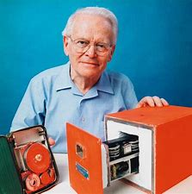

David Warren (full name David Ronald de Mey Warren) Was an Australian inventor. He is most famous for his invention of the Flight data recorder (invented in 1956), or more commonly known as the “black box”

  
  
     The “Black Box” is a device that records in-flight conversations and data. Warren came up with the idea of recording the flight crew’s conversation on a device that could be protected to increase its chances of surviving the crash. Although it has the name “Black Box”, it is coated with heat-resistant bright orange paint for high visibility in a wreckage, and the Black Box is usually mounted in the aircraft’s tail section, where it is more likely to survive a severe crash.

The recorder was well received in England (where the name “Black Box” was made up by a journalist at a briefing) and also in Canada where the idea was seen as a potential addition to beacons being developed there.

David died at the age of 85 in 2010, 19 July, Melbourne, Australia. After his death, He was buried in a casket bearing the label “Flight Recorder Inventor; Do Not Open”.

