Colours of my childhood
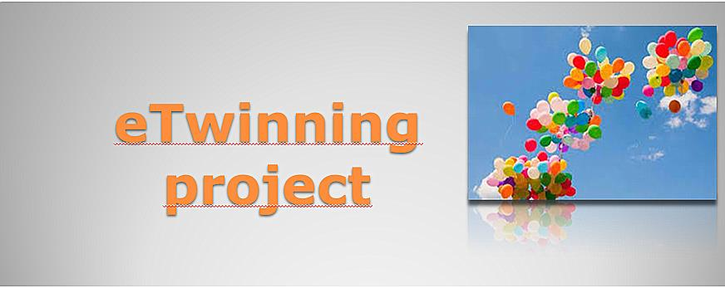
Description:
In this project students can express the same topic in many ways. It is up to them which tools they choose. They can sing songs, make pictures or performances, they can also use computer and internet. What is the value in this project that each school is able to present their own festivals, impartant holidays and other childrens celebrations.
At the beginning students from each partner school prepare their school description in ppt, which are shared in twinspace.Then students starts preparing logo of the project.
The teachers prepare a presentation about this process.It is also shared in twinspace. They can use any tools they want, they like.

Topic of each month:
- October- orange or brown
- November- purple or grey
- December- white or black
- January- yellow
- February- red
- March- blue
- April- green
- May- pink

The last task for each school is to make a “colorful dictionary” and present it on twin space.
Objectives:
- Get to know different countries and become aware of their culture.
- Improve English and ICT skills.
- Encourage cooperative learning and creativity.
- Our students will keep in touch with the other students in other countries and cultures.
- They will also learn their funny abilities.
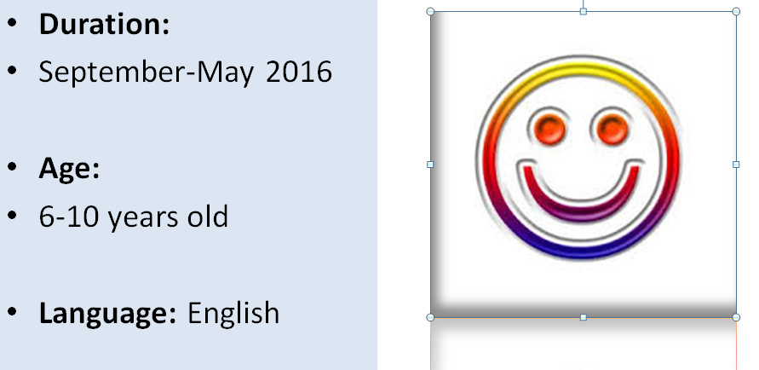
Daria Madej 114 Primary School in Warsaw, Poland

