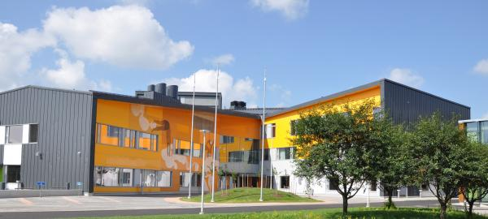Kungsvägens skola in Nickby hjärta

ROUND TABLE DISCUSSION

Music is on in the background all through the podcast

Reporter 1:
Hi everyone and welcome to our programme where we will be discussing one of the targets for Europe 2020: fighting social exclusion and poverty.
First, we will try to define the terms social exclusion and child poverty, then we will introduce and comment on some of the findings about the issues in the EU as presented in the EU 2020 reports.

The music in the background becomes louder for 3 seconds and then fades

First of all, let’s clarify the term “social exclusion”.
According to the Collins dictionary, social exclusion is “ the act of making certain groups of people within a society feel isolated and unimportant”

Reporter 2:
And what about the term Child poverty?

Reporter 3:
According to the United Nations Children’s fund UNICEF, “children living in poverty are those who experience deprivation of the material, spiritual and emotional resources that they need to stay alive.
This deprivation leaves them unable to enjoy their rights, achieve their full potential, and participate as full and equal members of society”
What do you think this definition means?

Reporter 4:
It means that the child doesn’t get everything that it needs, money, emotional support and a carefree childhood.

Reporter 5:
According to the Eu report 22% of children living in lone-parent households, and 25% living in large families are most at risk for child poverty.

Reporter 6:
Why do you think it is like this?

Reporter 2:
I feel like this might happen because in lone-parent households, the income is usually lower since only one parent works.
A lot of the parent’s attention goes to other things than the child, like worrying about the household economics and stuff so the children might grow up with less emotional support and care

Reporter 1:
How does that affect the child, you think?

Reporter 3:
Well, the child might feel ashamed when the money is tight in the family and so they distance themselves from their friends
In big families the situation is quite similar, the money and attention from the parents must be shared between all the children.

Reporter 4 :
What about the children in migrant or minority families?

Reporter 5:
Children growing up in migrant or minority households also face more difficulties than other children.
The language might be a problem, and lead to less education and a harder time getting a job.
The family might not have a lot of money , have a harder time making friends and getting on in the society.
A lot of minorities also may grow up discriminated against because they’re different, which can have a negative impact on their self esteem.

Reporter 6:
What do you think about what the EU report states about the age of parents? Does it have anything to do with child poverty?

Reporter 3:
I think it’s fascinating that the EU report also says that children whose parents are below 30 have a lot higher risk of being poor than those who live with older parents.

Reporter 2:
Why do you think it is like that ?

Reporter 1:
Well, older people tend to have more stable, well-paid jobs while young parents often can be unemployed or maybe work part-time.

Reporter 5:
Does the educational level of the parent matter?

Reporter 6:
Well, the educational level of parents matters a lot, actually, according to the report:
For 30% of the poor children, the parents didn’t have a secondary level of education while the percentage for all children was 16%
The situation is also very different in different EU countries;
The share of children with low-skilled parents range from under 10% in nearly half of the EU states, to up to 65% in for example Malta and Portugal.

Reporter 3:
So with a higher education, parents are able to get better jobs and earn more money for the family!

Reporter 1 :
And the report goes on:
62% of jobless households with children are at risk of poverty,
And almost 10% of all children under 25 live in households where no adult has a job.

Reporter 2:
This has to affect the children of these families a lot, don’t you think??

Reporter 3:
Yes, it does, a lot. If the parents are having trouble supporting the family and need to focus most of their energy on getting through the day, there won’t be much energy left to see how the children are doing.

Reporter 4:
And how can this influence the children?

Reporter 5:
Well, the children might have more responsibility than they perhaps should at that age.
Or they might feel forgotten, and in worst cases, they might act so that they get in trouble just to get seen by the parents.

Reporter 6 :
So, the sad conclusion is that children who grow up poor are less likely to do well in school or enjoy good health .
They are also at a higher risk of becoming unemployed, poor and socially excluded.
Of course, not all children from poor families end up poor, unemployed and lonely, but hopefully we will be able to help those that do ,for example through the Europe 2020 initiatives.

Reporter 1:
Well, it has certainly been an interesting discussion, and we hope you have enjoyed listening to us.
The students involved in the talk were….
Thank you, and have a good day!

The music becomes louder for some seconds and fades away

