KEY ACTION 2 (KA2) – STRATEGIC PARTNERSHIPS FOR SCHOOL EDUCATION

The fourth Project meeting in Grammar School, České Budějovice, Česká 64
16 April-20April 2018

Location
Grammar School, České Budějovice, Česká 64
Our school provides acydemic type of study, 4-year schooling, 8-year schooling, sport studies

Our city České Budějovice

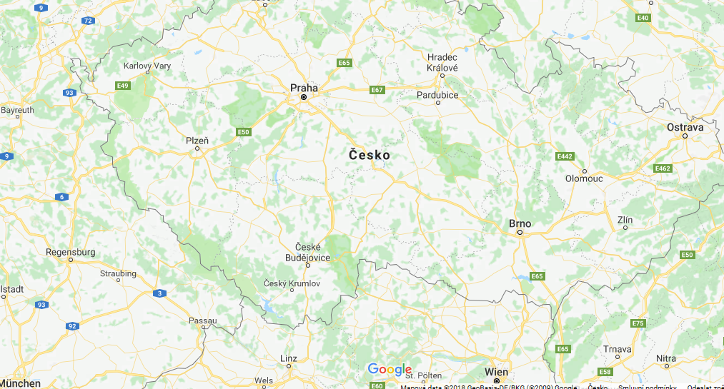

Area: 55,6km²
Population: 93,470

Participants
N0 | Country | School | Teacher
1. | England | Manchester | Samar El-Koussa
2. | Italy | IIS GALILEO GALILEI | Antonella Cornelli
3. | Italy | IIS GALILEO GALILEI | Cristina Moroncini
4. | Spain | IES David Bujan | Mercedes Alves Moreno
5. | Spain | IES David Bujan | Maria Dolores Martinez Rodriguez
6. | Macedonia | SOU “Orde Chopela” | Karolina Damjanoska
7. | Macedonia | SOU “Orde Chopela” | Aneta Pejovska
8. | Czech Republic | Gymnazium Ceske Budejovice | Marcela Radová
9. | Czech Republic | Gymnazium Ceske Budejovice | Martin Gunzel
10. | Czech Republic | Gymnazium Ceske Budejovice | Lukáš Boček
11. | Czech Republic | Gymnazium Ceske Budejovice | Petra Špišáková
12. | Czech Republic | Gymnazium Ceske Budejovice | Věra Krhounková

Participants at the project meeting in Gymnázium, České Budějovice,Česká 64:
7 students from Spain, 7 students from Macedonia, 6 students from Italy, 18 students from the host country.
And our consultant from the United Kingdom – Samar El-Koussa

From/to airport

Country | Arrival at Václav Havel Airport Prague | Departure from Václav Havel Airport  Prague
Macedonia (coach) | 15/04/2018 at | 20/04/2018 at 9:30 p.m.
Italy | 15/04/2018 at 14:45 p.m | 21/04/2018 at 12:10 pm
Spain 15/04/2018 at 14:55 p.m 21/04/2018 at 15:40pm

Agenda for the Erasmus+ meeting in Grammar School, České Budějovice, Česká 64
16/4/2018 Monday | Activities
8:30 – 9:00 | Welcome meeting
9:00-10:05 | Ice-breaking games Part I
10:05 -10:15 | Break
10.15 -11:45 | Workshop-creating safety features/ Creating a mutual denim sculpture
11.45-12.30 | Lunch break
12:30 -15:00 | Workshop-creating safety features/Creating a mutual denim sculpture
15:00- | Hunting the city sights , Voice Thread -teachers
15:00 - 15:30 | Teacherś meeting

17/4/ Tuesday | Activities
8:25 | Meeting in the school
8:30 -9:30 | Painting the sculptures from Macedonia
9:45-11:15 (9:30_9:45; 9:45-11.15) | Laboratories of CEVAK (drinking water supplier)
 | Lunch break
12.45 | Departure for Český Krumlov (Unesco Herritage Fund)  https://en.wikipedia.org/wiki/%C4%8Cesk%C3%BD_Krumlov  https://www.zamek-ceskykrumlov.cz/en
 | Sightseeing of Č.K. (a guided tour of the castle, town sightseeing)
17:30 | Arrival in CB
 | Teachers´Dinner

18/4/ Wednesday | Activities
8:25-9:45 (60 mins netto) | Laboratories-physical properties/  Lessons shadowing
 | A 10 mins break
9:45- 11:15 | Lessons shadowing/ Laboratories-physical properties
11:15-12:00 | Lunch break
12:15-13:00 | Bus for Silon Planá
13:00-15:00 | SILON Planá, an excursion in the premisses of a company producing technical compounds and polyester fibres  http://www.silon.eu/
15:15-17:00 | Hluboká n/Vlt  https://en.wikipedia.org/wiki/Hlubok%C3%A1_nad_Vltavou  https://www.zamek-hluboka.eu/en
17:30 | Arrival in CB

19/04/2018 Thursday | Activities
8:25 -11:00 | Workshops (according to real needs -safety features, sculptures,..)  Lessons shadowing for teachers available
11:30 -12:15 | Lunch
12:15-14:30  16:15 | Presentations for Fridayś lectures -project „Students Teach Students“  Excursion of Budwaiser Brewery
14:30-16:00 | Installation of exhibitions, fashion show preparation
17:00 -21:00 | Preparation of the „grand finále“ and party at the school

20/4/2018 Friday | Activities
8:25 -9:05  9:20- 11:00  11:00-11:30 | Preparation of the photo exhibition  Preparation of the fashion show  Fashion show for all students  Students voting
11:45-12:15 | Lunch break
12:15 -14:00 | Students´tuition (1.A)
14:00-14:30 | Break

21/4/2018 Saturday | Activities
 | Flight home

