Work plan Tømmerup Friskole Monday 28. January – Friday 1. February 2019

You will be working in the following groups during the week:

GROUP A:  Sira Argany and Camilla  Nerea and Freja  Ada and Petrea  Anna and Julie | GROUP B:  Mariona and Eva  Sira Bagés and Ida  Hector and Lucas  Claudia and Sofie
GROUP C:  Pau and Sebastian  Joan and Else Marie  Ruth and Josefine  Clara and Isabella | GROUP D:  Aina and Kathrine  Ivan and Mikkel  Africa and Thorbjørn

MONDAY 28TH OF JANUARY 2019
Important: wear warm clothes – you will be partly outdoors today! Remember to bring a camera or a mobile phone.

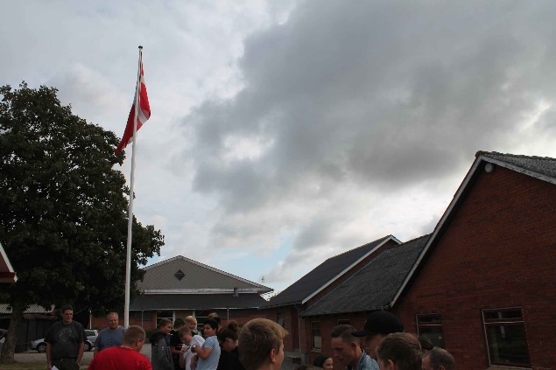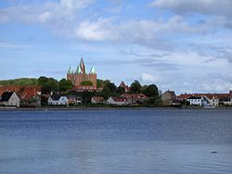
8:15 You meet at morning assembly
9:00 You meet at room 12, and there will be a guided tour at the school.
The guided tours will be in the groups A, B, C, D
9:45 Break
10:10 You meet at the parking lot in front of the school and we walk to the
public bus.
10:40 Tour game to explore Kalundborg. Follow the instructions on the papers you receive when we arrive at the Central Station in Kalundborg. You will do the tour game with your group.
12:00 You meet at the Central station. We will take the public bus back to school.
12:30 Lunch
13:00 You meet in room 12, and you will work on the photo collage in
connection to the tour game. HAND IN THE PHOTO COLLAGE AT 14:00!
Remember that you will have to present the results at morning assembly
Thursday 31th of January.
14:00 You work on the project webpage until 15:10
15:10 Cleaning by group A
15:20 Free time

Task for the Catalan students: Remember to do some filming from the village and surroundings – as well as from the school. You will need the film clips to make a film about your stay in Denmark.

TUESDAY 29TH OF JANUARY 2019
Important: wear warm clothes – you will be partly outdoors today! Bring a camara or a mobile phone.

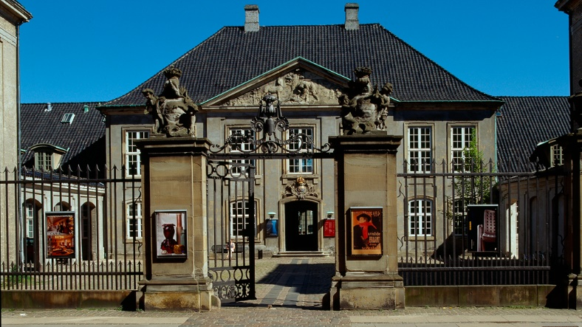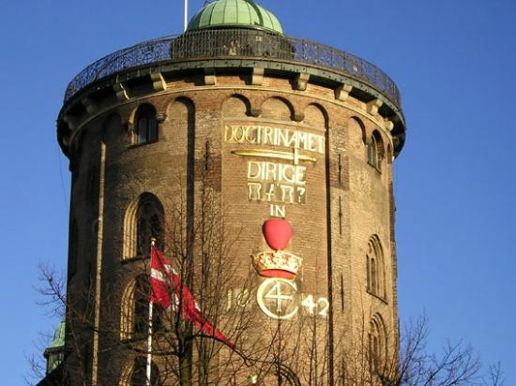

9:30 You meet at the Central Station in Kalundborg. We will go by train to
Copenhagen.
11:15 We will have a short walk through central Copenhagen. Please bring your
lunch packet.
13:00 You will participate in a 2,5 hours workshop at Designmuseum Denmark. It is about sustainable design. You will work in your groups.
15:30 We walk together to the Round Tower.
16:30 We leave the Round Tower and walk to Nørreport Station, where a bus will bring us back to school.
18:45 Free time

Task for the Catalan students: Remember to do some filming from Copenhagen and the workshop. You will need the film clips to make a film about your stay and experiences in Denmark.

WEDNESDAY 30TH OF JANUARY 2019

8:15 You will meet at morning assembly. There will be a presentation of
INS Flix for the rest of the school
9:00 You meet in room 12 to participate in a workshop on making sustainable
cardboards.
9:45 Break
10:10 You meet in room 12 and continue the cardboard workshop.

Special task for the Catalan students: you have to make some filming of the workshop.

11:40 Lunch
12:15 You edit and finalize the filming made by the Catalan students. You work
in your groups.
14:30 Free time
18:00 Dinner at Julie’s house

THURSDAY 31ST OF JANUARY 2019

8:15 You meet at morning assembly where you will present your photo
Collages from the Tour-game in Kalundborg
8:30 Normal lessons – see separate plan and groups
9:45 Break
10:10 Normal lessons – see separate plan
11:40 Lunch
12:15 You meet in room 12 where we will have a discussion on similarities and
differences between the two schools.
13:15 You write on the eTwinning blog about your experiences with the stay in
Denmark. Follow the instructions from the teachers in charge.
You work on the project web page.
14:30 Free time

FRIDAY 1ST OF FEBRUARY 2019

IMPORTANT! PLEASE WEAR VERY-VERY-VERY-VERY WARM CLOTHES. YOU WILL BE OUTSIDE IN THE EVENING IN TIVOLI – AND IT CAN BE COLD, BUT FUN ALSO, REMEMBER A BIG LUNCH PACKET, YOU WILL BE HUNGRY WHEN YOU ARE IN THE FILM STUDIOS, AND IT WILL NOT BE POSSIBLE TO BUY FOOD AT THE FILM STUDIOS!!!

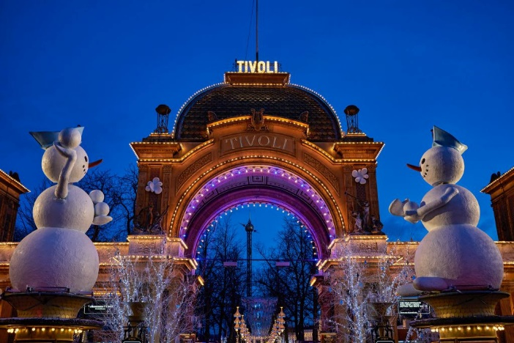

7:15 We meet at the parking lot in front of the school, where a bus is
waiting for us.
9:30 A 5-hour workshop on commercials at the film studios: Station Next near
Copenhagen. You will work in your groups on remaking professional
commercials.
14:30 We will go by public bus to the center of Copenhagen where you will
have time to do some shopping and to enjoy.
?? We will meet at the entrance to Tivoli, where you will have an entrance
ticket and a meal ticket. With the entrance ticket you can explore all the
amusements in the park.
19:40 We meet in front of the entrance facing the Central Station, and we will
walk to a bus waiting for us.
21:45 We are back at the school parking lot.

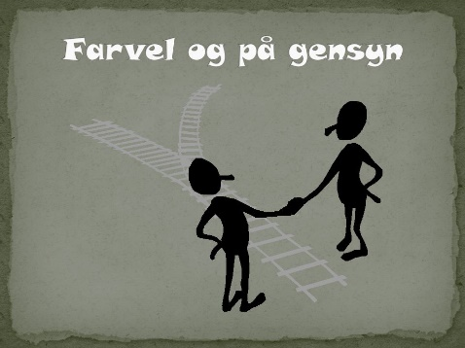

Lessons on Thursday 31st of January 2019

Lessons | 9th grade  Sira Argany, Mariona, Africa, Anna, Aina, Joan, Ruth, Ivan | 8th grade  Ada, Nerea, Sira Bages, Héctor, Claudia, Clara, Pau
8:30-9:45 | German | Math  Religion
10:10-11:40 | Math | English

