CHRISTMAST ONCE UPON A TIME IN BRDA
Once upon a time around Christmas there were different customs.
Between advent and Christmas there were the same rules that applies for fast. In that time, there were no parties, even the weddings were exception. In time of advent they went to church every morning, beside that they had to plough the field, they had to make many ŽRTVIC.
Because of the winter, in the Christmas time, they had to buy a lot of new suits for children. They made a big cleaning in the house, landowner brought a stump, witch symbols that Christmas night. Housekeepers had their hands full of work, they were baking many different cakes, like HUBANCO- walnut cake. Children had a special work to do, for example decorate the tree. Mangers were indispensable at the time of Christmas, it was made in their home, usually it was made from wood. Ornaments were made from walnuts and shiny cases. They put the tree in the spot where it was seen, usually in the kitchen. Children were making hearts, moons and stars from colorful paper. They didn’t know colorful lights so they had to pout up colorful candles. They were using special clips for candles. On the top of the Christmas tree, there was a comet. The family gathered around the tree and they prey and sang Christmas songs like (sveta noč, zvezdice božje). Some family went to church that night. The arrival of Santa Claus was less well-known customers.
Christmas night was to the first world war associated with differing habits, which they abandoned. Villagers from distant villages went to the church, with domestic torchlight, where was the polnočnica (mass in the middle of the night), and after the first world war with the LUMINI (paraffin lamp) even if the weather was bad, they had to visited polnočnico (mass in the middle of the night). Christmas was a
family holiday, day were all the family members were gathered and enjoying the day full of love.
That night they are warming themselves with stump, which was kindling throughout the night. Sparkles that were created at the kindling were predictive the wedding. Young girls prayed that night: "God give, that stump will sparkle, that I will get a husband. Mother of god hear me that there will be peace in our house."
(»Bog daj, da bi se čuja iskrila, de bom moža dubila. Mati božja me usliši, da bo mir v naši hiši.«)
Miha Mačus, 8. a
Taken from: Darinka Sirk, Ivanov venec: Briške šege in navade (2009)
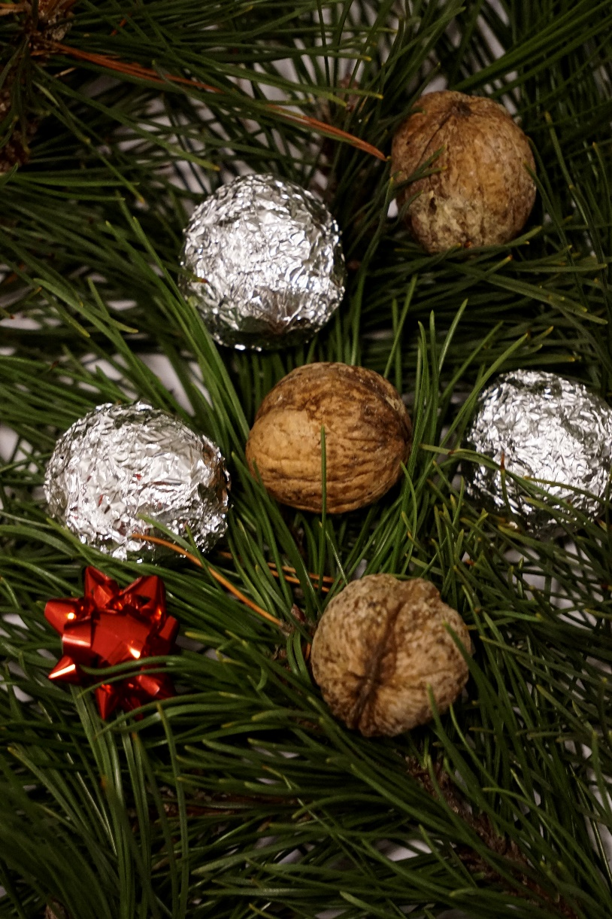

Example of the Christmas decorations once.
Picture: Ema Marušič, 9.b

